Contents
Table of Contents
Introduction 3
April 2014 5
May 2014 6
June 2014 7
July 2014 8
August 2014 9
September 2014 9
October 2014 10
November 2014 11
December 2014 12
January 2015 12
February 2015 14
March 2015 14
Patient Feedback 15
Performance 15

Introduction
NHS Borders has an excellent reputation in Scotland for all round good performance, delivering well in many areas including waiting times, finance and above all the provision of safe and high quality patient services.

This publication showcases a selection of achievements by employees from across our organisation who go the extra mile, every day, to care for the people of the Borders.

Whilst celebrating our success we must also be mindful that, as we head towards 2020 we face a number of challenges, as the population ages and continues to live with an increasing number of multiple health conditions.

We must all take a collective responsibility therefore to look after our health, and over the next year we will be asking you to engage with us, to tell us what matters to you, so that together we can shape the future of health and social care services in the Borders.

Two priority areas are:

Delivering safe and high quality patient care
A clinical services review is already underway, looking at developing new ways of working in and from our hospitals in order to improve patient care. Over the coming months we have

committed to widespread consultation and dialogue with the public at all levels from small groups to local councils.

Health and social care integration:
We have a good track record of joint working with Scottish Borders Council and the voluntary and third sectors. Following the introduction of legislation we now have to make a huge step change in delivering joint care. A new Integration Joint Board of Council and Health Board, with partners from other sectors, will plan and commission health and social care services that support people in ways that are effective and seamless and enable people to live healthier lives at home or in homely settings.

I look forward to engaging with many of you over the coming months.

John Raine, NHS Borders Chair

Here in NHS Borders, I am proud to say that we are fortunate to have dedicated staff who want to help take us forward to be the best we can be for our patients and carers.

The successes and achievements detailed in this report illustrate the breadth of activity that is undertaken across NHS Borders by these dedicated teams and individuals, and it is a pleasure to be able to share these stories.

NHS Borders is a learning organisation, and sharing is a fundamental part of the learning experience.

Over the next year we will be asking as many people as possible to share their thoughts with us by answering one very simple question; What matters to you?

I, together with the Chairman, members of the Board and representatives from a cross section of health services will engage with you so that we can truly understand what your expectations of clinical services in the Borders are. We will consider what needs to change to achieve the vision of everyone being able to live longer healthier lives at home, or in a homely setting, and with seamless provision of service across health and social care.
2015-16 will be challenging, but it will also be rewarding and we will continue to strive for excellence through learning, sharing and sustained improvements in all aspects of health care.

Jane Davidson, Chief Executive

April 2014

An Evening of Winners at NHS Borders Staff Awards
The first ever NHS Borders staff awards event took place on April 4th 2014. Fittingly entitled ‘Celebrating Excellence’, the evening, which was hosted by local businessman and volunteer Chairman of ‘the difference’ charity Mr James Marjoribanks, was a celebration of dedication, clinical excellence and person-centred care.

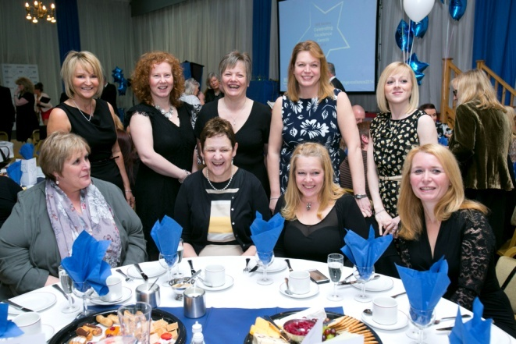
Special Care Baby Unit Nursing Team

The proud winners were announced as:
Chairman’s Award - ‘Michael’s Eye Operation Team (Dr. Nigel Leary, Dr. Imogen Hayward, Dr. Robert Murray, Alison Todd, Sister Betty Williamson)
Student of the Year - Kirsty Baxter
Person-centred Care - Special Care Baby Unit Nursing Team
Working in Partnership - Jenny Baird, IM&T Project Manager
Improving Health - Alison Quinn and Kerrie Blake, Maternity Care Assistants
Volunteer of the Year - The Borders General Hospital Participation Group, chaired by Mrs Ann Purvis
Innovation and Improvement - Gill Lunn, Midwife
Clinical Excellence - Melburn Lodge
Leading by Example - Rachael Marples, Baby Friendly Initiative Lead
Behind the Scenes - Cameron Miles and the Bedbusters Team, Discharge Liaison Service

NHSScotland Event – Poster Display
NHS Borders had nine posters shortlisted at the prestigious NHSScotland event. The posters were selected by a team of external reviewers; all of whom have expertise in Quality Improvement and Patient Safety. Shortlisted were:
Jacques Kerr / Chrissy Alcock / Mary Bishop / Julia Scott / Dr Sheena MacDonald – Achieving 100% compliance with Sepsis 6 Bundle through Emergency Department Nurse Empowerment
Sandi Haines / Justin Wilson / Dr Susan Kerr / Dr Paul Syme / Jacques Kerr / Jamie Thomson/Joy Borowska – Achieving the Stroke Swallow Screen Clinical Standard within a 4 Hour Target.
Anne Palmer / Justin Wilson / Dr Susan Kerr / Dr Paul Syme / Jacques Kerr/ Sandi Haines / Jamie Thomson / F Cockburn / S Grandison / J Schofield / J Nisbet / V Redpath / K Sainsbury / J Greig – Achieving Improvement in Overall Compliance with the Stroke Care Bundle
Yvonne Chapple & Fiona Munro – A Healthier Me. A Proactive approach to healthier lifestyles& dietary management for adults with learning disability in the Scottish Borders
Jacques Kerr / Mary Bishop / Alastair Meikle / Kirk Lakie / Jane Davidson – Hip 7: Using a bundle of care to streamline management of patients with fractured neck of femur
Nicky Gammie – Modelling a Sustainable Role for the Future: Assisted Birth Practitioner Midwives
Nicky Wheal / Linda Gray / Alison Hennessey, Claire Martin / Nicola Selhuber – NHS Borders AHP Outcome Measure
Jacques Kerr / Laura Jones / Allison Roebuck / Dr Simon Watkin / Jane Davidson – How to Achieve the Emergency Access Standard in your Region
Dr Simon Watkin / Andrew King / Justin Wilson / Lynne Mann / Erica Reid – Identifying System Level Delays in Patient Flow through Day of Care Survey
Well done to all participants for showcasing examples of sustaining quality and spreading quality improvement successes.

April showered awards on NHS Borders and the Macmillan Cancer Centre in NHS Borders received a prestigious national award in recognition of its good practice and high standards – one of only 19 sites within Scotland to be given such an award. Since opening, the purpose-built chemotherapy area has facilitated the repatriation of chemotherapy from Edinburgh Cancer Centre and now approximately 95% of cancer patients receive their chemotherapy locally. One patient commented: “It’s a wonderful resource for the community which does wonderful work and is hugely appreciated.”
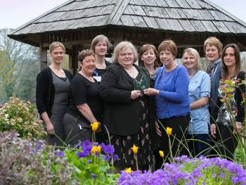
Borders Macmillan Patient Dot Haug accepting the Award from Macmillan’s Jean Maltman

May 2014

NHS Borders best practices shared with NHS Lanarkshire and NHS Ayrshire and Arran
During May we welcomed clinicians and managers from both NHS Lanarkshire and NHS Ayrshire and Arran who had heard positive stories about some of the work being undertaken in NHS Borders to support safe and efficient patient flow. They were keen to see firsthand how patient flow is managed within our area, how Wardview is used in support of this and also some of the work that is being undertaken in relation to improving the accuracy of Discharge Dates.

NHS Borders is named in UK 40 Top Hospitals for 2014
NHS Borders is one of the CHKS 40Top Hospitals for 2014, an accolade awarded to the 40 top performing CHKS client trusts and boards. The 40Top award is one of several awards that are part of the CHKSTop Hospitals programme. As well as national awards for patient safety, quality of care and data quality, CHKS celebrates excellence amongst its 400 clients across the UK. The 40Top award is based on the evaluation of 22 key performance indicators covering safety, clinical effectiveness, health outcomes, efficiency, patient experience and quality of care. The CHKS Top Hospitals programme awards were held in London on 13th May and were attended by over 200 guests including leaders from across the healthcare sector.
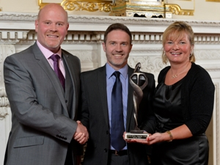
Alasdair Pattinson and Diane Keddie accepting the Award on behalf of NHS Borders

Honorary Lecturer Awards
For many years, Borders College have benefitted from subject specialists, working in their chosen fields, lecturing on a regular volunteer basis to enhance the education of students studying at the College. The College wanted to recognise this valuable contribution and therefore created an Honorary Lecturer role. At a ceremony in June, the first Honorary Lecturers were presented with their certificates. Among those presented were: Lucie Page, Kirsten Thomas, Adam Wood, Scott Murray, Fiona Mann and Rod McIntosh all from NHS Borders. A proud moment!

A new model of care for people affected by drugs and alcohol was introduced by the Borders Alcohol and Drug Partnership (ADP) during this month. Launched at a Substance Misuse Conference at Tweed Horizons, which was attended by national and local leaders in the field, the model sees Borders ADP working with new partners with a focus on community based support.

The new look NHS Borders website was launched in May. The site is fully compatible with tablets and mobile phones, and also has an improved search guide and interactivity, with blogs, social media and video clips to enhance the user experience.

Culture starts at the top
NHS Board began a 360° appraisal – the first of its kind in Scotland’s NHS – asking a range of people what they thought about the Board and the results will provide a basis for improvement.

June 2014
Improving OCS (Office Communications Server) for more integrated working Work has been on-going to take full advantage of the many facilities OCS offers including improving communication links between ourselves and Scottish Borders Council. NHS Borders OCS users can now call SBC users, check their presence, instant message, conference and video call, saving our resources for virtual meetings.

Breastfeeding Awareness Family Picnic On 24 June at the Melrose Cricket Ground, NHS Borders, Scottish Borders Council and BiBs (Breastfeeding in the Borders support) held a second annual family picnic to help raise awareness of breastfeeding and the importance of making breastfeeding in the Borders easier and more acceptable to others.
Around 75 people including, parents, babies, toddlers, health visitors and breastfeeding peer supporters braved the rain to come along.
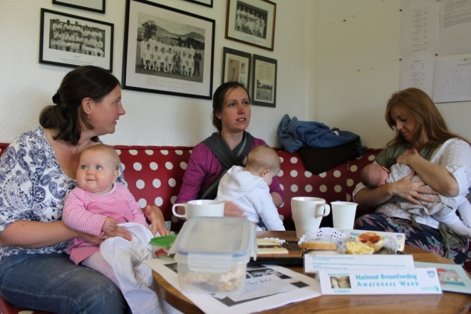

Visit from Alex Neil Cabinet Secretary On the 24 June, Alex Neil, Health Secretary for Scottish Government visited the Borders General Hospital to meet some of those who contributed to NHS Borders achievement at the CHKS Top Hospital Awards 2014. 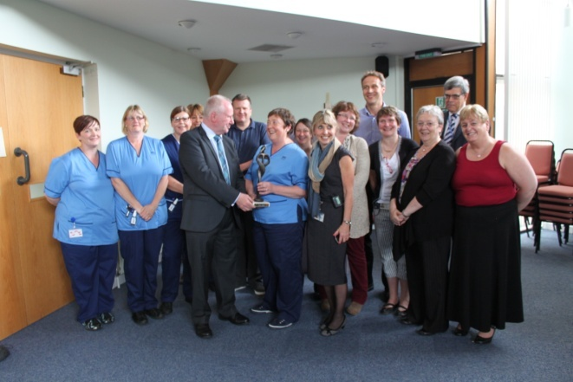
Visit by Alex Neil Cabinet Secretary

Contribution to this year’s NHSScotland Everyone Matters Event. At the beginning of June 2014, NHSScotland held their annual NHSScotland event in Glasgow. The event was focused on spreading and sustaining quality and looking at the next phase of the quality improvement journey in Scotland. Three case studies were presented at the Everyone Matters session at the event, with one of those three being on Desmond, an NHS Borders service provided for Diabetic patients.

Shirley Rodgers from NHSScotland Health Workforce said: “Thank you for your invaluable input to the Everyone Matters session at the NHS event. The three case studies were all very different, interesting and really brought the session to life. The participants had plenty to reflect on discuss as a result of these and it seemed as though lots of sharing was going on.”

The Margaret Kerr Unit (MKU) made a lasting impression on the Borders Book Festival, held in Melrose in June. The Unit was the chosen charity for the event and representatives were on hand for the four days to talk to people about the MKU and specialist palliative care services in the Borders. A ‘Lasting Impressions’ workshop was also hosted by Clair Norris, artist. Lasting Impressions is a beautiful mosaic artwork in the MKU, made up of hundreds of individual tiles, each imprinted with a memory.

On 23 May, NHS Borders unveiled a special plaque to celebrate the contributions made by volunteers and the health board’s achievement of the Investing in Volunteers Award. The celebration brought volunteers and staff together to share their experiences. Chairman John Raine said “I am very proud of NHS Borders for achieving this award for a second time. It is important to make sure that all volunteers are valued and well supported throughout the duration of their time with us. This award can reassure people that the hard work continues even after an award is achieved.”
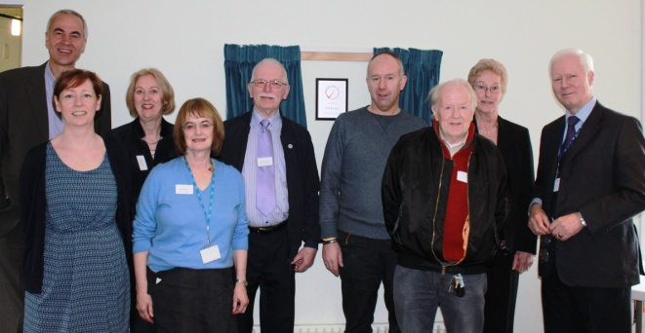
Volunteers (Caroline Green, Christina Mark, George Anderson, Bill Lees, Andrew Leitch & Jean Proudfoot with John Raine, Evelyn Fleck & George Thomson

July 2014
Commonwealth Games Volunteering
Well done to Adrian MacKenzie, our Lead Prescribing Support Pharmacist in NHS Borders, who worked at the Commonwealth Games as part of a team of volunteer pharmacists, having taken annual leave to allow him to undertake this role.
He worked in the Commonwealth Games Village
Polyclinic, drawing on his experience as a Volunteer Pharmacist at the London 2012 Olympics.

It was good to see that our Stroke Service was shortlisted as a finalist for the National Patient Safety and Care Awards held in London the previous month. Borders staff made it to the top four of the seventy stroke services entered from across the UK.

NHS Borders Sector Based Work Academy -Pre-employment programmes – Graduation Event NHS Borders joined Skills Development Scotland, Jobcentre Plus and Borders College to celebrate the success of 11 trainees who completed a six week pre-employment ‘Train to Care’ programme in a graduation ceremony at Borders College, Galashiels on 11 July.

Ward 12 complete successful fundraising for new Bladder Scanner
They did it! The ward team and friends of Ward 12 worked tirelessly this year, both on and off the ward to raise over £6000 for a new bladder scanner. The team previously had access to a bladder scanner on another ward but Staff Nurse James Gold decided that the ward would benefit from their own scanner, to enhance the care being provided to patients. After a lot of persuasion from an old friend who is a marathon runner, James signed up to Edinburgh Marathon. He told his colleagues who were delighted to support him – providing that they didn’t actually have to run! Before long, ‘fundraising fever’ had spread across the whole ward and they organised a bake sale, a handbags and gladrags sale and the Friends of the BGH raised £230 at the annual staff softball tournament. The Borders Barmy Army ran on treadmills in BGH for a day, between them covering the distance of three marathons while rattling buckets to raise £543.55.
With the support of his team, James completed the marathon and despite it being a tough physical challenge, the thought of the new scanner was enough to get his tired legs over the finish line. James said “The thing I’ve enjoyed most about the whole thing is seeing the ‘ripple effect’ of the marathon fundraising. The whole team were behind this project and everyone has worked together to achieve our goal”.
Director of Nursing and Midwifery at NHS Borders, Evelyn Rodger said: “I would like to pass on my congratulations to James, Susan and the team for the proactive approach they have taken to purchase an item of equipment that enhances the patient experience in Ward 12. I would also like to thank everyone who donated to enable us to complete the project in such a short space of time.”

Walk for Wards
This year Walk for Wards was launched across the UK in the Borders our team of walkers raised a total of almost £1600, with £710 raised for Ward 15 and over £850 for Melburn Lodge. Melburn Lodge is a fantastic example of a nursing team pulling together to raise money for an enhancement to their own ward. They decided to implement Playlist for Life - the creation of a playlist of reminiscent songs, which is uploaded to an iPod for the patient to listen to. It boosts engagement, recollection of memories and brings joy to patients and their relatives. Being able to respond to music - the first sense to be developed and the last to go at the end of life – is the one thing that dementia cannot destroy. The fundraising team helped them set up a web page, organise their walk, and promote the event. Playlist for life has benefitted a number of patients on the ward.

August 2014
Stroke treatment at NHS Borders is the best in Scotland – it’s official! NHS Borders is providing the best care in the country, according to the annual report by NHS Scotland. We provided 81% of stroke patients with the appropriate care bundle – which is considerably more than the average 58% throughout Scotland. Sandi Haines, Stroke Co-ordinator was delighted with the results, which reflect the positive changes within the service over recent years.

Interested in Volunteering?
On 28 August NHS Borders launched an appeal to attract volunteers who have an interest in enhancing patient experience. NHS Borders has a total of 146 active volunteers and during 2014/15 NHS Borders recruited 56 new volunteers. 34 of these volunteers have been recruited to expand the provision offered by existing well established roles and the remaining 22 have joined us in newly created roles.

September 2014
Plans were revealed to extend Selkirk Health Centre, which is intended to alleviate pressure on accommodation within the health centre.
Smoke Free Grounds On 1 September, Borders General Hospital site became the latest healthcare site in NHS Borders to go smoke free in line with the Scottish Government’s plan to make every hospital in Scotland smoke free by 2015. The Borders General Hospital was branded with new smoke free posters around the hospital site to encourage staff and patients to keep the grounds smoke free. Smoke free grounds extended to the entire BGH site, including the car parks. This is another positive step in educating the community about the benefits of not smoking.

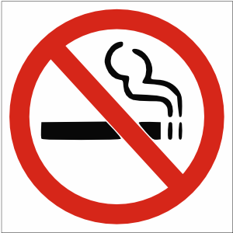

Duns Primary School show off artist talent
An artwork challenge was set to all Border Primary Schools, by NHS Borders Art Group Chair Dr John Stephen last year, to produce artwork with a Commonwealth Games theme.
The winners of this challenge were Duns Primary School. With the help from parents and extended families the pupils from all 16 classes worked together to create weavings inspired by their school logo. Out of the 16, 4 were picked by the ‘Friends of Duns Primary’ to make up the final display. With a lot of help from Janis Embleton, a local weaver from Swinton, the winning panels were turned into weaving patterns for everyone to weave.

Dr John Stephen said: “I am very proud to accept the loan of these weavings on behalf of NHS Borders. We are honoured to display this work until the new school in Duns is complete and ready to display them. This piece will be an inspiration for future generations of pupils.”
He added: “The creation of these panels has been a whole community effort.”

October 2014
Small Changes Big Difference
NHS Borders launched a new campaign this month asking staff, the public and businesses across the Borders to make small changes in their life and work practice which will make a big difference to their health and wellbeing.

Stressbusters
NHS Borders launched its very own Stressbusters team this month. The team of experts will increase awareness and understanding of mental health issues in the and provide information on staying mentally healthy. They have been working closely with staff within NHS Borders and Scottish Borders Council, and through use of social media and community outreach education sessions, they will increase the profile of psychological conditions, making it easier and more acceptable for people to talk about how they feel.
Re-Start a Heart/Nation of Lifesavers
During October NHS Borders was delighted to hand over 50 defibrillators to Scottish HART, a Selkirk based charity who raise funds for research into Cardiomyopathy and other heart diseases. Scottish HART is working tirelessly with communities across the Borders to ensure that defibrillators are available and can be readily accessed by members of the public when required. When CPR and defibrillation are used together chances of survival from a sudden cardiac arrest increase from 9% to 50%.
NHS Borders has also teamed up with the British Heart Foundation to create a ‘Nation of Livesavers’ by teaching local people lifesaving CPR skills and is the first Scottish health board to do so.

NHS Scotland Staff Survey 2014
The National Staff Survey gives everyone who works for NHSScotland the chance to say what it is like to work within the organisation and along with the 2020 Workforce Vision makes a commitment to valuing the workforce and treating people well. NHS Borders achieved the highest response rate of all mainland boards at 53% which was 10% higher than any other mainland Health Board.

The end of a Very Successful Era
Ann Purvis, Chair of the BGH Participation Group, retired this month. A farewell event was organised by the group in recognition of Ann’s contribution to NHS Borders over the past 10 years. This dedicated lady led successful and award winning projects in this time, including reducing noise in the hospital at night and nurse in charge name badges.
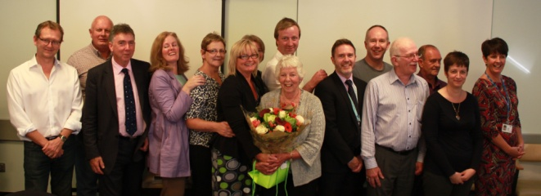
Ann Purvis and colleagues

November 2014
Chief Executive Calum Campbell was appointed as new chief executive of NHS Lanarkshire this month. Not in itself something to celebrate you might think! However, Calum paid tribute to the people of the Borders who helped him during his five year tenure. He said: “I have been privileged to work with dedicated teams who continually strive to deliver excellence in person centred care, and would like to thank everyone for their continual commitment to NHS Borders, which has resulted in us being one of the best performing health boards in Scotland.”

NHS Borders Annual Review took place on 05 November. During the morning session, around 50 staff joined members of the Board for the first ever ‘Ask the Board Live’ forum. The audience had a chance to ask questions directly to members of the Board and it proved to be a highly interactive and informative event.
The afternoon session was led by the Chairman of the Board, John Raine, and gave both members of the public and staff the opportunity to hear how NHS Borders is performing. The audience was also given a snapshot of the bigger picture and what the possible future challenges facing NHS Boards may look like.

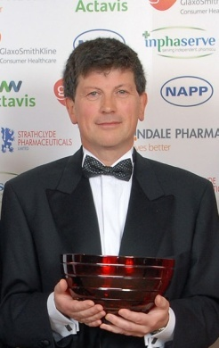
Borders Pharmacists reap rewards
At The Thistle Hotel in Glasgow almost 400
pharmacists, industry members and their respective guests attended the twelfth annual Scottish Pharmacy Awards. This year's winner of the Special Recognition Award was Borders' community pharmacist, George Romanes.

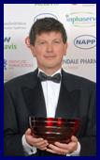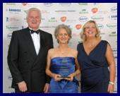

George, who owns several pharmacies in the Duns, Berwick and East Lothian areas, is well known for his community service and for his sterling contribution to the pharmacy field and to his patients and community in particular. A thoroughly deserving winner!

George was not alone in representing the Scottish Borders at this year’s event, Lauder pharmacist, Hilary Evans picked up the Scottish Pharmacist of the Year Independent Award at this year’s event.

A further well done must also go to nominated pharmacists Liz Leitch and
Allison Carruthers for Hospital Pharmacist of the Year award and Libby Kennedy for Innovations in Prescribing Quality and Efficiency award .

LASS celebrates 10 year anniversary

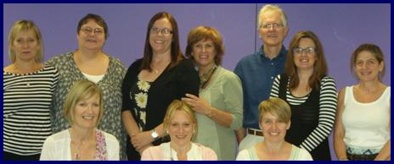
LASS service staff

This year LASS celebrated 10 years of providing support to adults aged over 16 who are at risk of developing coronary heart disease, diabetes and other chronic diseases and illnesses. LASS has seen over 5000 referrals since the launch of the pilot project in Kelso Health Centre in 2004. Since then the service has also delivered the Keep Well national programme, which offers cardiovascular checks to at risk groups aged 40-64 years, and Counterweight, a weight management programme.

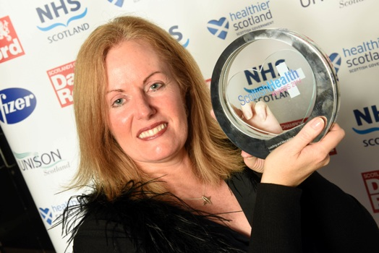
Jane Davidson with the award trophy

Jane Davidson, as Chief Operating Officer won the ‘Leading and Managing for Quality’ Award at the Scottish Health Awards in November. Jane has led and encouraged teams to embrace an improvement approach that makes it easier to give better care to patients and to work alongside patients and carers. Jane was one of two NHS Borders finalists at the Awards – our multi-disciplinary mental health service came second in the ‘Care for Mental Health’ category for their tireless work on implementing the ‘Star Wards’ programme, working with partnership organisations to improve patients’ quality of time and treatment outcomes.

The first Early Years Centre in the Borders opened in November, offering a range of drop-in facilities and programmes for parents and children in Galashiels. With more outreach coverage planned in other locations, these centres will include input from midwifery, health visiting, school nursing, family support, early learning and childcare.
Borders children have the best teeth in mainland Scotland – it’s official! A recent survey of Primary 1 pupils across the country revealed that almost 74% in this region had no signs of decay. Only Orkney and Shetland showed higher results.

The annual dementia conference was held in Scottish Borders this month. Hosted by Peter Lerpiniere, a dementia liaison nurse from NHS Borders, the event was hailed as a great success.

December 2014
Royal Voluntary Service On-Ward Volunteers.
NHS Borders is working with the Royal Voluntary Service (RVS) to support the roll-out of on-ward volunteers across adult inpatient wards in Borders General Hospital and the Community Hospitals. The first cohort of volunteers started this month and are initially supporting Ward 4 and the Department of Medicine for the Elderly. Once initial evaluation and feedback has been undertaken, the plan is to extend this service to all inpatient wards in BGH and community hospitals.

January 2015

MBE awarded to NHS Borders Cancer Nurse Specialist We are very proud to announce that NHS Borders Cancer Nurse specialist Judith Smith has been awarded with an MBE (Member of the Order of the British Empire) in the Queen’s New Years Honours list 2015.

Judith received this award for her significant achievement and outstanding service to the Borders community through her previous role as Macmillan Haematology/Oncology Clinical Nurse Specialist and latterly as Macmillan Nurse Consultant in Cancer and Palliative Care within NHS Borders.

Judith, started her nursing career as a Staff Nurse in the Royal Infirmary of Edinburgh 30 years ago, moving back to the Borders in 1990. Since 1998 she has been involved with the development of cancer services in NHS Borders. In particular she has challenged traditional models of care and championed the development of a nurse led chemotherapy service in the Borders Macmillan Centre which now treats over 95% of patients locally saving them the trip to Edinburgh. A recent national audit of the chemotherapy service commended the unit on several fronts highlighting the “innovative leadership and team working within and out with the unit”.

Speaking of her award, Judith said: “to be awarded this honour has been an overwhelming experience. I was shocked when I received the letter thinking initially it was for jury service, and then that it was a joke!”

Judith is a dedicated and enthusiastic professional and is recognised as a clinical expert in the field of cancer nursing. She is committed to the continuing development of cancer and palliative care services and in the delivery of consistently high standards of care to patients with cancer and their families and carers.

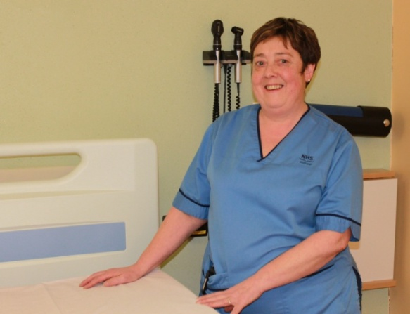
Judith Smith MBE

The first patient safety bulletin for NHS Borders was launched in January 2015. The bulletin, entitled Learning to be Better aims to share learning from patient experiences. The bulletin includes case summaries and examples of good practice and key learning.

Borders General Hospital signage gets a makeover. A colour coded wayfinding system was introduced in Borders General Hospital this month, in order to simplify the patient journey through the hospital. Colour coding also reduces the amount of information previously required on signage.

Visit to Saint Francis Hospital by NHS Paediatrics Team. In January, a paediatrics team led by Ruth Magowan from Queen Margaret University visited Saint Francis Hospital in Katete Zambia, which is twinned with Borders General Hospital, to deliver a week of paediatric training. This course was extremely successful, with 56 student nurses trained in a wide variety of topics ranging from the early recognition of deteriorating patients, through to neonatal resuscitation. Rod McIntosh, Senior Resuscitation Officer, BGH accompanied them and introduced scenario-based carousel training, along with the use of paediatric early warning scoring and blood transfusion observations. This proved very successful and the medical staff in Zambia have introduced this as a monthly based training programme within the hospital.
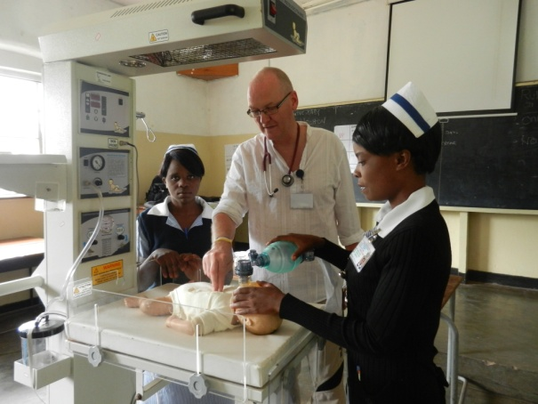
Rod in action

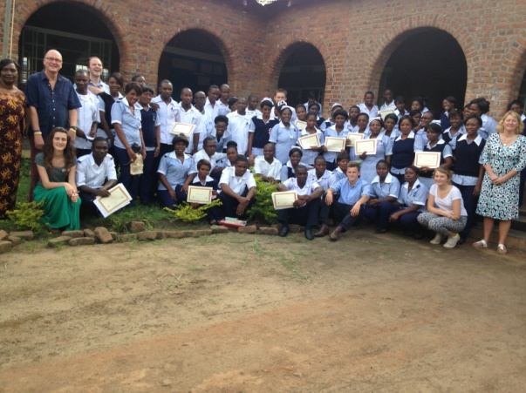
Staff and visitors at Saint Francis Hospital

February 2015

NHS Borders reported that the region has one of the highest sign-up rates for organ donation in Scotland, with 43.8% of the community signed up to the Organ Donation Register.

NHS Borders Training & Development Sector Based Work Academy celebrated a further cohort of Train to Gain for administration students. The four week programme included placement and statutory and mandatory training. This successful scheme is helping participants develop their skills and be job ready on successful completion.
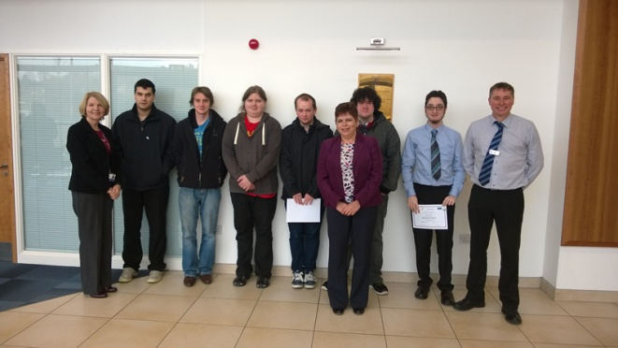
Train to Gain Students receiving certificates

Minister praises Borders Alcohol & Drugs services in the Scottish Borders. Paul Wheelhouse, Minister for Community Safety & Legal Affairs met with Borders Drug and Alcohol service managers, service users and family members in the Borders this month. He said “Borders Drug & Alcohol Partnership has an excellent reputation for delivery and this was a fascinating visit, during which I was able to hear about the work local services are doing to assist service users on their recovery journey.” Access to treatment is rapid in the Borders, with 95% of adults referred for alcohol and drugs starting treatment within three weeks during 2014/15.

Transforming Care after Treatment (TCAT) Programme – Newsletter launched
Issue 1 of a new monthly newsletter was launched on 1st February. The newsletter will be a platform for sharing all TCAT developments. The overall aim of the programme is to ensure that people who have completed treatment for cancer are supported and prepared to live an independent life with confidence, knowing who to contact and when. The newsletter has a wealth of information on access to support, calendar of events, and hints and tips on a range of topics from stress to your finances.

March 2015

NHS Borders is the first Scottish Board to be recognised for its commitment to supporting employees who are carers and has been awarded the Carers Scotland ‘Carer Positive’ kitemark!
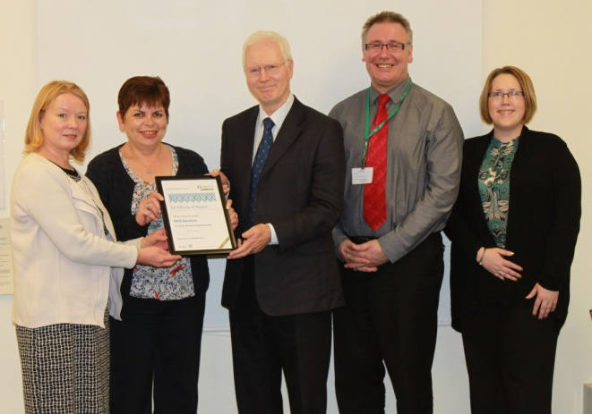
The award is presented to employers in Scotland who have a working environment where carers are valued and supported. NHS Borders provides options for flexible working for carers, including condensed hours, part-time working, job-share and emergency family leave.
Simon Hodgson, Director of Carers Scotland, said: “NHS Borders has demonstrated its commitment to providing a supportive working environment for employees who are carers. It rightly deserves to be recognised as a Carer Positive employer and is to be congratulated on becoming the first territorial health board in Scotland to receive this award.”

Patient Feedback

NHS Borders values feedback that is received from patients, carers or family members. Through patient opinion, complaints and commendations the organisation can improve and take into consideration comments and suggestions. The NHS Borders Board regularly hear patient stories at their public meeting. Some of the positive feedback NHS Borders received from patients over the last year included the following comments:

“Throughout my stay, I was treated promptly, professionally and with great kindness, by everyone who was involved in my care, from the Consultant, the ward and A&E doctors, all the nurses and ancillary staff. The domestic staff and porters were so kind and helpful and the food was excellent”

“The level of care received was of the very highest standard. This was the first time in hospital in over 60 years, so it was with significant trepidation that when the patient found they were being admitted, their fears were very quickly dissipated and told us they felt they were treated as a VIP as were all the others in the ward”

“You took a precious person under your care and the way you have restored them has been nothing short of miraculous. Their illness has been made more bearable by your tender loving care”

“My immediate care was mainly preformed by nurses who were excellent and very professional. I was then transferred by a cheerful Porter to the Ward. There my care from all the nursing staff was first class. However what was even more impressive was the patience of the Nurses dealing with an elderly confused patient, who every so often would call out for someone, each time a Nurse attended promptly and calmly reassured the patient in a kindly manner”

“I have a lot of contact with the centre, and they are an amazing group of nurses, who are caring - they make you feel like the only person in unit and you matter”

“I cannot praise the staff enough. Their thoughtful and caring ways make me feel much happier and relaxed when my partner attends the Day unit, we think the “girls” are absolutely wonderful”

“ I was shown so many random acts of kindness all the way through my stay, from a nurse helping me shower at 2.30am, a Doctor bringing me some of her own tea for me to try, a cleaner who would smile and chat while cleaning my room – and so many more”

Performance

NHS Borders manages performance through the agreed performance management framework. A summary for performance for 2014/15 can be found in the attached End of Year Managing Our Performance Report which was presented to the Board in June 2015.

