Pharmacy Wi-Fi
Connection overview

Pharmacy New Wi-Fi is called CPNET
Before it can be accessed by a mobile device, each user needs to be set up on the main computer
Look for this icon - Meraki Manager

- Each pharmacy will be given a user name – probably the pharmacy NHS mail email account and a password
- Use these details for Dashboard Login.

- When opened you will see a list of the people/devices that have access to the Wi-Fi.  - From here, you can create new users and also disable users.  - To create a user you need to fill in details on the Create User form.  - Put in users email address – this will be their username and also be the email address that receives the email with username and password for access to Wi-Fi  - Select Create User once finished  - Close the window and finally select Save on the dashboard | 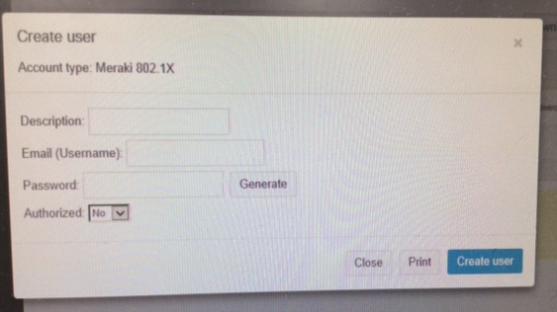
They will receive an email like so –
When they select Wi-Fi CPNET on their device they use the username and password in the email to access the Wi-Fi.

