Advice for patients with Achilles Tendinopathy.

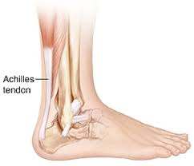
For further advice and self care information you can:
Visit: www.nhsinform.scot/msk
Download: ‘MSK Help’ app free from app stores

What is it?

Achilles tendinopathy is a condition that causes pain, swelling and stiffness of the Achilles tendon that joins your heel bone to your calf muscles.

Why does it happen?
It is thought to be caused by repeated tiny injuries to the Achilles tendon as the tendon is unable to cope with the strain being placed upon it. This leads to repeated small amounts of damage within the tendon fibres, resulting in the tendon continually trying to heal itself. You may often hear this condition called Achilles tendinitis or tendinosis but these terms refer to the same thing.

Common Symptoms
These are the most common symptoms people develop.
- stiffness and pain in the Achilles first thing in the morning which eases after a few minutes of walking
- tenderness in the Achilles and there may be a thickening or lump you can feel
- pain tends to be variable in nature, it is often not so bad during exercises but worse after rest.
Treatment
Treatment includes:
- Relative rest - Avoid activities that you feel aggravate your pain but you could try swimming or cycling instead
- Ice packs – Applying ice in a damp tea towel for a maximum of 20 mins, 4 times per day or after exercises can help reduce pain
- Simple painkillers- paracetamol or ibuprofen
- Special exercises – aimed at stretching and strengthening the Achilles tendon.

Exercises
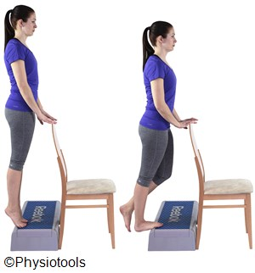
The exercise program recommended was originally designed by Alfredson in 1998 * and can therefore often be found on the internet as ‘Alfredson’s protocol’. It is an exercise program designed to gradually increase the stress going through the tendon but in a controlled manner. This exercises involves completing each of the 2 exercises 15 times, ideally twice per day, 7 days per week for approx 12 weeks.
Eccentric Calf Strengthening
Stand on your toes on the edge of a step and take support from the wall/handrail.
Put all your weight on your good leg and go up onto your tip toes. Transfer all your weight onto your sore leg and slowly lower the heel of the leg to be exercised towards the floor. Put your weight back onto your good leg and use that leg to rise back up onto your toes and repeat.
Repeat 15 times.
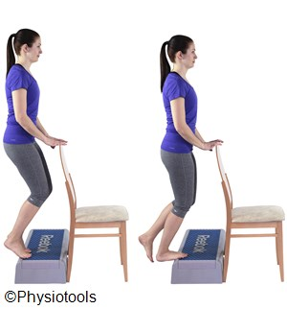
Eccentric Calf Strengthening
Stand on your toes on the edge of a step with your knees BENT Take support.
Put all your weight on your good leg and go up onto your tip toes. Transfer all your weight onto your sore leg and slowly lower the heel of the leg to be exercised towards the floor, keeping you knee bent. Put your weight back onto your good leg and use that leg to rise back up onto your toes and repeat. Repeat 15 times.

*Alfredson H et al (1998) Heavy load eccentric calf muscle training for the treatment of chronic Achilles tendinosis. Am. J. Sports med.26(3) 360-6.
For more information and demonstration of these exercises visit: https://www.youtube.com/watch?v=fHHbn_Odk4E

