Ankle Injuries: A guide for patients

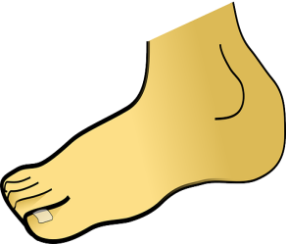
For further advice and self care information you can:
Visit: www.nhsinform.scot/msk
Download: ‘MSK Help’ app free from app stores

Early Management:
RICE (Rest, Ice, Compression & Elevation)
Rest
- walking may need to be reduced in the first few days
- try to walk as normally as possible. Try not to hop or walk on your toes
- “rest” does not mean “total rest”, it is vital to keep the ankle mobile ( see the exercises opposite)
- it is recommended that other weight bearing activities, e.g., running should only be attempted once the acute pain & swelling subside
Ice
- ice can help reduce the bruising and swelling
- use a bag of frozen peas (or similar) wrapped in a towel over the affected area
- this can be repeated every few hours for 10-15 minutes at a time, in the first few days
Compression
- You may find it helpful to wear a support or a Tubigrip when you are on your feet
- Don’t wear it overnight or when you are resting with your foot elevated
Elevation
- when sitting, it is helpful to keep the foot elevated above hip height

*Ankle sprains are very common injuries involving the ligaments around the ankle.
- bruising & swelling usually develop around the affected area
- most ankle sprains settle in 2-3 weeks, although the discomfort may persist for 2-3 months
Stairs
In the early stages you may find it easier to take stairs one at a time.
- going up –lead with the unaffected leg
- going down – lead with the affected leg
Exercises
- in the first few days, you should aim to do the following exercises every 1-2 hours
- move the ankle/foot as far as you can but don’t push into pain

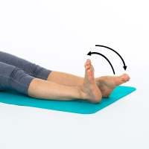

In sitting, bend & straighten the ankle. Repeat up to 10 times.

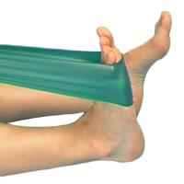

Place a towel around the base of your foot. Pull the foot with the towel until you feel a stretch in your calf. Hold for 10 seconds. Repeat 3 times.

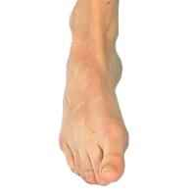

In sitting or lying, alternatively raise the inner and outer border of your foot. Repeat up to 10 times.

Progression of exercises
Over the next 1-2 weeks, you should try the following exercises a few times a day to improve your strength and balance and help you return to normal.

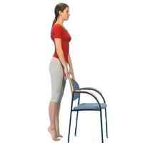

Using a chair for support, go up & down on your tiptoes. Repeat up to 10 times.

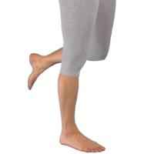
Stand & balance on your affected leg. Initially you may need to hold on to something for support. Aim to build this up to 1 minute.

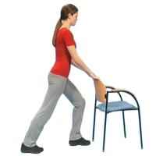
Step forward on your good leg. Bend the front knee forward. Keep the affected leg straight & heel on the floor. Hold for 20 seconds. Repeat 3 times

If you experience any of the following symptoms/ complications, please seek medical advice:
- pain that is persisting beyond the 2-3 month timescale
- persistent or new swelling
- ongoing difficulty weight bearing
- worsening pain

