General advice following an elbow fracture.
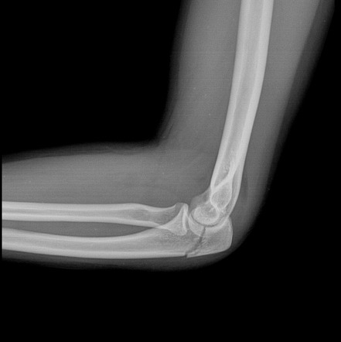

A guide for patients

For further advice and self care information you can:
Visit: www.nhsinform.scot/msk
Download: ‘MSK Help’ app free from app stores

Anatomy of the elbow joint
The elbow is made up from 3 bones; the humerus, the radius and the ulna. It is what we call a “hinge joint”. The joint is held strong by a capsule, ligaments and muscles.

How is a fracture treated?
Treatment depends on the amount of disruption there is to a bone.
If there are many fragments or it causes joint instability, surgery may be performed to nail/plate the bones together, often followed by a period in a sling. If the break is small or well-aligned, surgery may not be required and a cast applied.

Pain
Fractures can be very painful. If you have been prescribed painkillers take them as advised and this will help you manage the pain. If the pain becomes severe or constant you should consult your GP.

Swelling
You may notice swelling in your arm, wrist or hand. Keeping your arm elevated when at rest, if advised, will keep the swelling down. Ice is commonly used to reduce swelling. Use frozen peas or ice cubes wrapped in a damp tea towel, for 10 to 15 minutes, 2-3 times a day over the affected area.

Stiffness
Regular movement will help limit any stiffness in your shoulder, wrist or hand, and will speed up your recovery.

Weakness
Due to muscle inactivity as your fracture heals, the hand and wrist may feel weak. You must not carry or lift loads unless told by a health professional that it is safe to do so. Once the fracture is healed you can gradually start to increase the loads again, and exercises will help where appropriate.

Exercises
These are a few exercises that you can do to keep your hand, wrist and shoulder mobile, and to gently get your elbow moving again when appropriate. The elbow can normally feel stiff when you first start to move it. Try to do the exercises 4 times per day. You might find them easier to do after a hot shower or bath.

1. Hand exercises

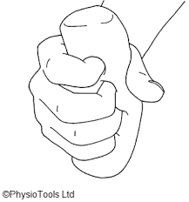
Holding a squeezy ball or ball of socks, clench your fist and hold for 5 seconds.
Repeat 20 times.
Bend your wrist upwards as far as is comfortable and then downwards as far as possible.
Repeat 10 times.
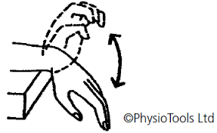

Shoulder exercises
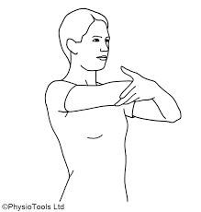
Holding your affected arm in your other, cradle it and lift up as far as you can above your head if possible.
Repeat 10 times.
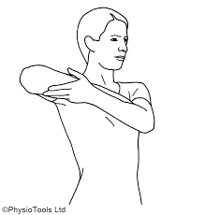
Cradle your affected arm in the ‘good arm’. Lift it out to the side as far as comfortable.
Repeat 10 times.

Elbow Exercises
You will be advised to do these when the fracture has fully healed.

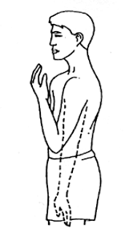
Bend your elbow as far as you can as if trying to touch your shoulder, and slowly straighten out again.
Repeat 10 times.
You may have to provide some assistance from your other arm but this should not be forceful.

Turn your forearm up and down as far as you can, keeping the elbow and upper arm still.
Repeat 10 times.

