Advice for patients with Frozen Shoulder.

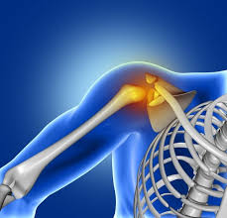
For further advice and self care information you can:
Visit: www.nhsinform.scot/msk
Download: ‘MSK Help’ app free from app stores

Anatomy of the shoulder joint
The shoulder is a ball and socket joint formed by the arm bone (humerus) and the shoulder blade (scapula). There is a loose bag or capsule which surrounds the joint. This is supported by ligaments and muscles.

What is ‘frozen shoulder’?
The shoulder joint tends to become stiff and initially painful, often starting without any cause. The loose bag (capsule) around the shoulder joint becomes inflamed and appears to tighten or shrink. The tightening along with pain restricts the movement.

Why does it occur?
A primary frozen shoulder is when the exact cause is not known. It is more common in people with diabetes and thyroid gland problem.
A secondary frozen shoulder can develop if the shoulder area is kept still for some time, for example, after a stroke, heart attack or after major injury or surgery to the shoulder.

3 main phases:
- Painful phase (can last from 2-9 months)
Shoulder can be painful at rest and movement, sleep is often disrupted as lying on that side is painful or difficult.
Treatment: Pain-relief. Pain killers, hot or cold packs. A steroid injection might be offered if suitable for you.
- Stiff phase (can last from 4-12months)
You may find taking your hand behind your back or head becomes harder and the shoulder becomes stiff
Treatment: Using the exercises in this leaflet to try and get the shoulder joint moving.

- The recovery phase (Can last 5-28 months)
Pain and stiffness start to improve keep working on the exercises to improve movement.

Exercises
These are a few exercises to help stretch your shoulder. Try to do them regularly 1-2 times a day. You might find them easier to do after a hot shower or bath. It is normal to feel a stretching sensation but if you get ongoing pain, reduce the exercises by doing them less often or less forcefully, or stop completely. If the pain is increasing, see a physiotherapist or a doctor.
Do not do these movements if they are painful rather than stiff.

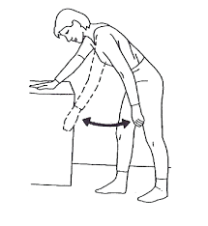
Pendulum
Lean forward with support and let your arm hang down. Swing the arm
- Forward and back
- Side to side
- Around in circles (both ways)
Repeat 5-10 times each movement
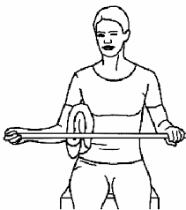
Twisting Outwards
Sitting holding a stick (e.g. rolling pin, umbrella)
Place a rolled up towel by your side and keep your elbow into your side throughout.
Push with unaffected arm so hand of the problem side is moving away from the mid-line.
Do not let your body twist to compensate.
Repeat 5-10 times

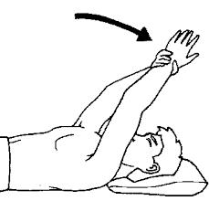
Arm overhead
Lying on your back support your problem arm with other hand at your wrist and lift up overhead.
Do not let your back arch
Start with your elbows bent if that is easier.
Repeat 5-10 times.

Twisting outwards/ arm overhead
Lying on your back, knees bent and feet flat.
Place your hands behind your neck or head, elbows up to ceiling.
Let your elbows fall outwards.
Repeat 5-10 times
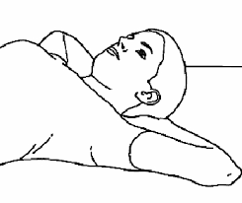
Kneeling on all fours
Start in four point kneeling. Keeping your hands still gently sit back towards your heels.
To progress the exercise, take your knees further away from your hands.
Repeat 5-10 times
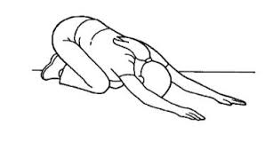

Stretching the back of the shoulder
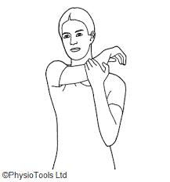
Take the hand of your problem shoulder across your body towards your opposite shoulder.
Give a gentle stretch by pulling with your uninvolved arm at the elbow.
Sometimes you can feel more stretch if you lie on your back to do the movement.
Repeat 5 times, holding for 20seconds.

Hand behind back
Stand with arms by your side.
Grasp the wrist of your problem arm and gently stretch your hand towards your opposite buttock, then gently slide your arm up your back.
Repeat 5 times.
