# HIP V6

# Golfer’s Elbow Management

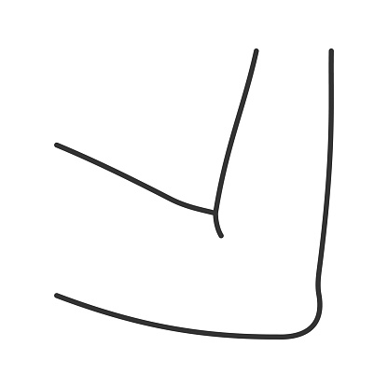

# A guide for patients

For further advice and self care information you can:

Visit: [www.nhsinform.scot/msk](http://www.nhsinform.scot/msk)

Download: ‘MSK Help’ app free from app stores

## What is Golfer’s Elbow?

Golfer’s elbow occurs when the tendons that attach to the inside of the elbow become irritated and inflamed. This occurs when an increased force or load is applied that the tendons struggle to handle. This condition shouldn’t cause any lasting damage and doesn’t lead to arthritis.

## What are the symptoms?

The main symptoms of Golfer’s elbow are:

* pain at the inside of your elbow
* tenderness on pressing on the inside of your elbow
* pain on lifting heavier items
* pain on bending your wrist
* pain and weakness on gripping

## What are the causes?

Many things can cause Golfer’s elbow including:

* repetitive activities such as doing DIY
* excessive gripping activities
* weakened or tight muscles in the forearm
* direct trauma to the inside of the elbow

## Treatment

Treatment usually involves conservative measures and rarely needs surgical intervention.

The first step is to try and avoid the things that are aggravating the pain as much as you can.

You may also benefit from an epicondylar clasp which aims to remove some of the tension from the tendons

Image copied from

ww.arthritisresearchuk.org

## Pain management

As well as resting, pain relief may help. You should always speak to your local pharmacist regarding the best type of pain relief to take. Any pain relief you have been advised to take should be taken regularly as per the instructions given. This allows it to have a cumulative effect which will help settle your pain better.

Alternatively, you could use an anti-inflammatory gel/cream and rub this into the area. This should be on the advice of your GP or pharmacist only.

In some cases, a steroid injection may be of benefit and this can be discussed with your GP. Steroid injections are not suitable for everyone and the pros and cons will need to be discussed.

## Exercises

You should try these 1-2 times per day within comfortable limits.

**Stage 1**

1. With your palm facing down, reach your arm out in front and straighten your elbow. Bend your wrist upwards then push the wrist up further with your other hand. Hold for 20-30s.

Repeat 3-4 times.



2. Stand with your elbow bent and palm turned down. Turn your palm up and down rotating your forearm.

Repeat 10 times.

## 



3. Bend your elbow then straighten it as far as you can.

Repeat 10 times.

**Stage 2**

Move onto this exercise when Stage 1 is pain-free.

4. Bend your affected wrist downwards. At the same time push it upwards with the other hand. The resistance should be equal so that there is no movement.

Hold for 5-10 seconds, 5-10 repetitions.



**Stage 3**

Move onto this exercise when Stage 2 is pain-free.

# C:\Users\lmcguigan\Desktop\wrist.png

5. Hold on to a tin of beans with your hand as shown. Slowly lower the tin down to extend your wrist. Then bring the tin back up to the starting position by helping with your other hand.

Repeat 5-10 times.