General advice following a shoulder fracture.
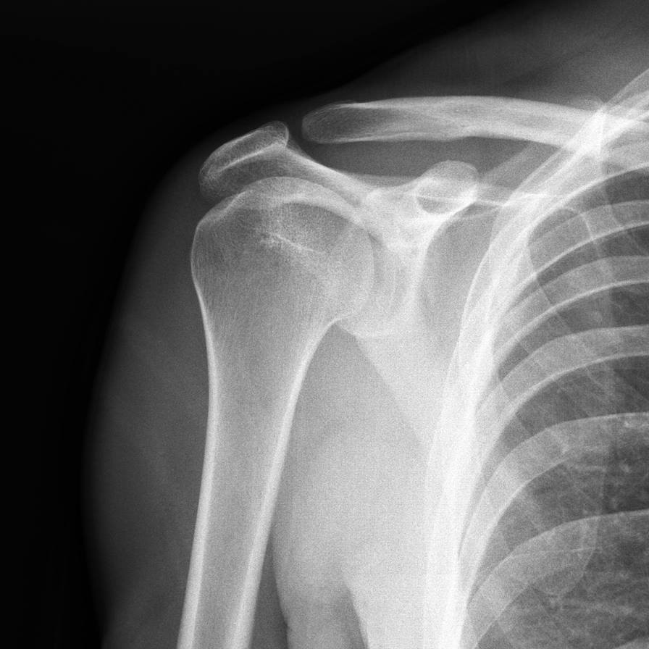

A guide for patients

For further advice and self care information you can
Visit: www.nhsinform.scot/msk
Download: ‘MSK Help’ app free from app stores

Anatomy of the shoulder joint
The shoulder is a ball and socket joint formed by the arm bone (humerus) and the shoulder blade (scapula).

How is a fracture treated?
Treatment depends on the amount of disruption there is to a bone. If there are many fragments or it causes joint instability, surgery may be performed to nail/plate the bones together, often followed by a period in a sling. If the break is small or well-aligned, surgery may not be required. A sling may still be required for a period of time.

Pain
Fractures can be very painful. If you have been prescribed painkillers take them as advised and this will help you manage the pain. If the pain becomes severe or constant you should consult your GP.

Swelling
You may notice swelling in your arm, wrist or hand. Keeping your forearm elevated when at rest, if advised, will keep the swelling down.
Ice is commonly used to reduce swelling. Use frozen peas or ice cubes wrapped in a damp tea towel, for 10 to 15 minutes, 2-3 times a day.

Stiffness
Regular movement of your arm will help limit any stiffness in your elbow, wrist or hand, and will speed up your recovery.
Weakness
Due to muscle inactivity as your fracture heals, the hand and wrist may feel weak. You must not carry or lift loads unless told by a health professional that it is safe to do so. Once the fracture is healed you can gradually start to increase the loads again, and exercises will help where appropriate.

Suggested exercises
You should aim to do these exercises 4 times per day. Stop if your pain gets worse.

Pendulum exercises
Bend from your waist and gently hang your arm in front of you. Rest your other hand on a table or chair for support and balance.

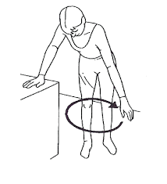
Gently swing your arm in a large circle.
Repeat 10 times in each direction. Gradually try to make larger circles.
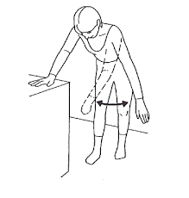
Gently swing your am from side to side, across the front of your body.
Repeat 10 times
Gently swing your arm backwards and forwards, along the side of your body. Repeat 10 times.
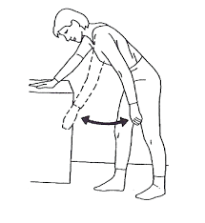

2. Elbow exercises
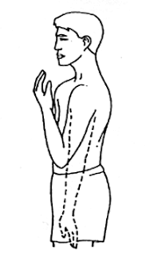
Bend and straighten your elbow as far as you can.
Repeat 10 times.

Turn your forearm up and down as far as you can, keeping the elbow and upper arm still.
Repeat 10 times.
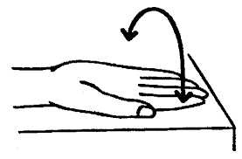

3. Hand exercises

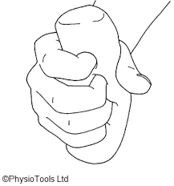
Holding a squeezy ball or ball of socks, clench your fist and hold for 5 seconds.
Repeat 20 times.
Bend your wrist upwards as far as is comfortable and then downwards as far as possible.
Repeat 10 times.
