Advice for patients with Subacromial Shoulder Pain.

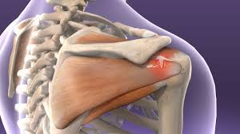
For further advice and self care information you can:
Visit: www.nhsinform.scot/msk
Download: ‘MSK Help’ app free from app stores

What is Subacromial Pain Syndrome?
This is a term used to describe the type of shoulder pain you have. It describes pain that arises from the space between your humerus (upper arm) and acromion (part of your shoulder bone) It is very common and causes pain in the shoulder and upper arm. It can spread up the neck, down the arm or across to the shoulder blade.

What causes Subacromial pain?
You have 4 tendons which join your shoulder blade to your upper arm and collectively these are called the ‘rotator cuff’. They are very susceptible to wear and can often become nipped between the 2 bones at your shoulder or become torn from gradual wear or sudden trauma. When either of these occurs you can get pain and an alteration in the way which the muscles control your shoulder. The terms ‘impingement’ syndrome or ‘rotator cuff tear’ may also be used in these cases.
How do I treat it?
Exercise is always the first line of treatment for this condition. If you try the following exercises there is a good chance you will be able to improve your shoulder pain.
Occasionally, if you don’t improve with exercises alone, other options are corticosteroid injection or Physiotherapy.
It is important to keep your shoulder moving to avoid further complications. You may need to persevere with these exercises for 6-12 weeks to see a big reduction in your pain- be patient!
1. Wall slides.
Standing in front of a wall or door frame. (You can use a cloth to make it smoother)
Step forward towards the wall as you run both arms up the wall as high as you can and then slowly down.
Do 5, rest, then another 5, rest and then another 5 (making a total of 15)

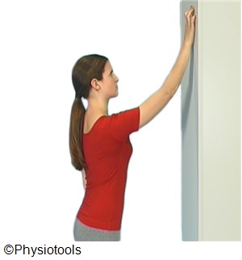
2. Press-ups.
Put your hands on a wall, just wider than shoulder width apart. Slowly lower your body to the wall and out again, like an upright push up. To progress and make it harder-stand further away from the wall.
Do 5, rest, then another 5 ,rest and then another 5 (making a total of 15)
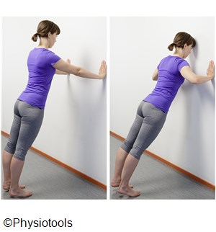
3. Shoulder Rotation.
Lie on your side with your sore shoulder upper most. Put a folded towel in at your waist and keep your elbow on it. Make a fist. Slowly rotate your forearm so your fist is pointing to the ceiling and then down again to point to the floor.
To progress you can add a light weight to your hand i.e. a 500ml bottle of water and then gradually build this up.
Repeat 5 times, rest, then another 5, rest and then another 5 (making a total of 15)

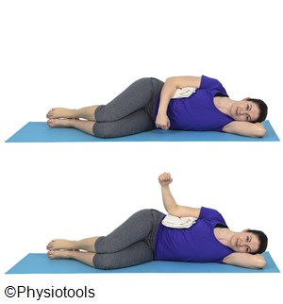
You can watch a video of a variation of these exercises on:
www.bess.org.uk/index.php/patients/patient-information-leaflets/subacromial-rehabilitation

