Posterior Tibial Tendon Dysfunction (PTTD)

A guide for patients
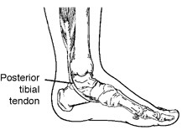

For further advice and self care information you can:
Visit: www.nhsinform.scot/msk
Download: ‘MSK Help’ app free from app stores

What is PTTD?
Posterior Tibial Tendon Dysfunction is one of the most common problems in the foot and ankle.
The tibialis posterior is a muscle in the lower leg. The tendon from this muscle runs behind the inside bone on the ankle, attaching under the sole of the foot and helps to hold the arch of the foot up.

Sometimes the tendon becomes stretched and inflamed due to overuse or injury and this condition can be called Tibialis Posterior Tendon Dysfunction, Tibialis Posterior Insufficiency or Adult Acquired Flat Foot.

Causes
- flat footedness
- trauma or injury – occasionally this condition may be due to fracture, sprain or direct blow to the tendon
- age– the risk of developing Posterior Tibial Tendon Dysfunction increases with age and research has suggested that middle aged women are more commonly affected
- other possible contributing factors– being overweight, diabetes and inflammatory arthritis

Treatment options
- anti -inflammatories (R.I.C.E)
- orthotics and appropriate footwear
- physiotherapy exercises
- surgery for tendon repair (if tendon has been torn)

Initial treatment
Reduce your level of activity and follow the RICE regime:

R – rest as often as you are able. Refrain from activity that will worsen your condition, such as sports and walking.
I – ice, apply to the affected area, ensure you protect the area from frostbite by applying a towel over the foot before using the ice pack.
C – compression, a Tubigrip or elasticated support bandage may be applied to relieve symptoms and ease pain and discomfort.
E – elevate the affected foot to reduce painful swelling.

Other information:
Footwear is important – it is advisable to wear flat sturdy lace-up shoes, for example, trainers or boots. This will not only support your foot, but will also accommodate orthoses (shoe inserts).

Physiotherapy exercises
You should aim to do these exercises 4 times per day.
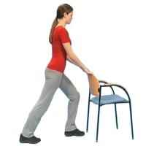
Calf stretch
Take support from a wall or chair. Stand with affected leg stretched straight behind you and the other leg bent in front of you.
Hold approx.30 secs, repeat 3 times

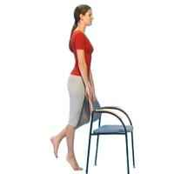
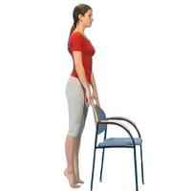
Heel raises (double and single)
Push up onto both toes
10 times, repeat 3 times

Progress to single foot as able

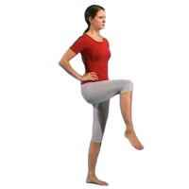
Single leg balance
Use support if needed.
Balance on affected foot for 30 seconds
Repeat 3 times
You should stand on pillow/wobble board to make the exercise harder.

Static toe press
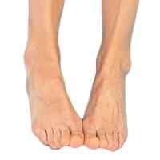
Sit on a chair or on the floor. Put the inner borders of your big toes together.
Press the inner borders of your big toes together.
Hold approx. 5 secs, repeat 10 times

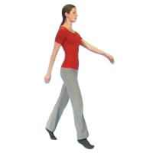
Toe walking
Walk on your toes for 30 seconds. Use a support if you need for balance,
Repeat 3 times

Foot arch squeeze
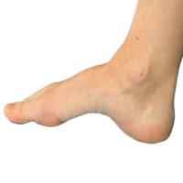
Sitting with your foot on the floor.
Shorten your foot by tightening the muscles on the sole of your foot, making an arch. Keep your toes pushed straight against the floor.
Repeat 10 times

