Physiotherapy and recovery following a wrist fracture

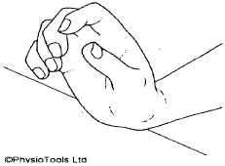

A guide for patients
For further advice and self care information you can:
Visit: www.nhsinform.scot/msk
Download: ‘MSK Help’ app free from app stores

Once the plaster has come off:

you can now start to use your affected hand for basic activities (e.g. eating, drinking and dressing)

you may have some pain and the arm will look different, be reassured this is normal

sit with your hand up with your elbow resting on a table if you are not using it, this will help with swelling. Avoid tight straps or watches that may restrict the swelling

wash your hands with warm water and use moisturiser to keep your skin soft

Try these exercises:
You should aim to do these exercises each day. Aim for 4 times throughout the day but ensure you take enough time to rest. Try between 10-15 repetitions of each exercise.
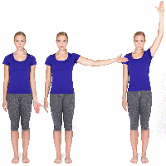
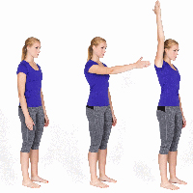
Shoulder exercises:
Try these exercises to maintain your shoulder range of movement.
Start with your arm straight and reach forwards and up then return to the starting position. Then reach out to the side and up.

Elbow exercises:
Stand with your elbow straight and palm facing up, bend your elbow and try to touch your shoulder. To get a stretch bend your wrist backwards so the palm faces up, then slowly straighten your elbow. Hold for 10 seconds.

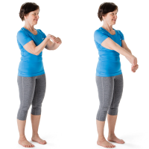
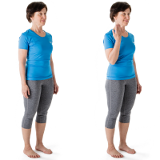

Wrist & Hand exercises:
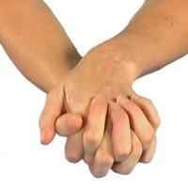
Clasp your hands together and support your forearms on a table. Put the back of one hand on the table and then turn your hands and put the back of the other hand on the table.

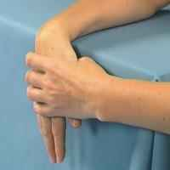

Rest your forearm on a table with the wrist over the edge; use your other hand to apply some pressure to bend it, hold for 10 seconds.

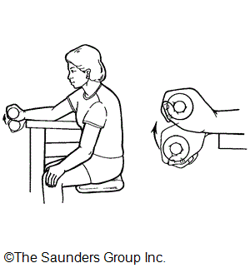

Rest your forearm on a table and use a light hand weight or tin to grip tightly, bend your wrist upwards hold for 10 seconds.

This leaflet should only be used by specific individuals following removal of your cast.
If you have any concerns, please approach your physiotherapist.

