

# Patellofemoral Pain (PFP) Syndrome

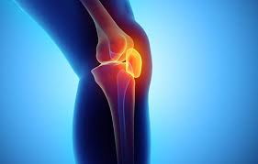

# A guide for patients

For further advice and self care information you can:

Visit: [www.nhsinform.scot/msk](http://www.nhsinform.scot/msk)

Download: ‘MSK Help’ app free from app stores

## What is patellofemoral pain?

Patellofemoral pain is pain that is felt at the front of and around the kneecap and is commonly caused by an imbalance or tightness of the muscles that support the knee, causing increased pressure through the underside of the kneecap.

## What are the symptoms of PFP?

* Pain on the front of or around your kneecap
* Pain aggravated by kneeling or squatting, or going up and down stairs.
* A grinding or scratching sensation or noise coming from the kneecap when bending or straightening the knee.

## What Causes PFP?

PFP is thought to be caused by a combination of factors including:

* Muscle imbalance such as weak quadriceps (anterior thigh muscle) or buttock muscles.
* Tightness in the quadriceps or hamstring (posterior thigh) muscles.
* Altered foot mechanics.

## How is PFP managed?

To try and reduce the pain in the short term, try the following:

* Keep active – exercise such as swimming and cycling are low impact on your knees.
* Try to reduce the activities that you find aggravate the pain, trying to keep between a **0 and 2** on the pain scale below.
* Liaise with your local pharmacist about what pain relief is most suitable for you.

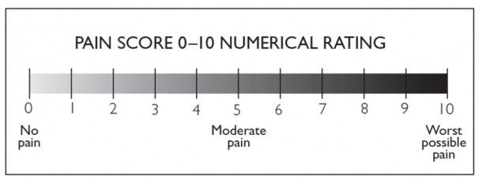

**Exercises**

The following exercises are for the early and later stages of your rehabilitation. It is important to follow the instructions and monitor how you are doing. Ideally, you should be doing these every day.

## Exercises for early stages (weeks 0-4)

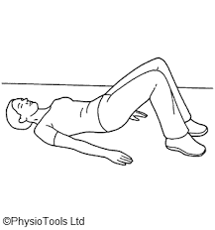

a)Lying on your back on your bed or the floor, with knees bent and feet on the surface.

Tighten your buttock muscles, and slowly lift your bottom up, and slowly lower back down.

Perform 3 sets of 10 repetitions.

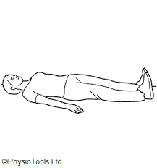

b) Lying on your back on your bed or floor with straight legs. Tighten your thigh muscles, pushing the backs of your knees down into the bed/ floor.

Hold for a count of 30 seconds. Relax.

Perform 3 sets of 10 repetitions.

1. **Exercises for middle stages (weeks 5-8)**

a)Lying on your unaffected side with your knees bent and feet together.

Keeping your feet together, lift your top knee off the bottom one. Do not roll backwards.

Perform 3 sets of 10 repititions.

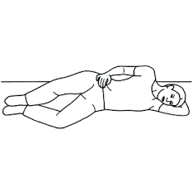

b) When the previous exercise is pain free, move on to this one.

Sitting in a chair with support at your lower back.

Straighten your affected leg out in front, straightening the knee and toes pointing up towards the ceiling. Hold for 5s.

Perform 3 sets of 10 repetitions. Repeat 3 times.

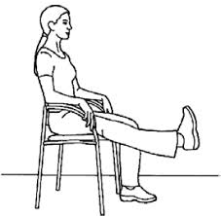

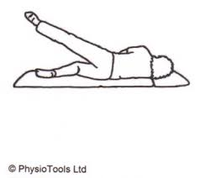

c) Lie on your unaffected side. Make sure your top leg is in line with your body. Lift the leg up towards the ceiling and slowly lower back to the starting position.

Perform 3 sets of 10 repetitions.

**3. Exercises for later stages (weeks 9-12)**

a) Stand with your back against the wall, with feet hip width apart and away from the wall.

Slowly slide down the wall as far as you are comfortable. Then slowly push back up again.

Perform 3 sets of 10 repetitions.

**Once this is entirely comfortable, do this without the support of the wall.**

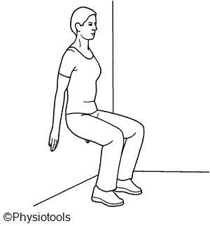

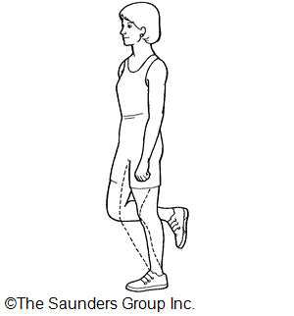

b) Once the previous exercise is pain-free, try this with one leg.

Stand on your affected leg, letting the knee bend as far as comfortable. Then place your unaffected leg on the floor, pushing back up straight.

Perform 3 sets of 10 repetitions.