

# De Quervain’s Tenosynovitis (DQT): A guide for patients

## De Quervain's syndrome | The British Society for Surgery of the Hand

For further advice and self care information you can:

Visit: [www.nhsinform.scot/msk](http://www.nhsinform.scot/msk)

Download: ‘MSK Help’ app free from app stores

## What is DQT?

DQT is an inflammation of the sheath (or tunnel) that surrounds the two tendons that move the thumb. These tendons run between the wrist and the thumb and this is where the pain is felt. The sheath becomes inflamed and sometimes thickened which makes thumb movements and some wrist movements painful.

It is thought that DQT is mainly caused by overuse such as a repetitive movement or sport. It is more common in females than in males.

## What are the symptoms of DQT?

* Pain near the base of the thumb
* Swelling at the base of the thumb into the wrist
* Pain on pinching, grasping and moving the wrist side to side.

You don’t normally need a scan to diagnose this problem and a health care professional will make a diagnosis from a history and specific tests.

If you develop any redness and/ or significant heat over the swollen area and feeling generally unwell, please contact your local health centre as this may be a sign of infection

## Finkelstein-Test-and-Eichhoff-testHow is DQT diagnosed?

A simple test called the ‘Finkelstein’s test’ can tell us if this is what you have. This involves placing your thumb across the palm of your hand, making a fist around it and bending the wrist towards your middle finger. If this aggravates your pain, this is a positive test.

## How is DQT managed?

There are many things that can help in the management of De Quervain’s Tenosynovitis:

* Trying as best you can to avoid the activities that aggravate your pain.
* Use pain relief – anti-inflammatories are normally recommended; however they cannot be taken by everyone. Please speak to your pharmacist with regards to what is most appropriate for you to take.
* Using ice regularly. Applying a cool pack or ice wrapped in a tea towel to the sore area for 15-20 minutes, three times a day can help reduce the inflammation.
* If you feel your pain is work-related, speak to your employer about an occupational health assessment.
* Wearing a splint called a **thumb spica** during the daytime when doing any activities that would normally aggravate your pain.

Normally, symptoms of DQT will settle in 6 to 12 weeks. If it doesn’t, it may be that a corticosteroid injection will help. However, these are not suitable for everyone and underlying health conditions and some medications may make this an unsuitable form of treatment for you.

If things do not settle in the above timescale, it may be worth discussing with your GP, or your Health Centre’s Advanced Nurse Practitioner or First Contact Physiotherapist.

**Thumb Spica Splint:**

**Fitting your splint:**

Your thumb spica should comfortably fit your thumb and wrist. Try not to tighten it too much as this may aggravate your pain.

* Open the wrist section thumb spica and lay it on a flat surface
* Place your hand palm down onto the thumb spica with your thumb through the thumb section (adjust the Velcro strap as required)
* Bring the elastic part around your wrist and Velcro closed.

**Washing:**

* 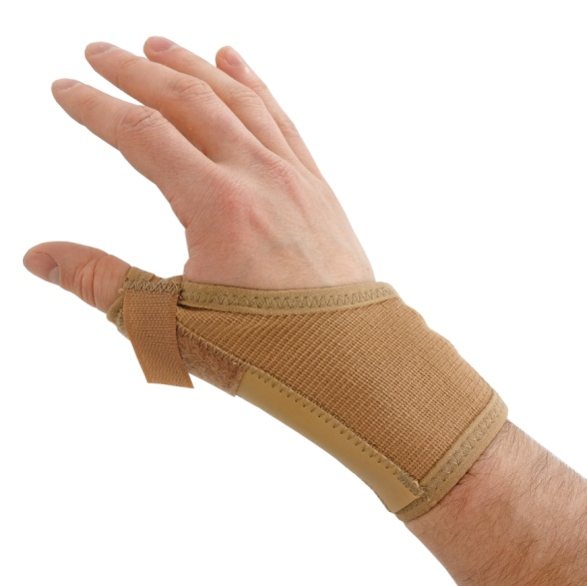Remove the metal bar before washing.
* The splint can be washed in the washing machine, although you may want to put it in a pillowcase first to keep it separate from the rest of your washing.
* Do not dry the splint on a radiator or in direct sunlight, as this will wear the elastic and cause the splint to change shape.
* Replace the metal bar before wearing the splint.