

# Getting your finger moving again after a fracture or dislocation

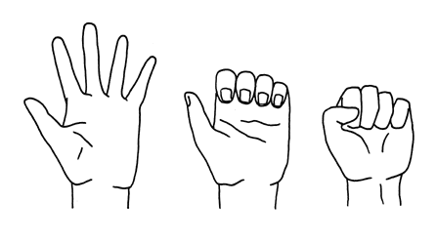

# A guide for patients

For further advice and self care information you can:

Visit: [www.nhsinform.scot/msk](http://www.nhsinform.scot/msk)

Download: ‘MSK Help’ app free from app stores

## When you come out of your splint/ stop having to strap your finger:

## You can now start to use your affected hand for basic activities (e.g. eating, drinking and dressing).

## You may have some pain and the finger may look different, be reassured this is normal.

## Sit with your hand up with your elbow resting on a table if you are not using it, this will help with any swelling. Avoid wearing rings on this finger until the swelling has fully subsided.

* Massage the finger/ hand using moisturiser, focussing on a movement towards the wrist to help disperse any swelling.
* Spend some time daily with your hand in a basin of warm water, moving your fingers by bending and straightening to help loosen off any stiffness.
* Invest in a small pot of putty/ modelling dough (all will become apparent in the exercise section!!)
* Make a pot/ jar of small objects (paperclips, marbles, Scrabble pieces etc). Empty this out onto a dinner tray or kitchen table every day and pick up the objects using your thumb and the affected finger to put them back in.

**Exercises**

The following exercises are designed to help your finger regain movement and strength following your injury. You should aim to do them 3-4 times per day if possible:

## Mobilisation exercises

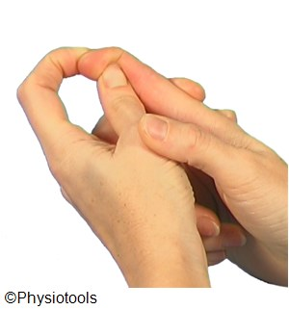

a) Support below the top finger joint.

Bend your fingertip. Assist the movement with your other hand.

Hold 10  secs. Repeat 5 times.

b) Repeat this at the middle joint of the finger, and then at the base of the finger.

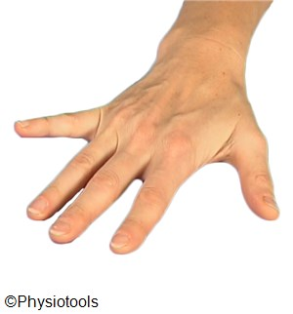

c) Put your palm on a table.  
  
Straighten your affected finger as much as possible by pushing into the table. Hold for 10s. Repeat 5 times.

d) Then lift the finger up off the table, hold for 5 seconds and repeat 5-10 times.

Repeat  times

.

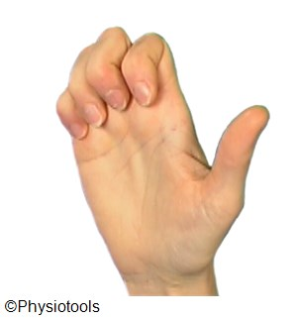

e) Elbow on a table. Straighten the fingers up to the ceiling, then hook the fingers as shown. Hold for 5s. Repeat 5 times.

f) Then repeat this by straightening the fingers out and make a full fist. Hold for 5s. Repeat 5 times

**2. Strengthening exercises – these are advised when the finger is moving more freely.**

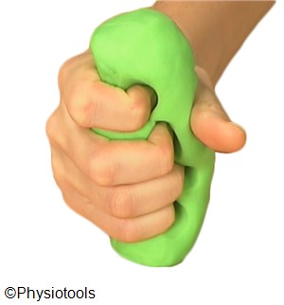

a) Support your forearm on a table holding putty/ modelling dough in your hand.  
  
Bend your fingers pressing deeply into the putty. Then straighten fingers as much as possible.

Repeat 10  times

.

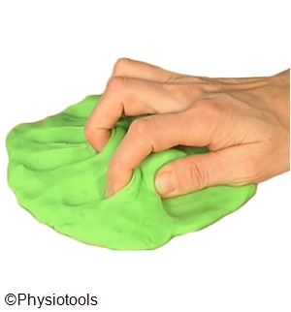

b) Put the putty on a table and push your fingertips deep into the putty keeping forearm on the table.  
  
Bend fingers into a fist pushing them deeper into the putty, then straighten your fingers.  
Repeat 10 times

.

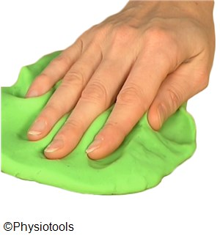

c) Place your forearm on a table and your hand on putty with fingers apart.  
  
Bring fingers together while pushing fingers into the putty.  
Repeat  10 times

d) Then repeat but pushing the fingers apart this time. Repeat 10 times.

**\*This leaflet is designed for people following finger injury and should only be carried out if advised.**