

# Osteoarthritis (OA) of the Hand: A guide for patients

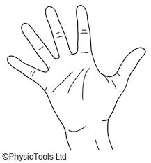

For further advice and self care information you can:

Visit: [www.nhsinform.scot/msk](http://www.nhsinform.scot/msk)

Download: ‘MSK Help’ app free from app stores

## What is osteoarthritis?

It is estimated that around 8.75 million people in the UK have seen a doctor about osteoarthritis.

Osteoarthritis starts with the roughening of cartilage. If this happens, the body can put in place a ‘repair’ process to try to make up for the loss of this important substance. The following can then happen:

* Tiny bits of extra bone, called osteophytes, can grow at the ends of a bone within a joint.
* There can be an increase in the amount of thick fluid inside the joint.
* The joint capsule can stretch, and the joint may lose its shape.

Sometimes, the early stages of osteoarthritis can happen without causing much pain or trouble. However, it can lead to irritation inside a joint, as well as pain and stiffness.

## What are the symptoms of hand osteoarthritis?

* It can affect hands and wrists, particularly the joints at the ends of the fingers or at the base of the thumb.
* It can cause pain and stiffness, and make it difficult to use your hands and wrists properly.
* Osteoarthritis can cause bony lumps to develop on the hands, particularly on the fingers.

You don’t normally need an x-ray to diagnose this problem and a health care professional can make a diagnosis from a history and specific tests.

## What causes hand osteoarthritis?

The exact causes are still not fully understood. Osteoarthritis is more common in women and usually affects people from the age of 45 onwards. Some things that might contribute are:

* Previous injury such as wrist fracture or finger dislocation
* Family history of OA
* A very manual job
* The ageing process

## How is hand OA managed?

Although we cannot reverse the changes in the hand, there are things that can help alleviate some pain and stiffness associated with the condition:

* If possible, it can help to avoid tasks that make the pain worse and put strain on your hands and wrists.
* Keeping your hands and wrists moving as much as possible can help ease symptoms. Doing the exercises below as part of your daily routine can be beneficial.
* Bathing your hands in warm water when they feel stiff.
* Over the counter analgesia and anti-inflammatories can help ease pain and help you to keep moving your hands. See you local pharmacist for advice.
* Your GP can prescribe stronger painkillers if felt appropriate.

**Exercises**

The following exercises can help with the mobility in your fingers and thumb, as well as the overall strength of your digits and hand, which helps to maintain function.

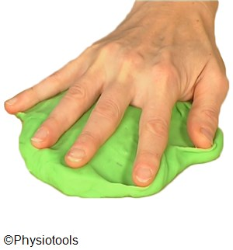

1. Begin with the palm of your hand on a tissue or towel on a table, fingers apart.

Pull your fingers together by pressing your hand down into the table and bunching up the towel between your fingers. Repeat.

You can also do this without using a towel or tissue, and simply by pressing down on the table and squeezing your fingers together and then stretching them apart.

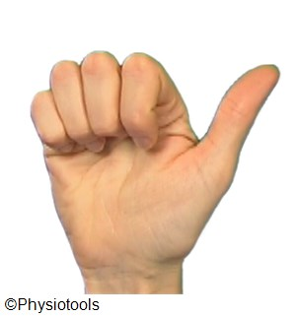

2. Sit with your elbow on the table.  
Bend your fingers 90 degrees to the palm and then clench your fist. Straighten your fingers.

Repeat  10  times

.

3. a) Elbow or back of your hand on a table.  
Put your thumb against each fingertip in turn.  
Repeat 10 times

b) Practise picking up small objects.

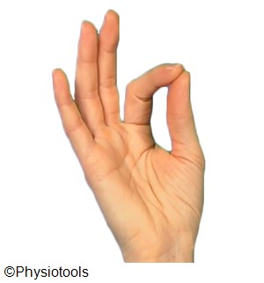

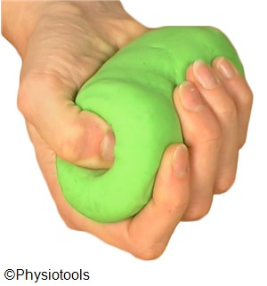

4. Place your forearm on a table with palm up, holding putty in your hand.  
  
Bend your thumb into the putty.  
Repeat 10 times

5. Support your forearm on a table holding putty in your hand.  
  
Bend your fingers pressing deeply into the putty. Then straighten fingers as much as possible.  
Repeat 10 times

