

# Temporomandibular Joint (TMJ) Pain

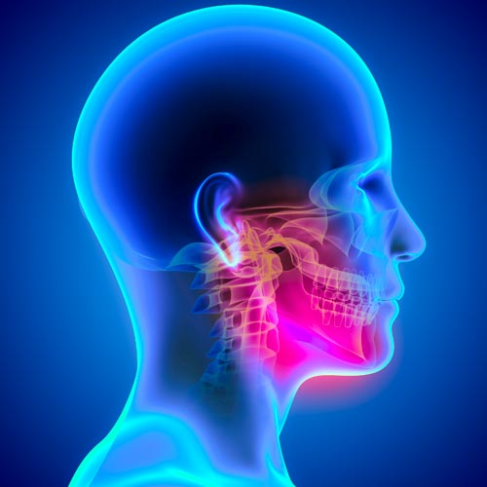

# A guide for patients

For further advice and self care information you can:

Visit: [www.nhsinform.scot/msk](http://www.nhsinform.scot/msk)

Download: ‘MSK Help’ app free from app stores

## What is the TMJ?

The TMJ is another name for the jaw. The jaw is made up of the mandible (the lower jaw) and the temporal bone (the socket). Causes of TMJ pain include:

* Overactivity of the jaw muscles (eg. From grinding your teeth or clenching your jaw)
* Trauma as such a blow to the jaw
* Wear and tear of the joint
* Stress

**What are the signs and symptoms of TMJ dysfunction?**

There are many signs of problems with the TMJ:

* Pain in the jaw and facial muscles
* Clicking or grinding of the jaw
* Headaches
* Dizziness
* Difficulty opening or closing the mouth properly
* Pain on chewing, talking and yawning
* Ringing in the ears.

**Advice for helping TMJ pain:**

* Try heat or ice regularly over the affected area for 10-15 minutes at a time. Ensure these are wrapped in a tea towel to avoid the risk of skin irritation or damage.
* Speak to your local pharmacist for advice regarding analgesia
* Try to massage the muscles around the joint.
* Try to avoid clenching your jaw or grinding your teeth – if you do this in your sleep, seeing your dentist for provision of a mouth-guard may be appropriate.
* Cut tougher food into smaller pieces
* Be mindful of your posture as poor posture can contribute to your pain
* Avoid using chewing gum
* Avoid sleeping face down

**Exercises**

The following exercises are designed to help regain movement, function and to minimise your pain in conjunction with the aforementioned advice:

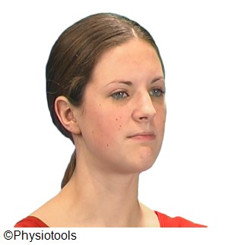

1.Relaxed jaw position.

Put your tongue on the roof of your mouth and allow your jaw muscles to relax. Hold for 10s

Repeat 5  times

2. With your tongue to the roof of your mouth, use your fingers to push your chin back and down.

Hold for 5s

Repeat 10 times.

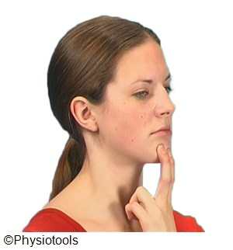

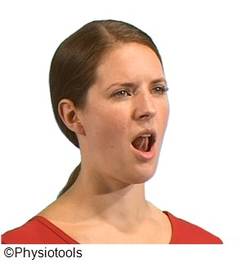

3. Place your tongue on the roof of your mouth.  
  
Open your mouth slowly, make sure that you move your lower jaw down in a straight line. Keep your neck straight.

Repeat 10 times

.



4. Push your lower jaw down, while resisting movement with your hand.

Hold for 5s.

Repeat 10 times

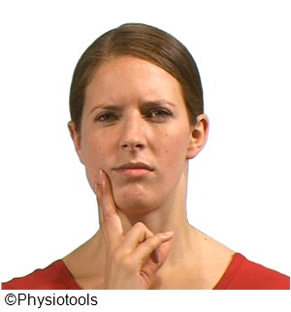

5. Try to move your lower jaw to the side, resist the movement gently with your fingers.

Hold 5 seconds.

Repeat 10 times each side

6. Sitting straight-backed.  
  
Pull your chin in, keeping your neck and back straight (not tipping your head forwards). Hold at the end position and feel the stretch in your neck. Hold for 5s

Repeat 10 times

.

