

# Whiplash

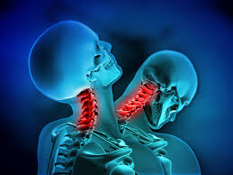

**A guide for patients**

For further advice and self care information you can:

Visit: [www.nhsinform.scot/msk](http://www.nhsinform.scot/msk)

Download: ‘MSK Help’ app free from app stores

## What is Whiplash?

Whiplash is a neck injury caused by a sudden movement of the head forwards, backwards or to the side and is most common following a vehicle collision. This movement can cause strain of the neck muscles and ligaments.

It is important to know:

* Permanent damage is rare
* Any serious injury would be picked up very early on
* The first couple of days following this injury are important – resting too much can prolong your symptoms.
* People who stay active and keep their neck mobile early on normally recover quicker from whiplash

## What are the symptoms of Whiplash?

Symptoms of Whiplash are not normally evident straight away and can develop over the first few days after the injury:

* Neck pain and stiffness
* Appearance of swollen muscles either side of the neck
* Reduced neck mobility
* Tenderness along the neck and shoulders
* Headaches
* Less common but can also occur – dizziness, some low back pain, pins and needles or numbness in the arms/ hands.

## How can I manage Whiplash?

* Seek advice from your local pharmacist regarding pain relief.
* Try heat or ice around your neck to help relax the tight muscles.
* Stay as active as possible and carry on with your normal activities. Modify tasks if you feel you need to.
* Try not to wear any neck collar provided to you for any more than a couple of days. Moving the neck is key to recovery!
* Carry out regular exercises.

**Exercises**

The following exercises should be done little and often throughout the day. When carrying these out, you should feel a stretchy type sensation, rather than pushing into pain. Make sure you stop the movement just shy of the pain.

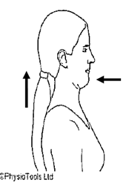

1. Sitting or standing. Gently pull your head back so it is in line with your shoulders. You should feel a slight stretch up the back of your neck. Hold for 5s.

Repeat 5 times.

2. Sitting or standing.

Slowly move your head to one side (ear towards shoulder) until you feel a stretch. Repeat to the other side.

Repeat 3-5 times.

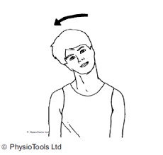

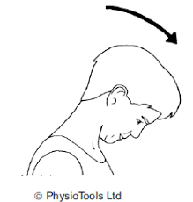

3. Sitting or standing.

Slowly move your head forwards, moving your chin down to your chest, until you feel a stretch. Then come back up and move your head backwards, looking towards the ceiling.

Repeat 3-5 times.

4. Sitting or standing.

Slowly turn your head round to one side until you feel a stretch. Then rotate to the other side.

Repeat 3-5 times.

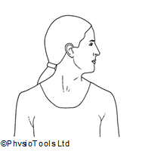

**If any of the exercises are too uncomfortable to do, please stop them and try again a day or two later.**