Osteoarthritis (OA) of the Knee

You have been referred to the Department of Orthopaedics as you have symptoms of Osteoarthritis (OA) of the knee. Please read this leaflet as it gives you information about your condition.

What is Osteoarthritis (OA)?
Osteoarthritis is a condition that affects the joints causing pain and stiffness. The knee is one of the more commonly affected joints. It is sometimes referred to as degenerative joint disease or wear and tear.

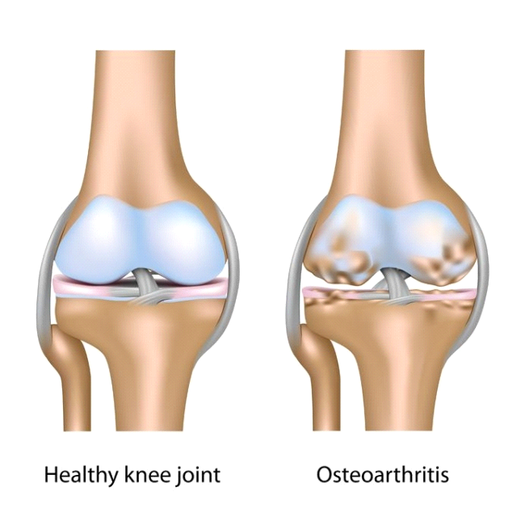

What causes Osteoarthritis (OA)?

All normal joints and joint tissues are constantly undergoing some form of repair because of the wear and tear that our daily activities place on them. However, in some people, it seems that this repair process becomes faulty and OA develops. A certain amount of wear and tear is normal as we age.

Factors that may play a role in the development of osteoarthritis include:

- Age: OA becomes more common with increasing age. By the age of 65 at least half of the people will have some OA in some joint (s).

- Obesity: Knee OA is more likely to develop if you are overweight. This is because there is an increased load on the joints and a potential for more damage.

- Your Sex: Women are more likely to develop OA than men.

- Genetics: There may be some inherited tendency for OA to develop in some people if your parents, brothers or sisters have had OA.

- Previous Joint Damage or Deformity: This may be from a previous fracture or injury around the knee joint that has caused damage to the joint surfaces.

The exact cause of OA is unknown. It is probably a combination of the above factors.

What are the symptoms of Osteoarthritis?

- Pain, stiffness, and limitation in full movement of the joint are typical. The stiffness tends to be worse first thing in the morning but tends to loosen up after half an hour or so.

- Swelling and inflammation of the knee can sometimes occur.

- An affected joint tends to look a little larger or more knobbly than usual.

- A grating or cracking sound or sensation at your knee is fairly common.

- Weakness and muscle wasting around the knee joint can make it difficult to fully straighten the knee.

- Reduced function- i.e. climbing stairs, walking for long distances, kneeling.

You may experience all or some of those symptoms. Your symptoms may vary for no apparent reason with bad spells of a few weeks or months broken by better periods.

How Is Osteoarthritis Diagnosed?

We usually diagnose Osteoarthritis based on your symptoms and the physical signs that we found when your knee was examined. There are no blood tests for Osteoarthritis. X-rays are often not needed to diagnose Osteoarthritis. However, sometimes your doctor may suggest X-rays or other tests if they are uncertain about the diagnosis and want to rule out other problems.

We do not routinely provide a hospital appointment for Osteoarthritis.

What You Can Do To Help Yourself?

There is no cure for Osteoarthritis. However, OA may not necessarily get worse and there are many things you can do to manage the symptoms to maintain an active lifestyle.

Reduce stress on the joint

- Keep to your ideal weight. Extra weight on the joint can make symptoms worse. Even a modest weight loss can make quite a difference.

- Avoid high heels. Wear appropriate footwear with cushioned soles or insoles.

- Try not to overstress your joint by doing too much all in the one day e.g. spread household chores throughout the week.

- Avoid being in one position for too long when possible to help prevent stiffness.

- Use a walking stick if you have one.

Exercise

It is important to find the right balance between rest and exercise. Generally, too much activity can increase pain in a knee with Osteoarthritis but too little can cause the joint stiffen up.

Osteoarthritis in the knee can weaken the thigh muscles (quadriceps). This can increase your knee pain and you may feel as if your knee has a tendency to give way perhaps even causing you to stumble or fall. Doing the exercises at the back of this leaflet everyday should help.

A physiotherapist in your local hospital or health centre can give you advice on exercise and managing with early osteoarthritis. Some physiotherapy departments have classes for patients with osteoarthritis of the knee.

Swimming can be a very good way of exercising and keeping fit. The water supports the body’s weight so that little force goes through your joints as you exercise and causes very little pain.

Leisure centres also run a variety of exercise classes that may be suitable and enjoyable. These classes can help to introduce you to exercise especially if you have not done it for quite some time.

Other Treatments

Some people find that they can also get some pain relief from using hot or cold packs. Try wrapping crushed ice in a damp towel and hold it for five to ten minutes against the part of the knee that hurts. You can do this every two to three hours. Make sure you use a damp towel between the ice and the skin to avoid an ice burn.

Or you could use a heat pad or a hot water bottle with an insulated cover on it. Make sure this is not too hot and not directly touching your skin. You can apply this for 10 to15 minutes three to four times a day.

Medication

If you still have pain after trying the above you can speak to your doctor to discuss medication for pain relief.

Surgery

You won’t necessarily need a knee replacement if you have Osteoarthritis of your knee. Your healthcare team will always try other measures before suggesting a knee replacement. If your symptoms are still manageable and your medication is effective then you may prefer to wait. Most people who have a knee replacement are over 55. The earlier you have a knee replacement the greater the chances that you’ll eventually need further surgery. The evidence shows that knee replacements perform less well in younger patients.

What is a knee replacement and risks?

If your knee is damaged by arthritis and the pain, stiffness and disability are having a serious impact on your everyday activities and you have tried all the self help advice we may consider you for a knee replacement. It is worth noting that 1/5 of patients who have a knee replacement are not happy with the result.

Are there any reasons why I can’t have a knee replacement?

Unfortunately, some people may not be able to have a knee replacement even though their arthritis is very bad. This may be because:

- You have a circulatory condition that may exclude you from having a knee replacement.

- Your thigh muscles (quadriceps) are very weak and may not be able to support your new knee joint

- You have deep or long-lasting open sores (ulcers) in the skin below your knee, increasing your risk of infection.

- You have other medical conditions that put you at higher risk from an anaesthetic.

Risks of Surgery

As with all procedures, this carries some risks and complications.
Common: (2-5%)
- Pain: Your knee will be sore after the operation. If you are in pain, it’s important to tell ward staff so they can give you medicines. Pain will improve with time. Rarely, pain will be a chronic problem and may be due to any of the other complications listed below, or, for no obvious reason. Large scale studies have shown that up to 1 in 5 people have ongoing pain after a knee replacement.

- Bleeding: Some patients may occasionally need a blood transfusion or iron tablets. Rarely, the bleeding may form a blood clot or large bruise within the knee which may become painful and may require an operation to remove it.

- DVT: (deep vein thrombosis) is a blood clot in a vein. The risks of developing a DVT are greater after any operation (and especially a bone operation) DVT can pass in the blood stream and be deposited in the lungs (a pulmonary embolism – PE). This is a very serious condition which affects your breathing. Your surgeon may give you medication to try and limit the risk of DVTs from forming. Some hospitals will also ask you to wear stockings on your legs, while others may use foot pumps to keep blood circulating around the leg. Starting to walk and moving about as soon as possible after your operation is one of the best ways to prevent blood clots from forming.

- Knee stiffness: may occur after the operation, especially if the knee is stiff before the operation. Manipulation of the joint (under general anaesthetic) may be necessary.

- Prosthesis wear: With modern operating techniques and new implants, knee replacements last many years. However, in some cases, they fail earlier. The reason is often unknown. The plastic bearing is the most commonly worn away part.

Less Common: (1-2%)

- Infection: We will give you antibiotics at the time of the operation and the procedure will also be performed in sterile conditions (theatre) with sterile equipment. Despite this infections still occur (1 to 2%). The wound site may become red, hot and painful. There may also be a discharge of fluid or pus. If the infection is superficial this can be treated with antibiotics. However if the infection is deper and involves the prosthesis, we usually treat this with antibiotics and an operation to washout the joint. In rare cases, the prosthesis may be removed and replaced at a later date. The infection can sometimes lead to sepsis (blood infection) and strong antibiotics are required.

Rare: (less than 1%)

- PE: a Pulmonary Embolism is the spread of a blood clot to the lungs and can affect your breathing. This can be fatal.
- Altered leg length: the leg which has been operated upon may appear shorter or longer than the other.
- Altered wound healing: the wound may become red, thickened and painful (keloid scar) especially in Afro-Caribbeans.
- Joint dislocation: if this occurs, the joint can usually be put back into place without an operation. Sometimes this is not possible, and an operation is required, followed by application of a knee brace.
- Nerve Damage: efforts are made to prevent this; however there is a risk of damage to the small nerves of the knee. This may cause temporary or permanent altered sensation around the knee. There may also be damage to the Peroneal Nerve, this may cause temporary or permanent weakness or altered sensation of the lower leg. Changed sensation to the outer half of the knee may be normal.

- Bone Damage: bone may be broken when the prosthesis (false joint) is inserted. This may require fixing either during the operation or at a later date.
- Blood vessel damage: the vessels at the back of the knee may rarely be damaged, this may need another operation.
- Death: This very rare complication may occur after any major operation and from any of the above.

Useful Exercises

The guide below will help ensure you are working at the right level:

Pain during exercise
Aim to stay in the green or amber boxes. If you are in the red area then you can modify the exercises by trying reducing the amount of movement during an exercise, reducing the number of repetitions, reducing the weights, reducing your speed or increasing rest time between sets.
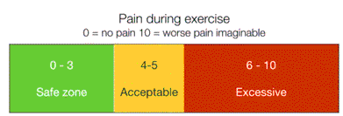

Pain after exercise
Your pain or other symptoms should return to your pre-exercise baseline within 30 minutes of exercising. You should not feel an increase in pain or stiffness the next morning. If you do, the next time either reduce the amount of movement during an exercise, reduce the number of repetitions, reduce the weights, reduce your speed or increase rest time between sets. If this does not help seek advice or stop that exercise completely.
If you have a mobile phone you can use the camera function to scan the QR code below to see a video demonstration of the exercises.

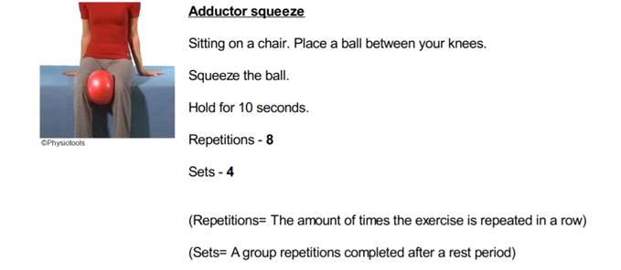

*Pick 1 of the next 2 exercises to do. The first 1 is the Easy level exercise*

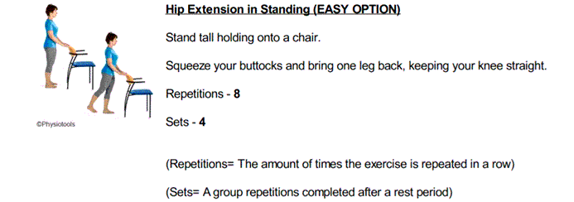

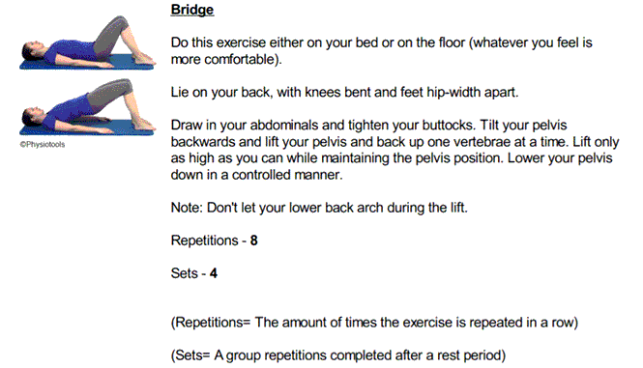

*Pick 1 of the next 2 exercises to do. The first 1 is the Easy level exercise*

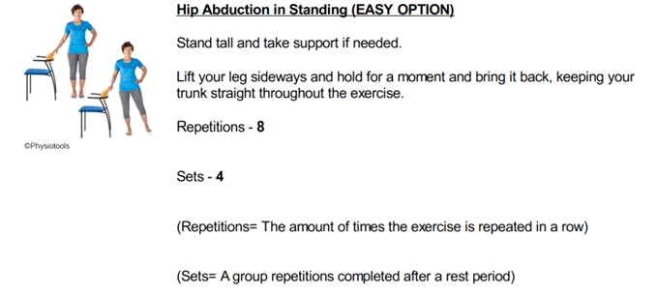

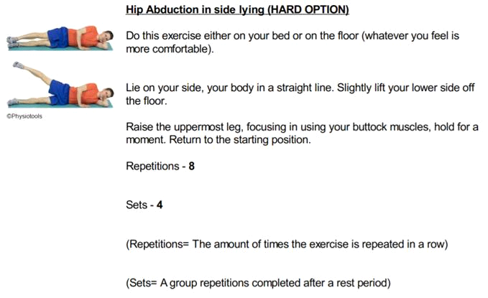

*Pick 1 of the next 2 exercises to do. The first 1 is the Easy level exercise*

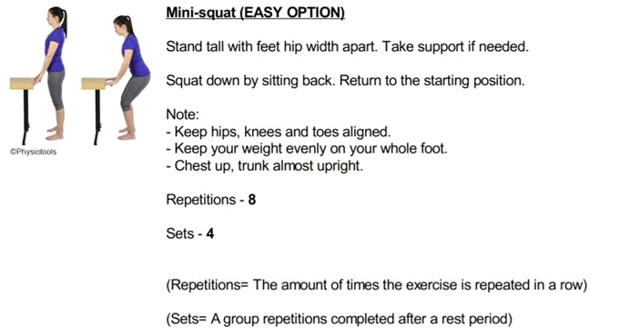

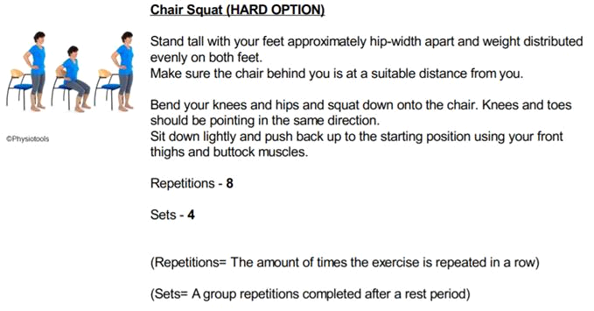

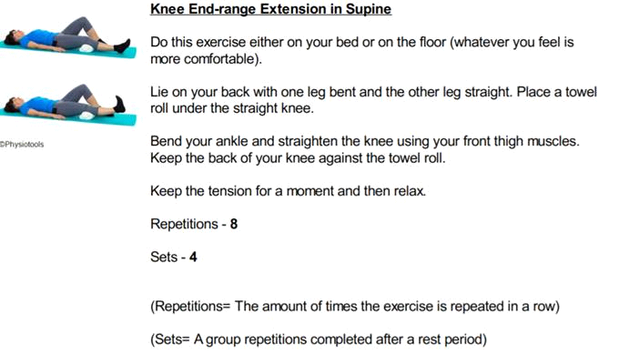

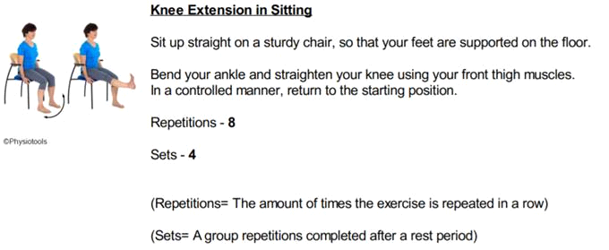

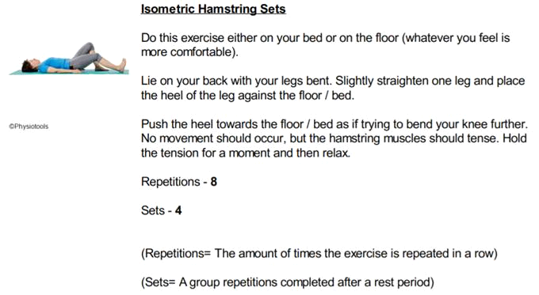

*Pick 1 of the next 3 exercises to do. The first 1 is the Easy level exercise*

