**Discharge**

The child/ young person will be discharged from Occupational Therapy for one or more of the following reasons:

* The child’s goals have been met or they have completed their intervention
* Those closest to the child/ young person are equipped with the advice and strategies to continue to support ongoing development.
* The child is not benefitting from Occupational Therapy currently
* The child or family do not attend appointments, or they have chosen not to continue with Occupational Therapy
* The child/ young person moves out with the Scottish Borders



**Contact Details**

Prior to contacting the service, we suggest you explore our resources online and on Facebook;

[www.nhsborders.scot.nhs.uk/cypot](https://eur01.safelinks.protection.outlook.com/?url=http%3A%2F%2Fwww.nhsborders.scot.nhs.uk%2Fcypot&data=05%7C01%7Cclaire.scott%40borders.scot.nhs.uk%7C5eaa05f4a950439d50c508dab03d7cb1%7C10efe0bda0304bca809cb5e6745e499a%7C0%7C0%7C638016075365482348%7CUnknown%7CTWFpbGZsb3d8eyJWIjoiMC4wLjAwMDAiLCJQIjoiV2luMzIiLCJBTiI6Ik1haWwiLCJXVCI6Mn0%3D%7C3000%7C%7C%7C&sdata=%2FaqJM9brnTxNkhPO0NQCSIDSGL6Iv3cZHKT4JBVxjLo%3D&reserved=0)



[www.facebook.com/CYPOTNHSBorders](http://www.facebook.com/CYPOTNHSBorders)

If you wish to seek further advice, please contact our Enquiry Line:

🕾 01896 826033 (voicemail) or

🖳 [Paediatric.OTEnquiries@borders.](mailto:Paediatric.OTEnquiries@borders.%20%20)

**scot.nhs.uk**

We aim to contact you within 5 working days

**For a copy of this information in:**

* **large print**
* **another language**
* **Braille**
* **BSL DVD**
* **audio tape**

**Please contact 01896 826033**



**Children and Young People’s Occupational Therapy**

**A guide for parents and carers**

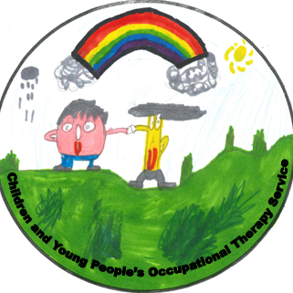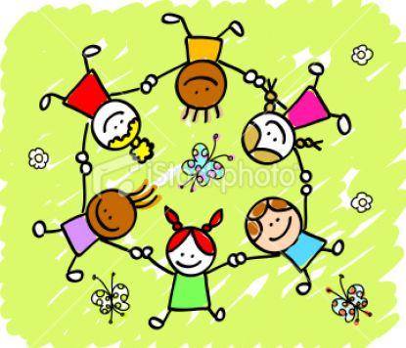

**Children and Young People’s Occupational Therapy**

The Children and Young People’s Occupational Therapy team are community based and provide a Borders wide service to children and young people aged 0-18 years in home, school, and health settings.

The team work with children, young people and those closest to them, who have difficulties with the functional skills necessary for their everyday life.  The service will aim to support those with concerns to enable the child/ young person to maximise their opportunities to develop in the following areas:

* Functional abilities e.g. dressing, eating, toileting etc
* School skills e.g. pencil control, access to the environment, attention and concentration
* Play & leisure skills
* Sensory regulation
* Gross and fine motor skills
* Routines
* Sleep

**Seeking Advice and/or Support from Occupational Therapy**

Advice and support can be sought from the service by contacting team directly using our Enquiry Line or via our Enquiry Email Inbox. (See back of leaflet).

An Occupational Therapist will discuss the concerns which relate to the child's functional difficulties with the person seeking advice and will offer one of the following:

* Reassurance
* Signposting to another more appropriate service
* Advice
* An individualised assessment

Advice may also be sought from the service from Health Care Professionals, Education or Social Work.

**Occupational Therapy Intervention**

Ways of supporting the child/ young person may include one or more of the following:

* Support, advice and strategies for parents, carers, teachers, and other service providers.
* Invitation to a parent/carers group
* Recommendation of specialist equipment to support functional skills, learning and sensory regulation (at home and school)
* Direct therapy with the child either individually, or in a group
* Occupational therapy intervention may involve joint working with others involved with the child