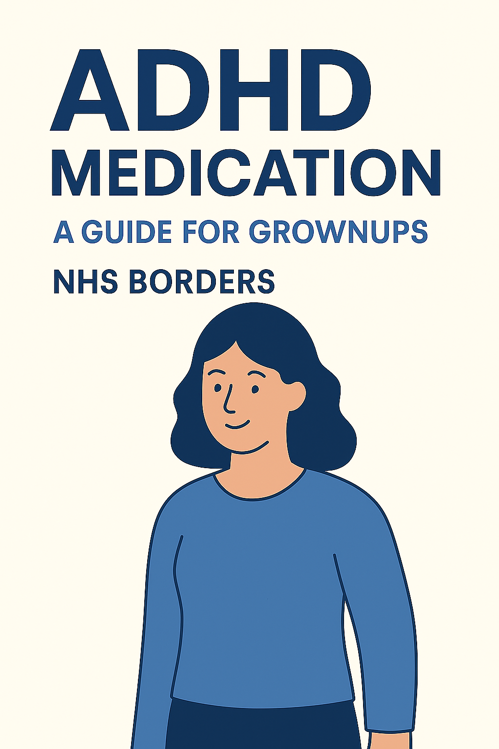
What about a video instead?

This is a written document however if you prefer to have the same information in video there is a link here from a different Health board that has good information.

Note there is a section at the end regarding contact details, however this is not the correct contact details for NHS Borders. The information to contact NHS borders CAMHS is at the end in section 6.
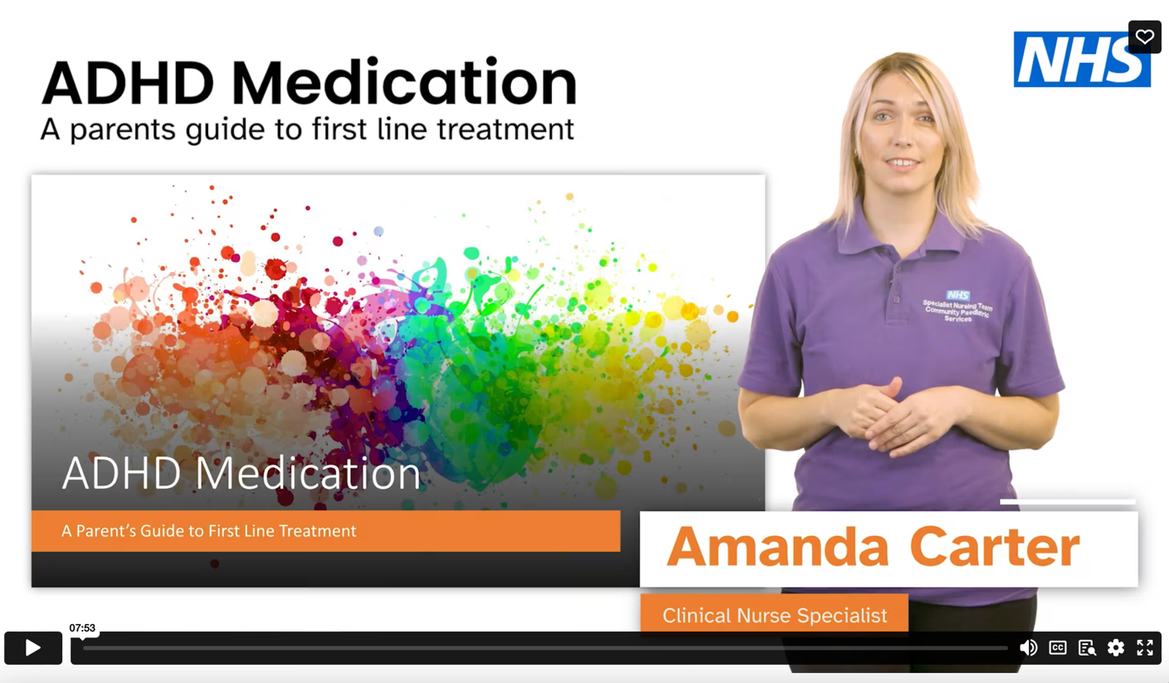

Video link for ADHD Medication explained

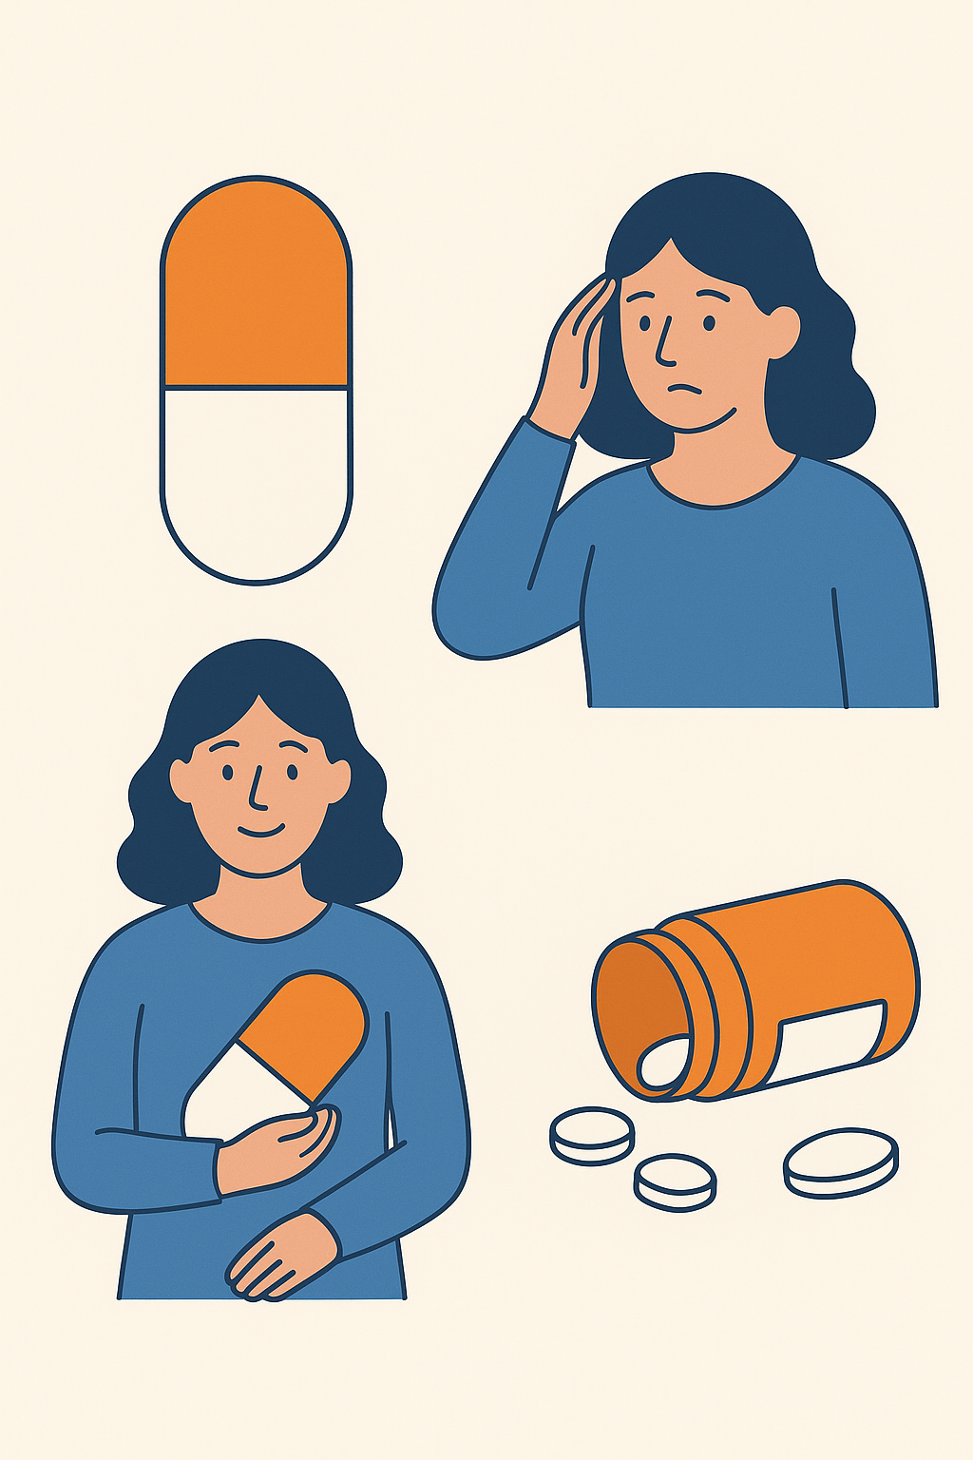
Contents

- Introduction (p4)

- Why consider medication? (p4)

- Stimulant medication (p4)
- What are stimulant medications and how do they work?
- Do they work?
- How do I know stimulant medication is working?
- Methylphenidate
- Amphetamines including lisdexamphetamine and dexamphetamine
- What dose and when?
- What are the side effects?

- Non-stimulant medication (p8)
- Atomoxetine
- Guanfacine

- Monitoring and more information (p12)
- How will the medication be monitored?
- How long will they be on medication?
- Children’s rights, confidentiality and consent

- Useful contacts and resources (p14)

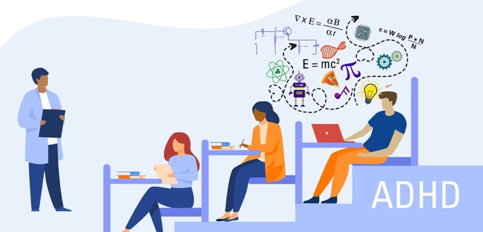

- Introduction
ADHD (Attention deficit hyperactivity disorder) can be supported in a variety of ways. These include strategies that everyone can try and medication that is an option but is not for everyone. Strategies that could be of benefit e.g. extra support in school, changes to the classroom and behavioural strategies. These strategies are discussed further in the ADHD pack. It’s important to discuss ADHD with your child or young person and the important people around them e.g. teachers. Medication is just one part of the whole treatment plan. It needs to work alongside other behavioural strategies and treatment.

- Why consider medication?
ADHD medications are not a 'cure' for ADHD. They will not change your child or young person's personality. To get the best outcome for your child or young person, ADHD medication should be used alongside strategies and techniques.
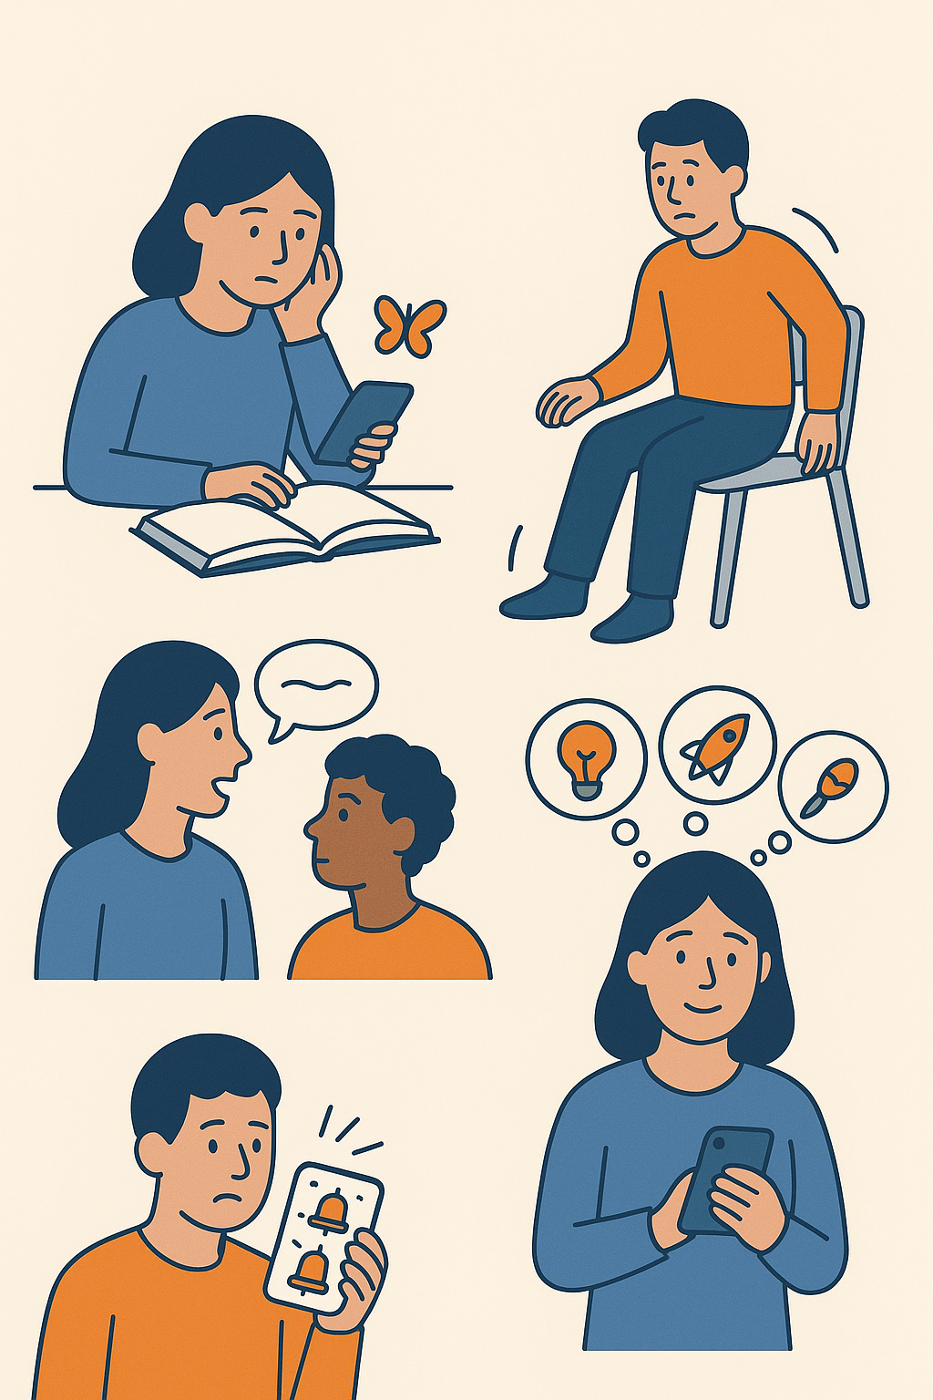
It will be helpful for you and your child or young person to know what ADHD medications could do for them.
ADHD medication can help your child or young person:
- start and finish tasks
- focus on tasks
- be more aware of their surroundings
- listen better
- reduce fidgeting
- be more organised
- feel calmer
- help working memory

Before starting medication the prescriber will ask about the young persons physical health, and family history of heart issues. Some children might need to have an electric reading of the heart (ECG) prior to starting the medication as there are some very rare heart issues that can be a problem with the medications.

3. Stimulant medication

What are stimulant medications and how do they work?

Stimulants are a group of medications used to manage symptoms of ADHD. They are generally recommended as the first choice for children and young people with ADHD. Non-stimulant medication is recommended if the stimulants do not work, cause significant side effects or are not suitable for your child or young person.

Stimulant medications stimulate the dopamine systems of the brain. The dopamine system affects the brain’s alertness, reward, impulse control and organisational skills.

Stimulant medication improves concentration and reduces hyperactivity and impulsivity. These are fast-acting medications, and the effects can be felt within an hour after taking them.

You will sometimes see drug names and brand names used – here is a quick table to show you which brand names relate to each drug.

Drug names | Brand names
Methylphenidate (methylphenidate hydrochloride) | Equasym XL  Concerta XL  Medikinet
Dexamphetamine
Lisdexamfetamine | Elvanse

Do the medications work?

Many studies have shown that about 70% of children with ADHD will show an improvement in concentration and a reduction in other symptoms of ADHD with stimulant medication.

Long-term studies show continued positive effects of medication and that young people with ADHD who receive medication have better adult outcomes in general than children who have not. This does not mean that medication is right for everyone. Your clinician will discuss this with you as all children are individuals, and please ask us any questions you have.

How do I know stimulant medication is working?

Commonly carers/parents report the following:

“They are less on the go all the time”
“They are more able to complete tasks and follow instructions”
“I’ve had fewer concerns from school and their report card was better than usual” –
“We are getting on better as a family”

“I can tell when the tablet runs out after a few hours”

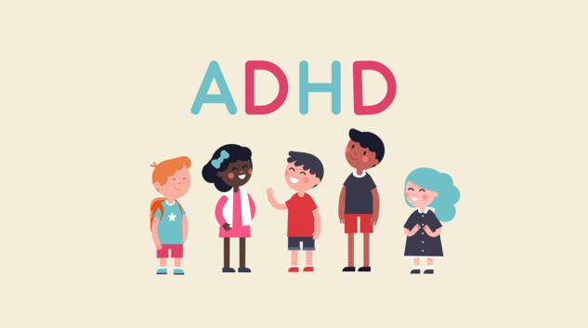
Methylphenidate
Methylphenidate is the most commonly prescribed medication for ADHD in the UK.
The medicine can be taken as an immediate-release tablet (small doses with shorter hours that it affects the body) or as a modified-release tablet (larger dose which releases throughout the day). The medication usually takes between 30 to 60 minutes to work.
How long does it work for | Type of medication | Brand names
2 to 4 hours (immediate release) | Tablet - Take 2 to 3 times a day  Tablets can be crushed or cut however is bitter to taste. It should be taken with or after food. | Medikinet
6 to 8 hours (modified release) | Capsule - Take once a day in the morning  If your child struggles with swallowing, the contents of capsule can be sprinkled on yogurt or mixed with jam and swallowed. | Medikinet XL  Equasym XL  Ritalin XL
10 to 12 hours (modified release) | Tablet - Take once a day in the morning  Do not crush or break modified release tablets because the medicine will not work properly. | Matoride XL  Concerta XL  Xaggatin XL

Amphetamines including lisdexamphetamine and dexamphetamine
Lisdexamfetamine and dexamphetamine are in a group of medicines called amphetamines. Amphetamines, when used inappropriately, for people without ADHD can be addictive however, there have numerous studies that show ADHD medications are not addictive for people with ADHD and that they will not cause your child to abuse substances when they grow older.
Amphetamines can be taken before or after eating food, it is not affected by food. They will need to take the amphetamine at the same time every day (usually morning).
If they miss a dose, do not give them the missed dose. This can cause issues with sleep. Give them the next dose as usual. Never give a double dose of amphetamines.
Medicine | How long does it work for | Type of medicine | Brand names
Dexamphetamine | Up to 4 hours (immediate release) | Tablet - Take 2 to 3 times a day  Tablets can be crushed or cut.  Capsule - The capsule can be swallowed whole or opened up and stirred into a drink or food. If the medication is stirred into a drink or food, it must be stirred until fully dissolved and swallowed immediately. | Dexamphetamine  Amfexa
Lisdexamfetamine | Up to 13 hours (modified release) | Capsule - Take once a day in the morning  If your child struggles with swallowing, the contents of capsule can be mixed in water or juice. | Elvanse

What dose and when?

Most children will start on a low dose and then slowly increased as needed. The medication is usually divided into 2 or 3 doses per day.

Once they are settled on the right dose of medication for them, your GP will usually take over the prescription however they will be followed up in the ADHD clinic with CAMHS.

Some families decide together to have a break from medication at weekends, holidays and after school. This is a personal choice and will depend on various factors.

What are the side effects?

All medications have some side effects, but usually, stimulants are safe and well accepted by most bodies.

Most common initial side effects of stimulants include:
- headaches
- abdominal pain
- dizziness
- tearfulness

These are often related to starting medication or increasing dose and usually improve after one or two weeks.

Sometimes young people on stimulant medications do not feel as hungry and therefore do not grow or gain weight at the same speed as other children. It is important that we monitor height and weight to monitor for this. If you are worried about how they are growing mention this to your doctor or nurse.

Other important potential side effects include:
- insomnia (trouble getting off to sleep)
- reduced appetite
- emotional side effects e.g. tearfulness

Stimulants also have rare side effects. They can affect the heart, causing symptoms such as:
- increase in blood pressure
- increased pulse rate

This is why we check these at each appointment and why it is important to attend regularly. It’s also important that we know about any family history of heart diseases and conditions so that we can make the safest plan for each person.

Side effects will disappear if medication is stopped or often if the dose is reduced. We have lots of experience in a variety of ways of minimising the impact of side effects and discussion about this will be part of your child’s ongoing monitoring and care.

If you have any doubts or worries, ask us for advice. If you are still worried or unhappy about medication it can be stopped.

Non-stimulant medication

These are a different group of medicines that work in different ways to the stimulant medication. These take longer to start working and need to taken for longer to feel the effects. They must be taken every day.
Everybody’s body is different so some medications will suit some people better. It's very common to try different medications at different doses to find which one is best for your child.

Atomoxetine

Atomoxetine helps to improve concentration and impulse control and reduces over activity in young people with ADHD. It is generally used for people with ADHD who are not able to take stimulant medication, e.g. because of side effects.
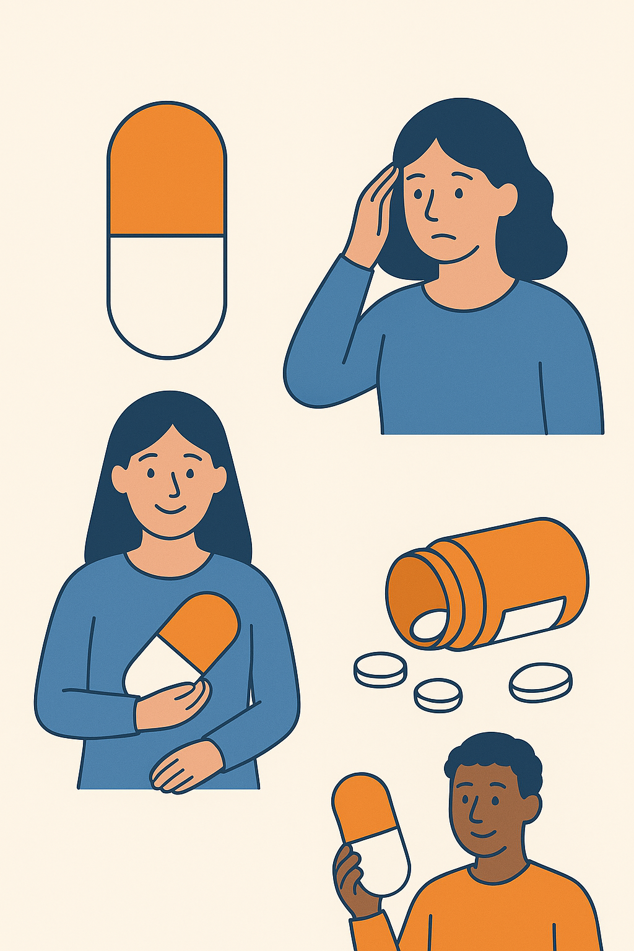
Atomoxetine has to be taken regularly for approximately 8 weeks before the benefits are seen. There may not be a big difference in symptoms when starting on atomoxetine. It must be taken every day to see effects.

Once Atomoxetine begins to work, the benefits should be seen throughout the day and night. Atomoxetine does not impact on tics.
If your child misses a dose, do not give them the missed dose. Give them the next dose as usual. You are unlikely to harm your child if you accidentally give them double the dosage. If you are concerned that you have given your child too much, call 111. Make sure you have the medication or packaging when you call.
If you or your young person choose to stop using atomoxetine, we would work together with the doctor wean them off it without causing issues e.g. a sudden increase in ADHD symptoms.
How long des it work for | Type of medication | Brand names
Up to 24 hours | Capsule and liquid form - Take once a day | Strattera capsule  Strattera liquid

How do I know Atomoxetine is working?

Benefits can be seen in school as well as at home and usually you notice an improvement in:

Concentration: making it easier to stick to a task, follow instructions and complete tasks.

Impulse control: being more able to stop and think before acting.

Activity levels: Being more able to stay in their seat and less restless and fidgety.

What are the side effects?

Side effects may occur once medication is started, even though the benefit might not be seen yet. They often improve over time.

The most common side effects of Atomoxetine include:
- Tummy pain
- Reduced appetite e.g. not feeling hungry
- Emotional side effects
- Nausea e.g. feeling sick or like you are going to vomit

Less common side effects include:
- Increase in blood pressure or pulse. This is why we check these at each appointment
- Jaundice – a yellow colour skin or white of the eyes
- Allergic reactions to Atomoxetine are rare but can cause rashes and swelling

Guanfacine

This is a long-acting non-stimulant medication. It is given once a day to treat the core symptoms of ADHD when stimulant medications have not been successful or have been poorly tolerated (caused unacceptable side-effects). It can also be helpful for children who have tics and ADHD as it can help the symptoms of both.

Guanfacine is a medication that a few weeks to work properly. You may not see a big difference in symptoms at the start. It needs to be taken regularly for at least 2-3 weeks for the full benefit.
If they miss a dose, do not give them the missed dose. Give them the next dose as usual. Never give a double dose of guanfacine. If you miss more than one dose in a row, please speak to your doctor or specialist nurse for advice.
If you or your young person chooses to stop using guanfacine, we would work together with the doctor wean them off it without causing issues e.g. a jump up in blood pressure.
How long does it work for | Type of medication | Brand names
Up to 24 hours | Tablet - Take once a day – cannot be crushed | Intuniv

How do I know Guanfacine is working

Benefits can be seen in school as well as at home and usually you notice an improvement in:

Concentration: making it easier to stick to a task, follow instructions and complete tasks.

Impulse control: being more able to stop and think before acting.

Activity levels: Being more able to stay in their seat and less restless and fidgety.

What are the side effects?

Side effects may occur as soon as medication is started, even though the hoped effects can take several weeks. Side effects often improve over time.

Guanfacine side effects:
- mild sedation or sleepiness in some cases and because of this it can be taken in the evening.

Other side effects:
- Headaches
- tummy pain
- nightmares
- constipation
- dry mouth
- tearfulness and emotional side effects
- low blood pressure or slowing of the heart rate which is why these measurements will be checked at each clinic appointment.

Guanfacine SR does not cause or worsen tics, and is very unlikely to make the people taking it feel less hungry.

If you have concerns about side effect please discuss with your doctor.

Monitoring and more information

How will medication be monitored?

Decisions about whether to try or continue with medications, are a shared decision between the young person, the adults in their life and their doctor and nurse. This is based on a balance of the positives, any side effects and how people are feeling about the medication.

Everyone taking ADHD medications will be offered regular reviews. At the start the check-ups will be every few weeks and then once happy with the medication these reviews will be every 4-6 months.

At these appointments you should always expect to have done their:
- Heigh
- Weight
- pulse
- blood pressure

We will also enquire about any side effects experienced. This is also an opportunity for you and your child to ask about any questions you have about the medicines.
It is very important that you attend clinic appointments. In this way we can continue to ensure that they are on the best dose for them as they grow.

For some people the medication may be working well, but they may have a reduced appetite. For these young people the clinicians will give advice on strategies, such as eating before taking the medication, taking days off at the weekend or medication breaks during school holidays. Some children might need to see the dietician for support with this.

Please note that if you do not come to our clinic appointments, we will ask the GP to stop prescribing medication as we are unable to be sure that your child’s treatment is being monitored safely.

How long will they be on medication?

Everyone is an individual. Some young people’s ADHD symptoms improve, some manage their symptoms without medication, and some continue medication.

As young people get older, we recognise they should have more input and choice over treatment decisions. Especially in older teenagers it is ultimately their choice to take medication or not.

Our service currently sees children and young people up to the age of 18. If a young person continues to require medication after they are 18, they can be referred onto adult mental health services for ongoing follow up.

Children’s rights, confidentiality and consent

In CAMHS we value the voices of our young people and want them involved in all decisions made about their health.

Children and young people have rights to be supported in their health and well-being and in the decisions that are made about them. It is important for us to know they are able to give informed consent and we would always aim to provide appropriate information in order for this to happen.

Young people 16+: usually deemed capable of consenting to medical treatment by law. Therefore, we would always seek their permission to discuss their individual treatment plans with parents or guardians.

Children Under 16: may be mature enough to understand what is involved in their treatment. If so, they can probably decide about what information is shared with others e.g. parents and school. For 12–15-year-olds they usually have the ability to understand decisions about their care and confidentiality. We would always want to discuss the treatment with children, regardless of their age, but for younger children we would need parental/carer consent for treatment. If individual families have any questions about who can consent, please discuss this with your doctor or nurse.

We would advise that most young people involve the important adults in their life with the discussions and decisions they make.

- Useful contacts and resources:
Child and Adolescent Mental Health Service, Andrew Lang Unit, Selkirk TD7 4LJ Phone: 01750 237 15

ADHD Information Service (ADDISS), PO Box 340, Edgeware, Middlesex HA8 9HL
(Phone 020 8952 2909 / Fax: 020 8952 2909 / E-mail: info@addiss.co.uk)

Disability Living Allowance – Phone 0800 8822 00 / Text phone: 0800 2433 55
Website: www.dwp.gov.uk/eservice.

MIND (National Association for Mental Health)
Website: www.mind.org.uk/information/bookletunderstanding/underdstandingplusadhd.html

Royal College of Psychiatrists
Website: www.rcpsych.ac.ukmentalhealthinfo/mentalhealthandgrowingup/fiveadhdhyperkineticsdisorder.aspx

The Young Minds Parents Information Service, 102-108 Clerkenwell Road, London EE1M 5SE
Phone: 0800 0182 138.


NHS Medication for ADHD (attention deficit hyperactivity disorder)https://bedslutonchildrenshealth.nhs.uk/neurodiversity-support/adhd-attention-deficit-hyperactivity-disorder/medication-for-adhd-attention-deficit-hyperactivity-disorder/



https://youthmed.info/medicines/guanfacine/

EPIC resources https://clinical-brain-sciences.ed.ac.uk/epic-resources-download?token=UsXs_Ih8VgW_8UlogRMnOgtX0b_jlvRTQKUbox-ZAbU

