


Autism for young people and their families

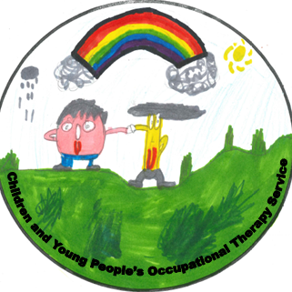



- Introduction

- What is Autism?
- Strengths
- How Common is Autism?
- Understanding a Diagnosis of Autism
2 Specific Differences & Helpful Strategies

- Language and Communication
- Visual Supports
- Social Interactions
- Flexibility of Thinking and Imagination
- Sensory support
- General calming strategies
- Sleep and bedtime
- Managing feelings
- Managing demands
3 Understanding and Managing Behaviour

- Understanding and managing challenging Behaviour
- Homework
- Transition and change
- Preferred behaviors
- Behavioral strategies

4 External Support

- General
- Social
- Financial

5 Resources
- Groups, Contacts and Resources in the Scottish Borders
- Local Supports in Lothian and Borders
- Parent Courses and Useful Resources
- Research and Guidelines
- Education
- Communication
- Financial Support
- Advocacy
- Carers
- Societies
- Self Help
6 Further Reading
- General
- Personal Experiences
- For Parents and Carers
- Siblings Understanding Autism
o For siblings aged 0 – 7 years
o For siblings aged 7-13 years
o For siblings ages 13+
- For autistic young people

Introduction

Your child has just been given a diagnosis of Autism.

Although this may leave you with mixed feelings, we hope it will allow you and those close to you to better understand and help your young person.
This booklet is aimed to try and help you all understand your young person, their diagnosis and how it may affect them in daily life. The information provided covers a wide range of differences, strategies and further information or support, to help you and others in your child’s life to understand them better.

What is autism?

The term Autism covers both autism and Asperger’s Syndrome, which previously were diagnosed separately. Autism is a lifelong developmental difference. Autism describes a particular way of processing the world and communicating with others. Although autistic people have this in common each person is an individual with their own unique set of strengths and their own areas of potential challenge.

Autism affects each person individually. Many adults live independently but others need support. In line with guidance from the National Autistic Society, we recognise the importance of using positive language when describing children and young people. We will use the following language - autistic child or young person. This guidance is based on language research on the preferences of autistic people, their families and professionals.
Some autistic people also have intellectual Disability and need specialist support throughout their lives. Others have average or above average intelligence. Whatever their level of learning or language, the core differences in autism will remain the same.
Autistic people tend to have differences or challenges with:
Social interaction and communication, such as the need for conversation to be two-way and also understanding what someone else may be thinking or feeling, including using and understanding non-verbal communication (e.g. facial expression, body language, tone of voice etc.).
Autistic people may have repetitive or restrictive routines which can be inhibiting and distressing for them or can help with increasing calm, structure and relaxation. The stress of daily life can impact on the emotional wellbeing of autistic people.
Autism can be a hidden difference. Those not familiar with or understanding of its effects on the daily life of the person can raise barriers and cause extra stress and discrimination without meaning to.

Strengths

All autistic people also have strengths. It is about finding and understanding these in the young person. You may already be aware of things they love or settings they thrive in. It is about using these strengths to encourage and support them to reach their potential.

Some examples include:

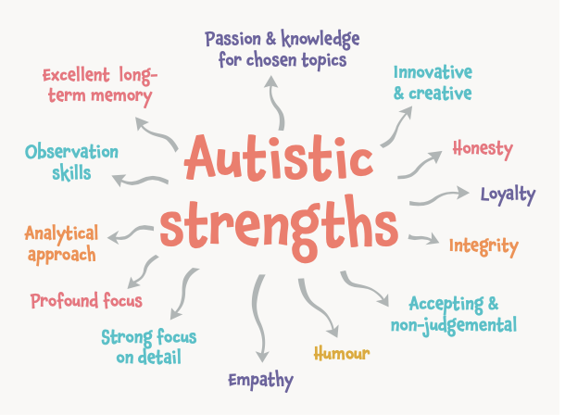

Your child may be particularly aware and receptive to an environment, which can lead your child displaying a number of strengths:
  - Likely to be a strong visual learner. As such the use of real objects, pictures, demonstrations and written material can all help with their understanding.
  - A good eye for detail and accuracy.
  - Once learned, information, routine or processes are likely to be retained.
  - Some can focus on their special interest for a long time and may choose to study or work in related areas
  - Sticking to routine can make autistic individuals’ reliable employees in an organised, structured environment.
  - Learning to read at a very early age (known as hyperlexia).
  - Memorising and learning information quickly.
  - Logical thinking ability.
  - May excel (if able) in academic areas such as science, engineering and mathematics as they are technical and logical subjects that do not heavily rely on social interaction.
  - Having an extraordinarily good memory (being able to remember facts for a long period of time).
  - Being precise and detail orientated.
  - Exceptional honesty and reliability.
  - Being dependable in regards to schedules and routines.
  - Having an excellent sense of direction.
  - Be very punctual.
  - Strong adherence to rules.
  - Able to concentrate for long periods of time when motivated.
  - A drive for perfection and order.
  - A capability for alternate problem solving.
  - A rare freshness and sense of wonderment.

How common is Autism?
The best current estimate would be 1 in 100 people in Scotland are autistic. A rate of around 90 in 10,000 people is the best current estimate. Of the 4,563,326 people living in Scotland, around 47,231 are thought to be autistic.
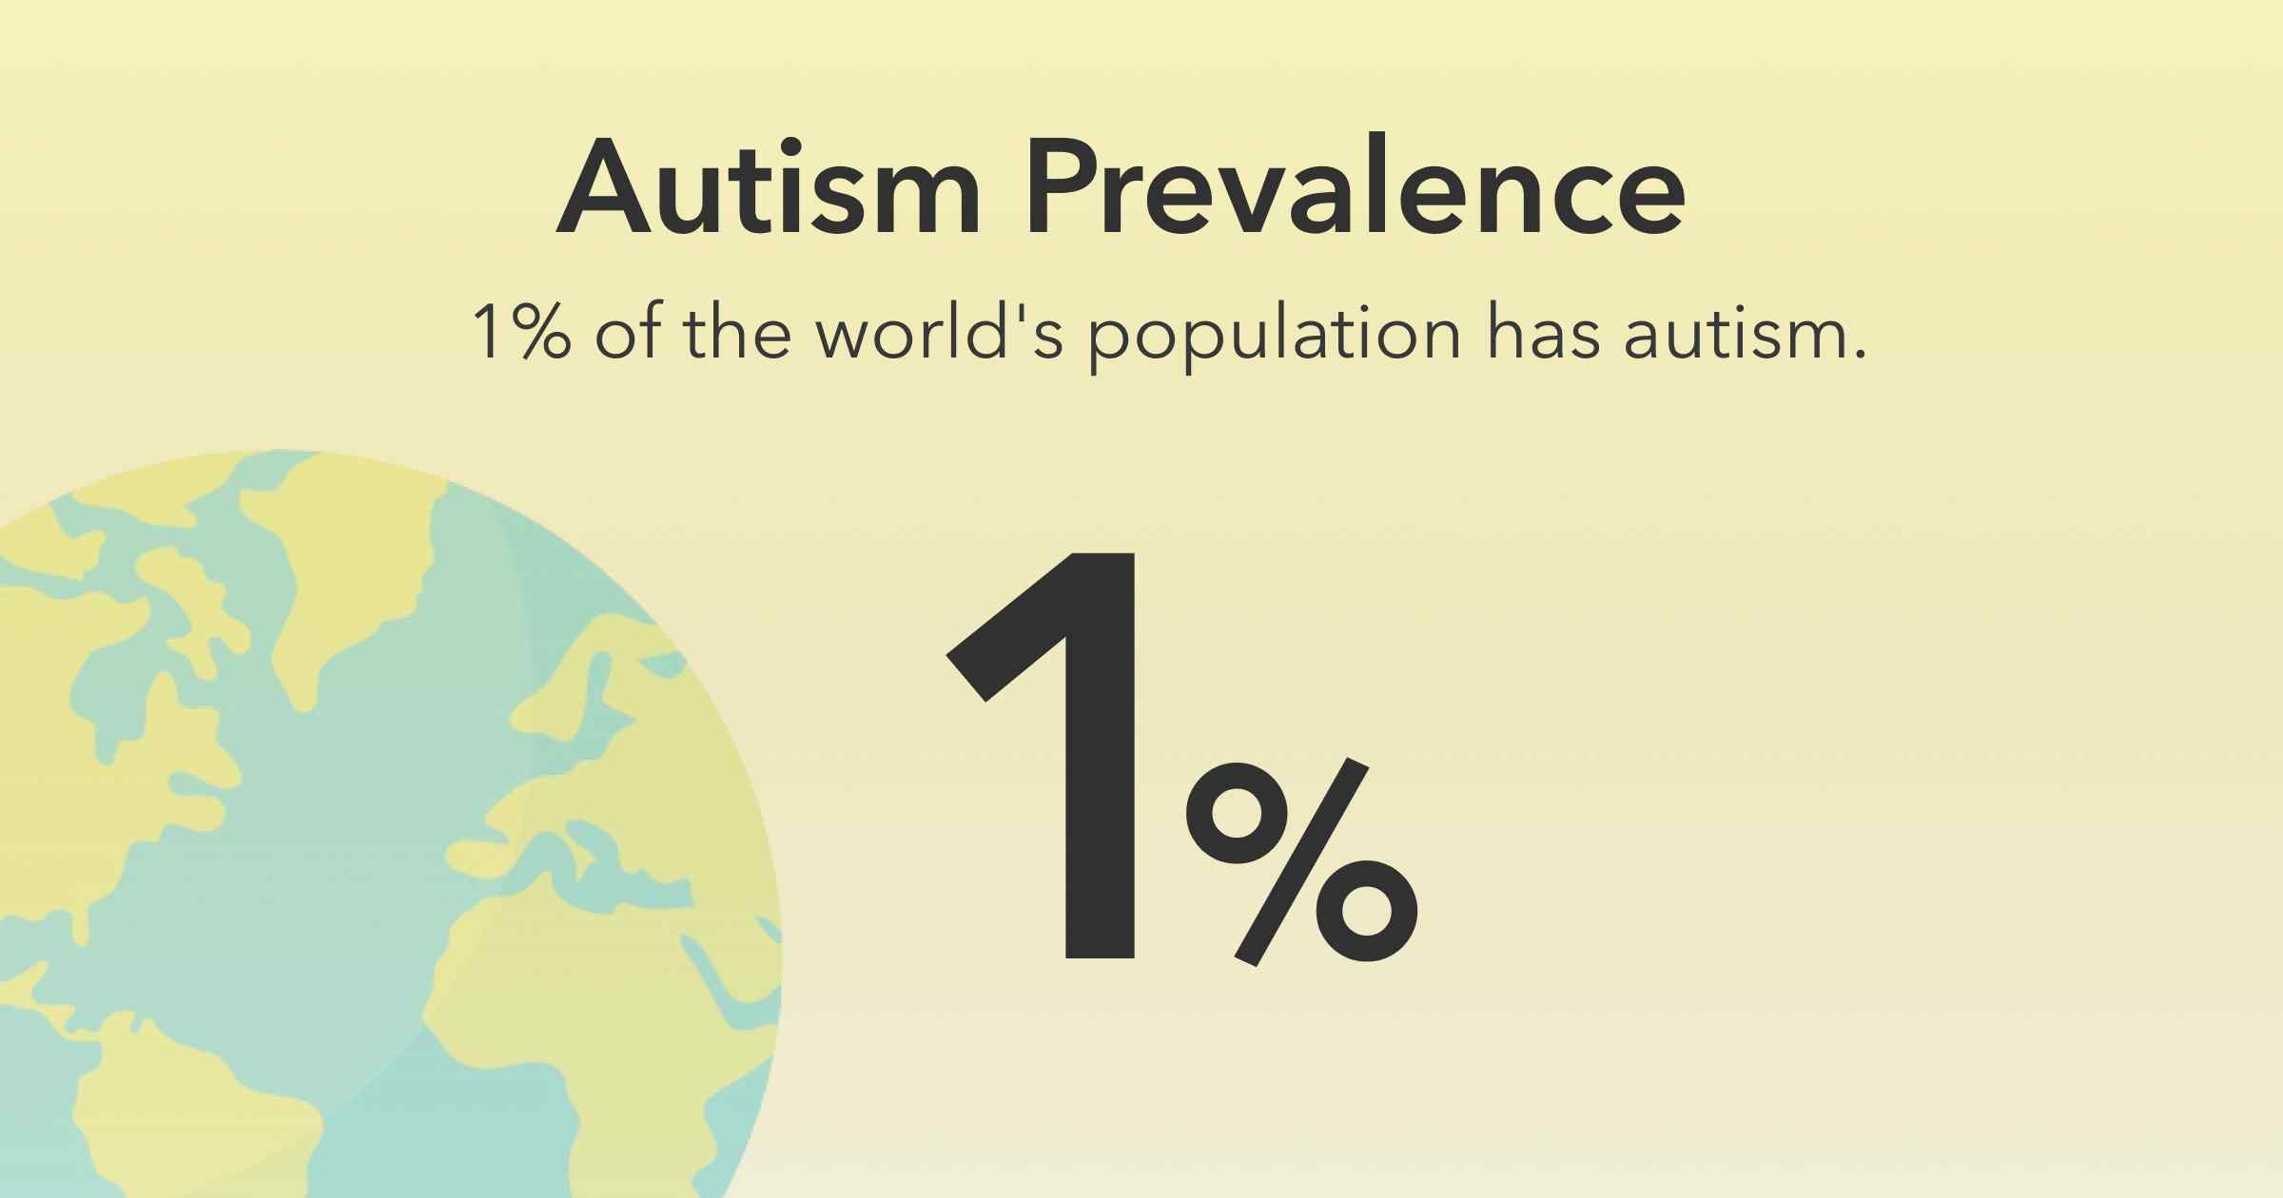

Understanding a diagnosis of Autism

No matter how well prepared you were for a possible diagnosis of Autism, when it becomes a reality, you may feel a whole variety of emotions. This is perfectly natural. But remember that your young person is still the same person.
In the period after diagnosis, parents/carers often concentrate on finding information and learning as much as they can to help the child. This is understandable as you want to do the very best for them. Having to grasp what this diagnosis means for your family, as well as meeting various professionals and learning ‘their language’, can be very daunting.
Families react in all sorts of ways and take varying lengths of time to come to terms with the diagnosis, and it is essential to help and support each other through this period.
Sometimes talking to others is helpful; sometimes parents/ carers may just wish to retreat to their own family home and shut out the world for a while. All these attitudes are OK.
Grandparents, close family and friends can often help and support you at this time, particularly if you have other children who need life to go on as before. However, depending on their age, your other children will probably be aware that there is a change in understanding so do need some explanation.
There are several helpful books written for siblings that will explain Autism in terms they can understand. You’ll find a short list in the Helpful Resources section of this booklet.
Many parents/carers have said that meeting other parents/carers who have gone through a similar experience can be very helpful. As well as giving emotional and practical support, they will be able to tell you about local activities.
Online support and information can be helpful for various reasons, including ease of access, speed of finding information and keeping in contact.

Specific Differences & Helpful Strategies

Autistic people experience the world in a different way to neurotypical people. All autistic people are individuals so not all of the examples below will be relevant to your family.


Your child may have some specific differences, which may be related to their understanding of particular types of communication and skills. The best way to reduce behavioural differences is by understanding their differences and any associated challenges. Understanding also increases confidence, once you understand autism the difference in thinking makes a lot more sense. This section aims to offer an insight into the differences you may have noticed in your child, as well as offering strategies that may be helpful in addressing these.

The examples given here will vary in importance between each person; your young person may have some, all, or very few of these differences.

Language and communication

One of the biggest differences of autistic children and young people is with language and communication. It may seem like they understand everything being said, but this may be because of a lot of other signals and clues, such as:
  - What usually happens at that time of day?
  - Your use of gesture
  - What other people are doing?
  - Cues in the environment (e.g. a swimming bag)
This can be likened to when we go abroad to a country whose language we do not know well – we rely on lots of extra cues. It is important to try to keep your language clear even if a child seems like they understand. Aim to avoid sarcasm and be positive when giving instructions; tell the child what they should do, not what they shouldn’t do, and say things in the order that they will happen.
Problems with communication can involve differences communicating with others, and understanding others. For example, this relates to using words and language flexibly and appropriately to the context or situation. It also means being able to understand other people's use of language, both verbal and non-verbal.
Your child may have differences in social communication, such as:

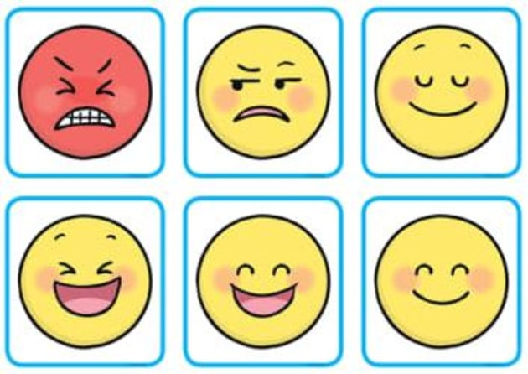
  - Have a difference understanding and use of gestures, facial expressions or tone of voice e.g. they may use their tone of voice in an unusual way or find it more difficult to use non-verbal communication such as eye contact.
  - Find it difficult to respond to questions and instructions, particularly longer instructions or question.
  - Have difference in starting and maintaining a conversation or engaging with ‘chit- chat’.
  - May understand things in a very concrete or literal way, which can make it difficult to “read between the lines” regarding understand sarcasm, jokes and common sayings.
  - Repeating words or phrases others have just said
  - Use complex words, but not understand their meaning
  - Talk about a special interest they have, not noticing that others do not share this interest
  - Difference understanding different viewpoints, new ideas and broad concepts

If a child has differences communicating, they are less able to communicate their needs. Challenging behaviour can be a way of trying to get their needs across to someone else. It may be a way for them to show they are confused, anxious, or upset about the situation.


Helpful Approaches:
  - Get the attention of your child before starting a conversation (for example, tap on their shoulder or say their name).
  - Reduce your language and use key words; reduce unnecessary words especially when they are upset.
  - Speak clearly and keep your sentences short
  - Allow time for them to process what you have said as there may be a delay in them making sense of what you have said. Try not to keep rephrasing your request during this time as this can cause them to become overwhelmed with copious amounts of information.
  - Say things in the order they will happen. Use "then" consistently to help them understand the sequence of events.
  - Tell them what to do rather than what not to do “walk!” rather than “no running!”.
  - Use pictures, symbols, gestures and actions to back up what you say verbally. Do not assume they have understood what you have said.
  - Pick up on their own use of language and look past the actual meaning of the words and think about what they may be trying to communicate to you e.g. are they anxious, worried, uncertain, or annoyed about something?
  - Try not to use humour or sarcasm unless you are sure that they understand or are in the right mood to accept this.
  - Be aware that your child may misinterpret or misunderstand the verbal information. Be aware of your child’s specific differences and how this may make them feel anxious, worried, confused, scared or frustrated.
  - Become a detective in working out what the verbal and non-verbal behaviour (e.g. body language) means to them and how they use it within interactions to communicate.

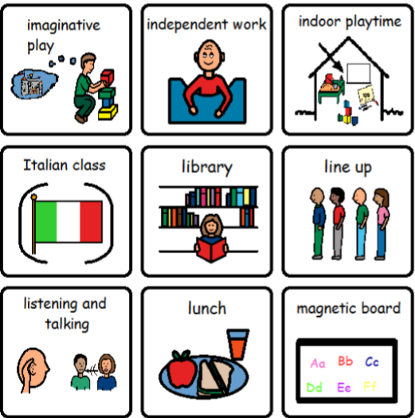
Visual Supports

A visual support refers to using a picture or other visual item to communicate with a young person who has differet understanding or use of language. They are adaptable, portable and can be used in most situations. Visual supports can be photographs, drawings, objects, written words, or lists. Research has shown that visual supports work well as a way to communicate. We see and use visual prompts every day, for example road signs, maps and shopping lists. They help us to function, to understand the world around us, and provide us with valuable information.

Visual supports are used with autistic young people for two main purposes. They help parents/carers communicate better with their young person, and they help their young person communicate better with others. Many autistic people are thought to be visual learners, so presenting information in a visual way can help to encourage and support their communication, language, and development. It can also promote independence, build confidence and raise self-esteem.

All autistic people can potentially benefit from using visual support, regardless of their age or ability. It’s an opportunity to communicate without complications.

Whichever visual support you decide to use, make sure it is tailored to the young person’s needs. Once you choose a type of visual representation (for example, line drawings), use it consistently so that the autistic person becomes used to it.
When it is time for an activity on the schedule to occur, cue your young person with brief, verbal instruction. For example, say “Check the schedule”. This helps your young person pay attention as the next activity begins.
When a task is completed, cue your young person to check the schedule again, using the procedure described above, and transition to the next activity.
Provide praise to your young person for following the schedule and for transitioning to and completing activities on the schedule. It may be useful to use a timer so that the young person is aware of transition times.

Basic visual symbols:



Happy OK Sad
Good Bad

Types of visual supports
Introduce visual supports gradually; it is best to start off with one symbol and then build up a collection.

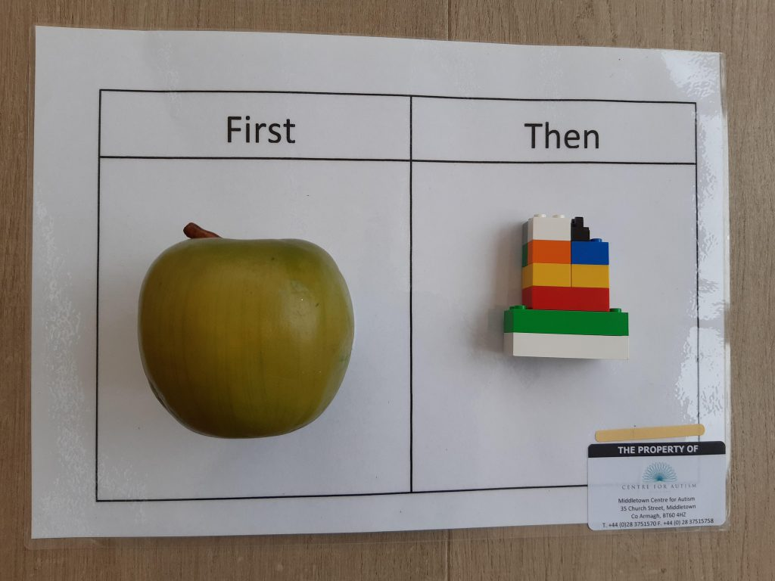
  - Real objects
  - Photographs
  - Written words

Areas where the use of visual support may help autistic people are:

  - Timetables/ schedules
  - Helping with sequencing
  - Transition and change
  - Starting and finishing activities
  - Introduction of new activities or situations – general knowledge, curriculum subjects, news
  - Instructions / reminders
  - Choice
  - Understanding emotions and expressions
  - Behaviour strategies
  - Social skills.

First-Then Boards

What is it?

A First-Then Board is a visual display of something your young person prefers that will happen after completing a task that is less preferred.
When is it helpful?

A First-Then Board is helpful in teaching autistic young people to follow directions and learn new skills. A First-Then Board motivates them to do activities that they do not like and clarifies when they can do what they like. A First-Then Board lays the foundation needed to complete multi-step directions and activities and to use more complex visual systems.
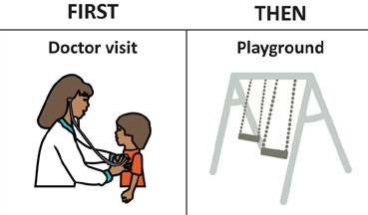

How do I teach it and use it?

Discuss with the young person what task you would like them to complete first (what goes in the “first” box) and the preferred item or activity (what goes in the “then” box) that your young person can have immediately after the “first” task is done. This preferred item/activity should be motivating enough to increase the likelihood that your young person will follow your direction.
Put the visuals on the board (e.g. photos, drawings, written words) that represent the activity you identified. Present the board to the young person with brief, verbal instruction. Try to use the least amount of words possible. For example, before beginning the “first” task, say, first put on shoes, then playpark when your young person is almost done.
When the “first” task is completed, refer back to the board. For example, say “all done putting on shoes, now playpark!” and immediately provide the preferred, reinforcing item or activity.
In order to teach autistic young people, the value of the First- Then Board, you must give them the reinforcing activity or item after they complete the “first” task. Otherwise, your young person may not trust the board the next time you use it.

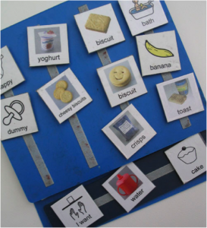
Other communication tools

Picture Exchange Communication System (PECS)

This approach is a behaviour-based intervention. PECS teaches a person to communicate their needs, wants and desires by exchanging a picture card for a desired item or activity. In time, the type and number of picture cards used by the person increases. This type of intervention should be provided in consultation with a speech and language therapist.

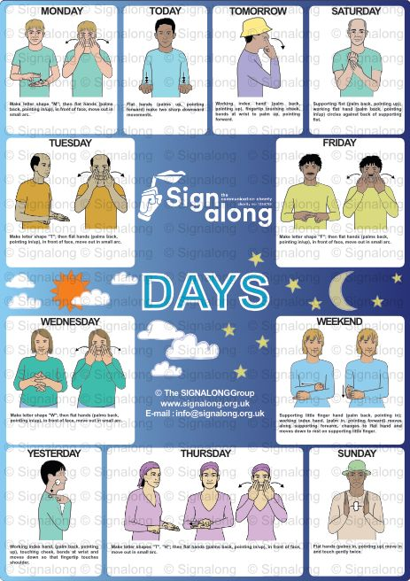

Signalong
Signalong is a sign-supported communication, based on British Sign Language, and designed to help people with communication differences, mostly associated with learning disabilities, autism and other additional support needs.

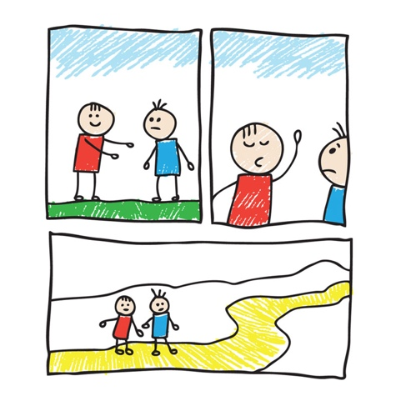

Comic strip conversations
Comic strip conversations are a way for people to exchange information and express themselves during a conversation. Colour, symbols, drawings and written words are used, alongside speech, to help people understand the ideas and emotions being expressed. These can also help people to understand past incidents or conversations.

Social stories
Social stories are short (written) descriptions of a particular situation, event or activity, to help autistic people to develop their understanding of relevant social cues and learn appropriate responses.

They include specific information about what to expect in a situation and relieve some of the anxiety around that situation. They can provide an autistic person with structure and guidelines for expected behaviour, and an idea of how others might behave in a particular situation. They can also introduce a new social skill. Social stories can be strengthened by using visual supports, such as symbols or illustrations.

You can use these simple stories as a tool to prepare the young person for a new situation, to address a problem behaviour, or even to teach new skills.

Social Interactions
Autistic people may have differences in the way they engage with others in a two-way social situations and social relationships. This relates to making sense of the social world we live in and understanding subtle social rules that we assume everyone is aware of e.g. what to do if someone says hello to you. They may not look for social interaction or contact or know how to take themes in a conversation. They may judge social interactions differently and break implicit ‘social rules’.
Social interactions also involve having an awareness of the needs of others, recognising and responding to others feelings and being able to empathise with others - putting yourself in their shoes and understanding how they may feel. Autistic individuals may have differences in these areas which may make social situations stressful because they may express themselves or interact with others in a different way which can lead to misunderstandings.
Having differences in making sense of the complexities of social interactions can result in challenges to developing and maintaining relationships. These differences may include:
  - May find it tricky to understand other people's emotions and feelings.
  - May have differences in their ability to expresses their emotions and feelings
  - May find it challenging to initiate and build relationships and friendships.
  - May be unsure of the 'social rules' for different settings and how to adapt to a variety of social settings
  - May be less likely to share activities or play with others.
  - May be reluctant or unsure of meeting new people or going into new environments
  - May find it challenging to recognise other people's emotions, likes, and interests.
  - Unsure how to or does not seek comfort from others.
As your young person may struggle to learn and understand complex social situations, they will need you to explain these rules, expectations and appropriate behaviours.


Helpful Approaches:
  - Try to make your feelings clear. If you feel happy, look and say that you are happy – teach them facial expressions.
  - Explain the boundaries and rules for a social situation and refer to them if needed (e.g. social expectations, saying hello to someone on the street).
  - Encourage the person to interact with others, for example, if they like computers, could they join a computer club?
  - Over time, help the person to develop social interaction skills, perhaps by practising situations at home or in school. A social worker, teacher or other professional may be able to help.
  - Help the person to understand and explain their feelings. For example, give your child their favourite toy and say, "This makes you happy."
  - Use stories as a way to explain appropriate ways of responding in certain situations.
  - Understand that some of their behaviours are a form of communication and are a way that they make sense of the world.
  - Encourage their understanding of situations by giving clear explanations about the reasons for people's actions.
  - Accept that the person may need some time alone.
Due to these differences, social situations can be overwhelming and stressful for autistic young people, especially as social rules become more complex. This can often lead to avoidance and behavioural reactions to this stress and anxiety.

Flexibility of Thinking and Imagination

Children with these differences may have challenges in everyday life - sorting out what to do when things change or coping when things go wrong. They may also have differences with attention, memory and organisation. Organising themselves and their environment may be difficult. Due to the differences they have, their behaviour may be challenging when they are faced with a situation they find hard to cope with.
Some of the challenges that your child may face in this area include:
  - Enjoys or requires structure and routine – becomes upset if routine is disrupted
  - Can find change difficult, especially without warning
  - May find it difficult to guess what other people are thinking or can misjudge what they are thinking
  - May have specific interests or passions
  - Prefers structures and routines and may be frustrated if others do not follow them
  - Can believe that others know what they know or cannot imagine what others may be thinking – referred to as “mindblindness”
  - May think in concrete and literal ways
  - Skills learnt in one situation may not be easily transferred or generalised to another context.
  - May understand time differently
  - Differences in understanding of sequences
  - Differences in linking events or actions – problems understanding cause and effect, for example – does not link behaviour with consequences
  - Can find changing from one task to another challenging
  - Some behaviours may be repetitive due to a need for sameness. This makes the world more predictable and so reduces a person’s anxiety
  - Differences in planning, setting goals and working out how to get a task started and how long it may take to complete
  - Differences in ability to reflect on past experiences to plan for the future e.g. making the same mistakes over and over
  - Differences in communicating details in an organised and sequential manner

  - Can miss important details, or, alternatively, become fixated on specific details and therefore may not appreciate the big picture
  - Differences in ability to retain information while doing something e.g. remembering a phone number while dialling
  - Differences in ease of picking up social cues
  - Differences with “working memory” (or “seeing in your mind’s eye”), which is an important tool in guiding one’s actions
  - May rehearse scenarios using different behaviours to assess outcomes

Behavioural reactions may happen when these differences impact your young person in a situation that leads to increased anxiety e.g. sudden and unpredictable change.

Helpful approaches:
  - Try to use repetitive behaviours constructively and incorporate the enjoyment of repeating the same action into everyday activities.
  - Structure the person’s day using a visual timetable, perhaps by using real photographs, pictures or a written/ visual timetable. These can be used to help explain changes and to work towards introducing flexibility and choices.
  - Prepare them for new or future events by making things concrete and clear e.g. photographs, symbols, social stories and visual sequences of what is likely to happen. Build in options for change and what the plan is if something can’t work e.g. if it is raining what are you going to do? How can you prepare for this?
  - Go over things in the order they will happen to help them organise this in their mind.
  - Provide clear and consistent boundaries e.g. only responding to repetitive questions 3 times. For example, explain and warn them of this and on the 4th time divert or distract their attention from this fixation and do not respond. This must be consistent.
  - They will benefit from everyone working with them in the same way. This will reduce their levels of anxiety, as they know what to expect.
  - Provide time when they can do their favourite activities.
  - Prepare the person for change by telling them about it in advance.
  - Make gradual changes.

  - Encourage the person to broaden their interests. For example, if your child collects chocolate wrappers, see if you can interest them in locating the countries where they are produced. This may lead to them learning more about the people and customs of different countries.
  - Help in developing these interests into hobbies, if possible. For example, if your child likes tearing paper, you could try teaching them paper folding or origami.
  - Provide opportunities to develop new or different interests. For example, if your young person likes water play, encourage them to learn swimming.
  - Provide fixed choice – option a or option b, as they may struggle to problem solve alone.

Support teaching problem solving strategies:

  - Help the child to identify what is the important goal.
  - Help them identify alternative ways to behave and when to use these.
  - Help them identify appropriate coping strategies e.g. using sensory tools or focusing on their passion to sooth distress
  - Help them recognise when to seek different behaviours and coping strategies.
  - Use flow charts and “planning paths” to map out how to reach their goals.

Use memory aids:

  - Prepare visual schedules e.g. checklists and review them throughout the day.
Use cues or strategies that help you remember the sequence of steps. For example, mnemonics are an example of a strategy or cue.

Sensory sensitivities

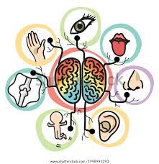
Our life is full of sensory experience. We respond to sensory information automatically often without realising that we are doing so; we touch, move, see, hear, taste and smell. We intuitively respond and interact with our environment. Sometimes we seek sensory information to make ourselves feel better (e.g. seek a cuddle).
Sometimes we retreat from sensory information if it makes us feel uncomfortable (e.g. very loud noises).
We all have different likes and dislikes when it comes to sensory experiences.
Autistic people can often experience sensory stimuli differently to neurotypical people.
Sensory stimuli may be challenging and sometimes, overwhelming. Autistic people may be over or under- responsive or have very strong reactions to sensory stimuli. This may then present in their behaviour as extreme agitation or distress in dealing with discomfort. Sensory responses can also bring joy and help with regulation.
By understanding an individual’s sensory preferences better, we can help to support them to manage situations that may be challenging for them. Preparing in advance for /or reducing exposure to a disliked or upsetting sensory experience may help the young person with the sensory sensitivities to feel calmer and be able to take part in daily tasks. It is important to recognise that differences in interpreting sensory information can have an impact on how we feel, how we think and how we behave or respond.

Reading the Signs: Sensory Strategies for Daily Activities
Becoming a detective can help you to better understand your child’s sensory preferences and how they respond to different sensory stimuli. This can then help you to support your child better when they are in environments that they find challenging.

Understanding your child’s sensory profile can also help you to choose the strategies that are likely to be the most effective in helping your child to regulate the amount of sensory information they need so that they can remain calm and do what they need to do in situations that may be challenging to them.
People know about the five senses but there are two other senses that help us make sense of all the information we receive. These are our sense of movement and body awareness.

We have great resources and videos online if you scan this QR code you can see:
nhsborders.scot.nhs.uk/cypot
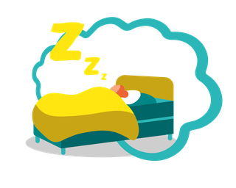
They include information on:
- Sensory integration
- Sleep
- Modulation and self-regulation

- Trigger zones
- Meeting your child’s sensory needs

Ideas and support for day-to-day activities:
- Bathing, showering and hair
- Haircare
- Nail care

- Out and about in the community
- Toileting
- Toothbrushing

General Calming strategies

Here are some suggestions and ideas of strategies that you may find are calming for your young person:

- Routines: Make a list or organise a specific routine. In particular after school or bed time routines will help to calm e.g. having specific places where important items are kept such as school bags. The more frequently you use a routine the more likely it is to become habit.

- Visual Supports: more information in visual support section above

- Environmental Checklist: consider the environment and what could be done to reduce possible triggers. The young person may be stimulated positively or negatively just by the environment around them e.g. light can be too bright or the room too noisy. Consider ways of changing the environment positively.

Outside the home
Playground equipment can be used to provide an area where a young person can play and have time out. Accessing local facilities may be more suitable at less popular times to reduce noise levels and distractions.
The following pieces of equipment can help the young person to have sensory experiences:


  - Swing, therapy balls, mini-trampoline or space hoppers for movement.
  - Sand and water pits for tactile experiences.
  - Play house or tent to provide a safe and calming area.
  - Small sheds in the garden to give a less distracting environment.
  - Soft play centres, ask staff when quietest time is.

Noisy, Busy Environments

  - Whenever possible, consider additional planning for special events such as firework displays, birthday parties, football matches. Is there a quick exit route if the young person becomes stressed? Is there a special toy/routine/contact that can be used to calm the young person?
  - Reflect on when to carry out everyday activities. Is there a quieter supermarket, off- peak time or on-line shopping? Is there a quiet space available e.g. dining booth?
  - Consider the wearing of snug clothing such as Lycra undergarments.
  - It may be useful to use earplugs or a music player with headphones, allowing the young person to listen to favourite songs/music. This may help to drown out environmental noises and help the young person stay focused on an activity.
  - A small toy to fidget with can help distract from other sensory input.
  - Pre warn them of noises you know they do not like and encourage helpful coping strategies e.g. cover their ears when there is a vacuum on.
  - Minimise clutter. Organisation tasks can be overwhelming
  - Be aware that they may have difference coping with being overloaded with sensory information when outside and you will need to plan for this.
Sleep and bedtime
Strategies to help children around bedtime
Anyone who feels wound up around bedtime might struggle to sleep. Children might have many worries around bedtime (e.g. being alone, niggles of the day).
- Reassure them that you are downstairs/in the house. Sometimes a picture map showing this can help.
- Explain how different family members have different bedtimes.
- Have time before bed when the child can talk over any worries.
- Certain oils. E.g. lavender added to bath water or bedcovers may aid relaxation
- Relaxation exercises, gentle massages and music tapes can also help.
Children typically respond well to routine and structures; they become familiar with the routine and can predict what happens next. It is important to consider timing when starting a new bedtime routine (e.g. not just before a family holiday when routines are likely to change). Bedtime routines are normally along the lines of teatime, followed by quiet play, bath and story and then being settled into bed with a goodnight phrase so the child understands that it is time to sleep. Bedtime routines need to be fairly simple with enough flexibility for all family members.

Videos and resources on sleep and support on this can be found by following these links or QR code.

www.nhsborders.scot.nhs.uk/cypot
www.facebook.com/CYPOTNHSBorders

Sleep diaries
A sleep diary can be useful to help parents/carers find out what triggers poor sleep behaviour and what seems to help. Sleep diaries can also be useful to help professionals understand the severity of a child’s sleep behaviour. Sleep diaries can also act as a visual incentive so the child can be rewarded if they stay in bed and try to sleep.
Create a relaxing and comfortable place:

- Make a child’s bedroom a safe, calm and pleasant place to relax.
- Do not use it as a place to send your child when they have been naughty.
- Try to separate out play and sleep areas.
- Some children are sensitive to light; black out blinds can make it dark. Others are afraid of the dark – a night light can help.
- Some children are sensitive to noise. Place the bed as far away from noise as possible. Other children might find gentle relaxing music helps them settle.
- For children sensitive to touch consider the type of fabric for sleepwear and bed covers.
- Ensure that they are warm enough but not too hot.

- Avoid too many stimulating toys and games e.g. video games, TV in the background. It helps to:
- Keep a regular bedtime for the child and wake them at the same time each morning.
- Limit day time naps.
- Make sure that they are not hungry at bedtime.
- To reduce the chance of the child falling asleep in the wrong place e.g. sofa it can help to keep them upstairs after bath time Avoid stimulating drinks and food high in sugar and additives.
- Avoid TV and computer screens, including tablets, phones or devices for up to two hours before bedtime – we say 1hr in clinic – yes 1hr, as the light from the screen disrupts a child’s normal sleep rhythm.
- Do not stay with the child in the bedroom until they are asleep, this way the child learns to settle themselves.
- Some children take time to settle themselves. Soft favourite toys can help offer the child comfort.
It is important to remember that it may take several weeks for a new routine to alter a child’s sleep patterns!

Managing feelings

Autistic children do not always find it easy to manage their feelings. They can become overwhelmed and feel unable to cope. An important skill to learn is the ability to monitor and manage their own emotions and behaviour, so that they can identify and respond appropriately to situations, which in turn increases independence and confidence. Possible strategies include:
- Relaxation – Relaxation approaches such as deep breathing, thinking positively, redirection to pleasant, calming activities such as taking a bath, listening to relaxing music, playing on a computer, having a swing or jumping on a trampoline can start to help someone manage their anxiety.
- Emotional regulation – Some autistic children may have different ways of managing emotions such as stress, anxiety and frustration, which can sometimes be expressed as outbursts of anger or aggression. It can help to identify the physical sensations that show they are becoming agitated and then to develop a range of alternative, more appropriate activities to help them calm down. These can include breathing exercises, counting exercises, going for a walk, listening to music, walking away from the scene or asking for help. The child should also be supported to develop the communication skills needed to show distress and ask for help.

Managing demands
- Some young people feel the need to control social interactions, and to ensure that everything is done on their own terms. Sometimes these responses are as a result of anxiety about the demands that they fear will be made of them.
- They can try to avoid everyday demands placed on them. They may do this by distraction attempts, or by refusing to speak or trying to drown out your voice with speech or singing. Young people do not choose to behave in these ways.
- To avoid these demands they may withdraw from situations or become disruptive.

Strategies

- Be consistent with rules and boundaries.
- Having rules written down so they can be referred
- Prioritise demands i.e. pick your battles.
- Examples of phrases to try: e.g. “I wonder if you know how to...?”, “I wonder how you do this; I can’t seem to work it out!”).
- Let the child think that they have come up with the idea (of what you want them to do).
- Use chatty language to disguise requests (e.g. Use props, phones, puppets, dolls and distance demands through them e.g. holding a puppet or phone and saying “I have a lot of things to do today, where shall I start?”
- Try to keep calm and level in your emotions
- Avoid confrontation as far as possible.
- Ignore unwanted behaviour where possible.
- Try not to take a young person’s reaction personally when disciplining them.
- Use the young person’s interest in adult roles, allowing them at times to teach you things.
- If a young person is using distraction to avoid an activity it is important to pay attention to the distracting behaviour but to remain focused on the task at hand.
- It is important to regularly monitor and check what the young person has taken in. It will help to go over this information a number of times and in different ways to ensure the young person has fully understood it.
- Remember that many unwanted behaviours are a result of anxiety rather than aggression and benefit from reassurance.
- Take time out before the young person has reached their tolerance limit.
- A specific strategy is likely to work one day and not the next, and so it is helpful to accept this and draw on a variety of approaches rather than just sticking to one.

3 Understanding and managing Behaviour

Understanding and managing challenging behaviour
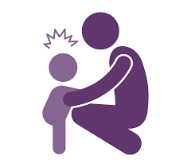
This section provides information about why autistic people might engage in challenging behaviour. It is important to first understand what is behind behaviour so that you can respond appropriately. Often this behaviour is your young person’s way of communicating something to you, such as asking for attention, refusing something, expressing a need or feeling. It may appear that your young person behaves inappropriately, however these behaviours may be because:
  - They are trying to communicate; behaviours are functional and have developed helpfully or unhelpfully to meet a need.
  - They may not understand the social rules.
  - They are feeling anxious, scared or frustrated as a result of differences understanding the situation, or perhaps experiencing sensory overload.
  - They enjoy a particular activity but may not understand its consequences. For example, a person may enjoy the sound of breaking glass but does not realise it is not safe or acceptable to break glass in public.
However, you may not know why your young person is behaving in a particular way. Below are some helpful strategies to help you think through why they may be responding in that way.
Helpful approaches:

  - Work with your child to develop clearer means of communication (e.g. use visual support).
  - Redirect the behaviour: for clapping their hands loudly, encourage them to play an instrument like drums.
  - If the person is anxious or upset, find a quiet place where they can calm down.
  - If you know there is an object that will help the child to calm down, such as a favourite toy, keep this to hand.
  - Provide alternatives where possible. For example, if the person does not like loud noises, give them earphones to wear when they are out and about.
  - Consider if there is a physical health problem e.g. earache or toothache
Working out the function of a type of behaviour will help to understand what your child is trying to communicate. You need to enter your child’s world and try to see the world as they do.
The cause of the behaviour could be:
  - Confusion or fear produced by unfamiliar events and situations.
  - Interference with daily routine or repetitive activities.
  - Differences in understanding explanations or instructions.
  - Lack of knowledge about how to behave appropriately.
  - Difference in communication of needs and feelings.
  - Sensory needs
  - Specific fears of situations or objects.
  - Pressure to do tasks

Homework
Autistic young people may have difficulties completing their homework. This may be because:

  - They can have differences in processing instructions and may not have been able to record their homework in class or have it recorded for them – it may be unclear what work needs to be done when they get home.
  - They can have a very rigid thought process and struggle to adapt to the change in working environment.

Transition and change
Many autistic people dislike change and rely on routine. It is important for autistic people to know when an activity or event starts and finishes, particularly when it finishes. Without this knowledge, it may be difficult and confusing for people to move on to another activity. Visual supports can be a good way of introducing changes, helping during periods of transition and perhaps helping people to become more open to the idea of change.

Starting to make changes

The best way to minimise the chance of difficult behaviour occurring is to anticipate it happening and take steps to avoid it if this is possible. Looking for any patterns in behaviour can often be useful to spot triggers and things that seem to help.

When thinking about dealing with a behavioural problem, it is worth focussing on one or two areas to change. Usually this is the type of behaviour that is most concerning or having the greatest impact on daily life. Some parents/carers find it helps to select something that may not be too difficult to start with so that you can feel more confident.

Consider the setting

Keeping the sensory environment quiet e.g. light and noise.

Use minimal language
When a young person is distressed, try to reduce the amount of language you use and the rate of your speech. It is likely that they will find it harder to take-in and process verbal information at these times.
Think about what you want the young person to do and communicate this in clear, short phrases. Try not to give choices until they are calm.

Moving on from difficult behaviour
Try to give them a ‘way out’ of the behaviour. Distract them on to another task and praise them when they begin to participate.

Managing upset
When there has been an outburst, autistic young people may have a high level of physical distress. It is well established that it takes anything up to 90 minutes to ‘cool off’ after episodes like these. The best tactic is to talk in a calm, reassuring manner, without trying to get them to explain why they acted in a certain way.

Reflecting on what has happened
Following a difficult situation, try to be a detective and identify the reasons why your young person may have become anxious or angry. You can look at some of the reasons why they become upset and to understand their behaviour in the context of Autism.
If you are able to do this at the time, your response may vary depending on what you think the underlying reason is e.g. if they are anxious about a new place, you may try to give them concrete information such as photos, maps or drawings to help them visualise what to expect.

Preferred behaviours
There are several ways to encourage the development of new skills by the way we respond to the young person. The following are a number of approaches that have been proven to be helpful:

  - Positive reinforcement – this means following behaviours with something positive like favourite activities, treats or objects or praise.

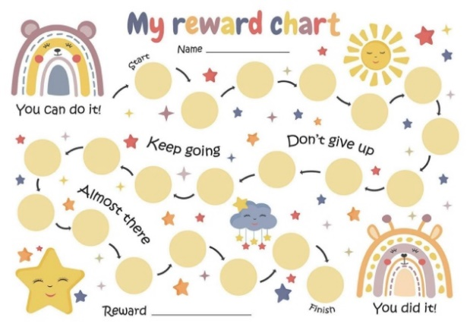
  - Rewards charts are an excellent way of demonstrating how well someone is doing, and reminding them what they’re working towards, a reward.

Behaviour Strategies

As well as introducing positive behavioural strategies, it is sometimes necessary to have a range of strategies available to respond to a behavioural incident or outburst. None of the following should ever be implemented on its own. If you need to use any of the following strategies, then you should also start to use the range of positive strategies on a regular basis at the same time.

We all use experience to work out how we are going to behave, if we find that we do something that brings about a good outcome, we will do it again, and we are more likely to behave that way in the future. This is human nature and it happens all the time. Similarly, if we find out that something we do does not bring about a favourable outcome, we are less likely to do it again. This principle gives us helpful ways of managing undesirable behaviour, one easy way of remembering this is:

IGNORE → DISTRACT → REDIRECT

These are best applied in the following ways:

  - Ignore the behaviour and still interact with your young person and distract them

When thinking about planned ignoring, it is important to be consistent. When you first try the strategy, your young person’s inappropriate behaviour will increase before it decreases. You may well think that everything is getting worse, but it is important not to give up. This increase in undesirable behaviour is called an ‘extinction burst’ and can be seen as your young person saying “This has worked for me before. Maybe I need to try harder to get the usual response.” Consistency is very important at this point, otherwise your young person will learn that increasing the behaviour will bring about the desired response and they may escalate to the same point the next time as well.

Planned ignoring can be used with a number of behavioural differences but it should never be used when there is risk of harm to the individual or others.

  - Redirect your young person’s attention to a preferred topic of conversation or activity can be effective in calming difficult situation.

  - Punishment does not work – This involves the use of an unpleasant response to reduce an undesirable behaviour and can include smacking, shouting or physical restraint. Lots of research has shown that this strategy does not work. It is not an effective way of promoting learning.


It is not effective because it does not address the root cause of the behaviour. It may reduce it in the short term, but often it will quickly be replaced by another undesirable behaviour because the cause has not been addressed. The only thing this teaches is that it is alright to be aggressive and can also lead to aggression in response to the person administering it. It also leads to a young person feeling bad about themselves and angry inside, which can then worsen their behaviour. Punishment is not a viable way of changing behaviour.

Useful tips to remember:

Take a break
Dealing with challenging behaviour can be highly demanding for parents and carers. All parents/carers need a break from caring for their young people from time to time – this is normal and healthy. Making sure that you have the energy to respond appropriately and to support an individual with challenging behaviours is one of the most important aspects of any intervention. Thinking about your own needs means that you will be better equipped to provide the best support possible to your autistic young person or family member.

Structure
  - Too much choice causes anxiety.
  - Environment must be structured, organised and predictable – this includes them knowing:
    - Where am I to be?
    - What am I doing?
    - How much do I have to do?
    - When will I know if I am finished?
    - What will I do next?
  - Offer clear breaks in between activities to unwind and relax.
  - Regular physical exercise tends to diminish aggressive behaviour and repetitive activities.

Clear rules and consistency

  - Have they understood?
  - Be consistent – make sure you follow through with what you say.
  - No surprises – always let them know ahead if there have been changes to plans.
  - Use language that is clear
  - Give plenty of warning.

Do not rely on verbal communication

  - Put it in writing.
  - Use plans and timetables, photos and pictures.

Recognise stress

  - Do not crowd or overload with information.
  - Allow personal space.

When supporting your young person

  - Make sure you have their attention.
  - Allow extra time for processing information.
  - Break the skills down into achievable steps to ensure success.
  - Use prompts to teach alternative behaviours.
  - Use their interest to teach a skill.
  - Reward success regularly and explicitly.
  - Short and brief verbal instructions.
  - Lots of praise.

4 External Supports

General Support
Getting it right for every child (GIRFEC)

GIRFEC is the national approach in Scotland to improving outcomes and supporting the wellbeing of our children and young people. The aim of the approach is to support families by making sure children and young people can receive the right help, at the right time, from the right people. The goal is to help them to grow up feeling loved, safe and respected so that they can realise their full potential.

The GIRFEC approach is child-focused, ensuring that children and families are at the heart of the decision-making process. Children and young people generally get the help and support they need from their family and community, but sometimes, perhaps unexpectedly, they may need a bit of extra help. Getting it right for every child helps families to access this additional support easily and without stigma. The approach supports families and practitioners to work together to identify and address needs early when they emerge. For more information, please check the Scottish Government GIRFEC webpage, available here: https://www.gov.scot/policies/girfec/

Wellbeing

SHANARRI is an acronym based on the 8 wellbeing indicators, which support children to grow up feeling lived, safe and respected.
These are: Safe, Healthy, Achieving, Nurtured, Active, Respected, Responsible and Included.
Thinking about these eight different indicators of wellbeing help make it easier for children and families and the people working with them to discuss how a child or young person is getting on at a point in time and if there are any needs or opportunities to promote wellbeing. Wellbeing must be considered within the wider context of the child’s life and what is or may affect their wellbeing.
Help With Travel

Autistic people can sometimes find travel or using public transport stressful or difficult, for example due to sensory sensitivities or unexpected changes to routine, such as a bus being late.

Travel providers can provide free support to disabled people, including autistic people. This help can be things like:
- The bus driver telling you which stop to get off at
- Having someone meet you and accompany you to or from your train
- Someone accompanying you to your ferry and keeping you updated on the journey
- Extra support to get through airport security

In some cases, you’ll need to book this in advance. To find out more, you should contact the provider you’re travelling with (for example, ScotRail, FirstBus or Border Buses). You can also visit the following website:
https://www.mygov.scot/transport-help/

Your child may be eligible for a Blue Badge if, because of their autism, they lack awareness of danger from traffic and therefore might risk the safety of themselves or others. Having a Blue Badge might also mean that you can get free transport on other services. Contact your local council for the full eligibility criteria and details of how to apply.

Social Support
Support from partners, family, friends or neighbours can be extremely important. However, help can sometimes also be requested from other services.
Social care involves different forms of personal care and other practical assistance for young people and adults who need extra support. Local Authorities have a legal duty to provide certain services to disabled people, which may include help with things like personal care. You should contact your local authority if you think that you or your young person need support in this way. Any support you receive will be based on an assessment of your family’s needs and should take account of your wishes and preferences.
Families of disabled children, including parents, carers, siblings and the wider family, might need access to practical and emotional support in their own right. If you care for an autistic child or young person, you may be entitled to support as an unpaid carer. Unpaid carers are eligible for support in their own right under the Carers (Scotland) Act 2016. This includes:
- the right for every carer to an adult carer support plan or a young carer statement which focuses on what is important to them;
- the right to statutory support to meet their eligible needs, as detailed in their plan or statement; and
- the right to be involved in assessing the needs of the cared-for person and in decisions about discharging the cared-for person from hospital.

Financial Support
Sometimes families can receive extra financial support or funding to help support their autistic child. Families can be eligible for a number of national benefits and tax credits, particularly if they are on low or single incomes.
In 2018, a Bill was passed through the Scottish Parliament. This Bill sets out a framework for the new Scottish Social Security System. The Bill also helps to transfer the eleven existing social security benefits, such as Disability Living Allowance and Personal Independence Payments, from the UK Government to the Scottish Government.
To find out more about the changes to Scotland’s social security system visit: https://www.socialsecurity.gov.scot/

To find out more about existing benefits and grants visit: https://www.mygov.scot/benefits/

Benefits also exist at local level to help with Council Tax, housing and health costs. Local Councils have Benefits Offices where individuals can visit or call to discuss their specific circumstances. You can find details of these on your local council’s website or visit the links in the Resources section at the back.
The Citizen’s Advice Bureau can also help you to find out what financial support you’re entitled to. Visit: https://www.citizensadvice.org.uk/scotland/
When you are applying for benefits, it is helpful to make a copy of any completed application forms before sending them. This allows you to refer back to exactly what was written if there is a query.
As well as benefits, there are many other types of financial support you may be entitled to:

- Your child may be entitled to a National Entitlement card, which is a national scheme that helps them to access various public services and facilities. It includes things like concessionary travel, access to leisure and library services and various discounts.
- You can apply for a CEA card (forms can be obtained from the cinema) which allows a companion to accompany an autistic person to the cinema for free and is accepted at 90% of cinemas nationwide (requires proof of certain benefits).
- Take A Break Scotland provides grants for short breaks for families and carers of disabled children and young people.
- The Family Fund also provides grants for low income families
- The Independent Living Fund (ILF) provides a Transition Fund to support young people aged 16-21 to enhance their independence.
- Contact can provide advice on benefits and financial support, including help with applying. You can call them on: 08088083555 or visit their website
- Turn2Us can provide advice and support about benefits

For links to the websites mentioned and for more information about where to find support, please see the Resources section at the back of this document

5 Resources

There is a wealth of information available on Autism, including books, videos and of course the internet. At times parents/carers can feel overwhelmed by it all and at a loss where to start, so the list will give a starting point for good-quality information.

Groups, contacts and resources in the Scottish Borders
ALISS: A Local Information System for Scotland
A national database which allows you to search for up-to-date information about groups and services in your local area, including advocacy, youth clubs, activity groups and advice and support services:
Web: https://www.aliss.org/

Autism Initiatives
Helps individuals and families learn methods to cope with Autism through skill development and personal growth.
Tel: 01896 755820
Address: 54 Ladhope Vale, Galashiels, TD1 1BT

Aberlour Options – Borders
Aberlour Options services are designed to make life easier for families where a child has a disability. They offer a variety of flexible support options for children and young people with physical and learning disabilities, including Autistic Spectrum Disorder.
Web: https://www.aberlour.org.uk/services/options-borders/
Tel: 01896 754 003
Email: Options.borders@aberlour.org.uk

BANG (Borders Additional Needs Group)
BANG is an outreach service for parents, young carers and disabled children with rare, complex and additional needs. Membership is free and open to any family living in the Scottish Borders with a child post or pre-diagnosis from the ages of 0-24. Our meetings and activities are for the whole family unit; parents, carers, siblings and grandparents
Web: https://www.bordersadditionalneeds.org/
https://www.facebook.com/BordersAdditionalNeedsGroup/

Borders Asperger's and Autism Group Support (BAAGS)
Tel: 01896 668961
Email: baagsmail@yahoo.co.uk
Address: 1 Cotgreen Rd, Tweedbank, Galashiels TD1 3SG

Interest Link
Provide a wide range of volunteer befriending support for people with learning disabilities ages 8+ and young people with autism aged 8-25, in the Scottish Borders. Support included 1:1 friendships, social groups and distance contact.
Web: https://www.interestlink.org.uk/

Meeting of Minds
A voluntary parent led support group, supporting households living with additional support needs.
Web: https://www.meetingofminds.net/
https://www.facebook.com/meetingofmindsscot/

Number 6
A service providing social opportunities and 1-1 advice and support for adults with high functioning Autism and Asperger’s syndrome in the Lothians and Scottish Borders.
Web : http://number6.org.uk/
Tel: 07570 953 331
Email : number6@aiscotland.org.uk

Occupational Therapy Service
A page to allow sharing and promotion of Occupational Therapy information within the Scottish Borders, specific to children and young people.
Web: https://www.facebook.com/CYPOTNHSBorders/

Wee Talk Borders
NHS Borders Children's Speech and Language Therapy Services with ideas for activities and resources.
Web: https://www.facebook.com/weetalkBorders/

Local Supports in Lothian and Borders
Pavilion Cinema
AUTISM friendly screenings shown on a monthly basis.
Web: https://pavilioncinema.co.uk/relaxed-screenings/

Edinburgh Leisure
Offers accessible swimming lessons and activities for children with additional needs.
Web: https://www.edinburghleisure.co.uk/activities/disability

Edinburgh International Airport
Can accommodate autistic children and ease the check-in and security-check process. Web: www.edinburghairport.com/prepare/special-assistance

Hearts F. C.
Season tickets available for autistic individuals either at a discounted rate or allowing a carer to attend for free.
Tel: 0333 043 1874

National Museums Scotland
Events and resources for autistic children and young people.
Web: www.nms.ac.uk/national-museum-of-scotland/plan-your-visit/support-and-resources-for-autistic-children/

Young Archaeologists Club
A muddy ten-week course held once a year. Book early as this is a popular group!
Email: edinburghyac@gmail.com
Web: http://www.yac-uk.org/clubs/edinburgh

Quieter Shopping Hours
Various supermarkets and shops offer quieter shopping hours with dimmed lights, no loud music or announcements and turning off noisy machinery. Check their social media pages/ website or ask in store to find out more information.

Parenting courses and useful resources
Scottish Autism
Scottish Autism ‘Right Click’ online courses for parents/carers of children with AUTISM. www.scottishautism.org/services-support/support-families/online-support-right-click

Beyond Autism
Beyond Autism offer a free course designed to introduce what autism is, and provide information on key topics.
https://www.beyondautism.org.uk/courses/an-introduction-to-autism-a-course-for-parents-families-and-carers/

EarlyBird
The National Autistic Society’s training programme for parents/carers of pre-school children with AUTISMs.
www.nas.org.uk/earlybird

Furture Learn
A free course to help understand more about autism, including diagnosis, the autistic spectrum and life with autism.
https://www.futurelearn.com/courses/autism

Open University
A free course from the Open University providing an introduction to autism and diagnosis.
https://www.open.edu/openlearn/science-maths-technology/understanding-autism/content-section-0?active-tab=description-tab

University of Derby
A free online course delivered by the University of Derby.
https://www.derby.ac.uk/short-courses-cpd/online/free-courses/understanding-autism-aspergers-and-adhd/

Useful Resources
Autism Initiatives Scotland
11 Granton Square, Edinburgh EH5 1HX
Web: http://www.autisminitiatives.org
Tel: 0131 551 7260

Autism Toolbox
An online resource developed to support the inclusion of autistic learners in Scottish Early Learning and Childcare settings, Primary and Secondary schools.
http://www.autismtoolbox.co.uk/

Autism Network Scotland
http://www.autismnetworkscotland.org.uk/

Contact Scotland
Scottish branch of a UK-wide charity which provides all sorts of information and advice to families with disabled children and young people:
https://contact.org.uk/scotland

Future Horizons Inc.
A good website for resources about AUTISM for families and professionals.
Web: https://www.fhautism.com/

National Autistic Society – Scotland
NAS is the largest UK organisation for people with autism and their carers.
Tel: 0141 221 8090
Web: www.autism.org.uk
Address: Central Chambers, 109 Hope Street, Glasgow, G2 6LL

Scottish Autism
Hilton House, Alloa Business Park, Whins Road, Alloa, FK10 3SA.
Tel: 01259 720044
Web: www.scottishautism.org
Email: autism@scottishautism.org

Sibs
UK based organisation which supports siblings of disabled people Web: https://www.sibs.org.uk/

Resources for Autism
Practical support for children and adults with autism
Web: www.resourcesforautism.org.uk

The Curly Hair Project
A social enterprise supporting people on the autistic spectrum and people around them.
Web: https://thegirlwiththecurlyhair.co.uk
The curly hair project is an organisation that helps people on the autistic spectrum and the people around them, founded by autistic author Alis Rowe. We use cool things like animated films, stories, comic strips and diagrams to make our work interesting and easy to understand. https://thegirlwiththecurlyhair.co.uk

Tony Attwood
Covers Asperger Syndrome and social skills:
Web: www.tonyattwood.com.au

Research and Guidelines
Sign Guideline 145
This guideline provides recommendations based on the assessment, diagnosis and interventions for autistic children, young people, adults and older adults. https://www.sign.ac.uk/assets/sign145.pdf

Autism Research Website
Research Autism is a UK charity dedicated to research into interventions in autism. They carry out independent research into new and existing health, education, social and other interventions.
https://www.autismresearchtrust.org

The Scottish Strategy for Autism
Scottish Government strategy for improving access to services and diagnosis for people with AUTISM, as well as research and training for people around them.
https://www.gov.scot/publications/scottish-strategy-autism/

Easy Read: https://www.pkc.gov.uk/media/32052/The-Scottish-Strategy-for-Autism-2011-in-Easy-Read/pdf/Scottish_Autism_Strategy_Easy_Read.pdf?m=636428858706930000

Supporting Disabled Children, Young People and Their Families Guidance
The Scottish Government has put together some guidance for families which contains national information about a variety of topics like financial support and where to find support in your community:
https://www.gov.scot/publications/supporting-disabled-children-young-people-and-their- families/pages/introduction/

Education
Enquire www.enquire.org.uk Helpline 0345 123 2303

Parentzone
https://education.gov.scot/parentzone/

Reach Scotland
Website run by Enquire to support young people with any issues they may be facing in education:
https://reach.scot/

My Rights, My Say:
Service run by Enquire to help support children and young people to understand their rights in education and to challenge things if they feel their rights aren’t being upheld: https://enquire.org.uk/myrightsmysay/

Communication

CALL Scotland
Scottish Organisation who provide support and information about technology and communication aids:
https://www.callscotland.org.uk

AUTISM-specific information: https://www.callscotland.org.uk/information/autism-spectrum- disorder/

Inclusive Communication
Website which provides information and signposting about inclusive communication: http://inclusivecommunication.scot/

Symbol Systems:
Below is a list of free symbol systems which you may find useful: https://mulberrysymbols.org/ http://www.tomorraccessibility.co.uk/bss.htm
These sites has some free resources available:
https://www.widgit.com/resources/index.htm
https://www.symbolsforall.org.uk/home/

Financial Support

Information on all benefits for disabled people:
Web: https://www.disabilityrightsuk.org/

Dial UK – Information and advice for people with disabilities:
Tel: 0808 800 3333
Email: helpline@scope.org.uk
Web: www.scope.org.uk/support/disabled-people/local-advice/

DLA applications and Carers Allowance:
Contact your local Benefits Agency or Benefits Enquiry Line Tel: 0800 121 4600

Family Fund Trust:
UK-wide charity who provide grants and funds to families with a disabled or seriously ill child or young person:
Web: www.familyfund.org.uk
Tel: 01904 550055

National Entitlement Card: https://www.entitlementcard.org.uk/what-nec

ILF Transition Fund:
https://ilf.scot/transition-fund/

Take a Break Scotland:
http://takeabreakscotland.org.uk/

Contact:
Web: https://contact.org.uk/
Tel: 08088083555

Turn2Us
https://www.turn2us.org.uk/

Local Council Benefits Offices:
Scottish Borders Council: https://www.scotborders.gov.uk/info/20000/benefits_and_grants

Encompass
A service that provides advice, information and support with payroll and employment to people enabling them to have more choice, flexibility and control of their own care.
Web: https://www.encompassborders.com/index.php/
Tel: 01896 759700

Advocacy
Scottish Independent Advocacy Alliance (SIAA)
Organisation which provides information about advocacy, as well as a database to help you find advocacy support in your local area:
Web: https://www.siaa.org.uk/
Tel: 0131 524 1975

Scottish Government Guidance on Advocating for Your Child
Webpage providing you with information to help you understand advocacy and some tips to
help you advocate for your child or young person:
Web: https://www.gov.scot/publications/childrens-advocacy-guidance/

Borders Independent Advocacy Service (BIAS)
A free, independent advocacy service open to anyone who lives or uses services in the Scottish Borders . They can help have your opinions heard and respected, and have your rights met.
Web: http://www.bordersadvocacy.org.uk/
Tel: 01896 752200
Email: info@bordersadvocacy.org.uk

Carers
Borders Carers Centre
Information, advice and support for carers in the Scottish Borders.
http://borderscarerscentre.co.uk/

Care Info Scotland
Organisation providing advice and support to carers: Web: https://careinfoscotland.scot/
Tel: 0800 011 3200

Coalition for Carers Scotland
http://www.carersnet.org/

Shared Care Scotland
National organisation providing support and information to carers. They also manage the Short Breaks Fund, which works to support unpaid carers to take a break from their caring role:
https://www.sharedcarescotland.org.uk/

Carer’s Scotland
https://www.carersuk.org/scotland

Minority Ethnic Carers of People Project
https://www.mecopp.org.uk/

Carer’s Trust Scotland
https://carers.org/country/carers-trust-scotland

Scottish Government Carer’s Charter
https://www.gov.scot/publications/carers-charter/

Societies

British Psychological Society (BPS)
St Andrews House, 48 Princess Road East, Leicester, LE1 7DR. Tel: 0116 254 9568
Web: www.bps.org.uk Email: enquiry@bps.org.uk

British Association for Counselling and Psychotherapy
(BACP)
Monday-Friday, 8.45am – 5pm
BACP House, 35-37 Albert Street, Rugby, CV21 2SG. Web: www.bacp.co.uk
Email: bacp@bacp.co.uk

Autism Services Directory
This is an online AUTISM-specific searchable data-base of autism services across the UK
Web: https://www.autism.org.uk/services/helplines/directory.aspx

Self-Help
The resources in this section offer information on developing life-tools to cope with stress, anxiety and low mood.

Scottish Borders based resources:
NHS Borders mental health and well-being resource
http://www.nhsborders.scot.nhs.uk/patients-and-visitors/our-services/children-young-peoples-services-directory/health-improvement-team/mental-health-and-wellbeing/

Helplines

Samaritans:
Open 24-hours per day, to offer emotional support if you want to talk to someone.
Tel: 0131 221 9999
Web: www.samaritans.org

Breathing Space:
Confidential phone line to help with worry.
Tel: 0800 83 85 87
Web: https://breathingspace.scot/

Self-referral Services

Living Life
An NHS telephone service, offering support self-help and CBT.
Tel: 0800 328 9655
Web: https://breathingspace.scot/living-life/

“Living Life to the Full” classes
A life skills course based on CBT techniques
https://llttf.com/

Get Set 4 Autism is run by Scottish Autism

This programme of support is available at any point in a family’s journey. Therefore offering pre assessment support to those whose children are on a waiting list for an autism assessment, but also post assessment support following an autism diagnosis.

Get Set 4 Autism | Scottish Autism

6 Further Reading

General
- A Mind Apart: Understanding Children With Autism And Asperger Syndrome. P Szatmar (2004)

- Cant Eat, Wont Eat: Dietary Differences And Autistic Spectrum Disorders. B Legge (2001)
- Emergence Labelled Autistic. T. Gradin (1986)
- Explaining The Enigma. U. Frith (2004)

- Through The Eyes Of Aliens: A Book About Autistic People. J. L. O’Neil (1999)

Personal experiences

- Eating an Artichoke. E. Fling (2000)
- George and Sam. C. Moore (2004)
- Martian in The Playground. C. Sainsbury (2000)
- Pretending To Be Normal. L. Holliday-Willey (1999)
- Autism And Me. R. Hoy. Vieo - 20 minutes. An 18-year old with autism explains what it’s like to have Autism.
- Rosie’s Story.23 minutes video. A young boy narrates the story of his young sister, Rosie, who has AUTISM.

For Parents and Carers

- A Treasure Chest Of Behavioural Strategies For Individuals With Autism. Fouse, B. And Wheeler, M (1997)

- Asperger Syndrome: A Guide For Parents/carers And Professionals. T.Attwood, (1997)
- Autism Spectrum Disorders: The Complete Guide. Sicile-Kira, C. And Grandin, T. (2003).
- Asperger Syndrome and Adolescence: Helping Preteens and Teens Get Ready For The Real World. T. Bolick (2004)

- Behavioural Concerns and Autism Spectrum Disorders: Explanations And Strategies For Change. Clements, John, and Zarkowska, Eva (2000).

- Calm Kids. Lorraine E Murray
- Caring For a Child with Autism. Ives, M And Munro, N (2002)
- Children with Autism and Asperger Syndrome: A Guide For Practitioners And Carers. Howlin, P. (1998).

- Encouraging Appropriate Behaviour for Children On The Autism Spectrum: Frequently Asked Questions. Richman, S (2006)

- Freaks, Geeks & Aspergers Syndrome. Luke Jackson
- How to Live With Autism and Asperger Syndrome: Practical Strategies For Parents/carers And Professionals. Williams, C. Wright, B. (2004).
- Ten Things Every Child With Autism Wishes You Knew. E Notbohm (2005)
- Transition Toolkit: A Framework For Amazing Change and Successful Transition Planning For Children And Young People With AUTISM. K. Boderick & T. Mason-Williams (2005)
- The Complete Guide To Asperger Syndrome T. Attwood, (2006)
- The Optimistic Child. M. E. Seligman (1996)

- Toilet Training For Individuals With Autism And Related Disorders: A Comprehensive Guide For Parents/carers And Teachers. M. Wheeler (1999)

- Topics in Autism. Siblings Of Children With Autism. A Guide for Families. Harris, S. L. (1994)
- Understanding And Working With The Spectrum Of Autism. W. Lawson (2001)

For siblings understanding Autism:

Siblings aged 0 – 7 years

- A book about what autism can be like. S. Adams (2009)
- Children with Autism: A booklet for Brothers and Sisters Davies J. (1993).
- Ian’s Walk: A Story about Autism. Lears, L. (1998)
- My Brother Sammy. Edwards, B. And Armitage, D. (1999)
- My Brother is Different. Gorrod, L. (1997)
- My family is different C. Brook (2006)
- My friend Sam: introducing a child with autism to a nursery school. L. Hannah (2007).
- My sister is different. S. T. Hunter (2006)
- Russell is Extra Special: A booklet for Children. Amenta, C. (1993)
- Since we’re friends: an autism picture book. C Shally (2007)
- Understanding Sam and Asperger Syndrome. C. Van Niekerk & L. Venter (2006)
Siblings understanding Autism:

Siblings aged 7-13 years

- Adams Alternative Sports Day. J. Welton (2004)
- Asperger Syndrome, the Swan and The Burglar. B. Boyd (2007)
- Asperger Syndrome, the Universe and Everything. K. Hall (2001)
- Blue Bottle Mystery: An Asperger Adventure. Hoopman, K. (2000)
- Buster and The Amazing Daisy: Adventures With Asperger Sundrome. N. Ogaz (2002)
- Can I Tell You About Asperger Syndrome? A Guide for Friends And Family. Welton, J. And Telford, J. (2003)

- Dannie’s Dilemma. C. Haldane & K. Jones (2008)
- Everybody Is Different: A Book For Young People Who Have Brothers Or Sisters With Autism.
Bleach, F. (2001)

- Friends Learn About Tobin. Murrell, D (2002)
- My Brother Has Autism. Campbell, K. (2000)
- The London Eye Mystery. S. Dowd (2008)
- Thomas Has Autism J. Powell (2006)
- Topics in Autism. Siblings Of Children With Autism: A Guide For Families. Harris, S. L. (1994)
- What Does It Mean To Have Autism? Spilsbury, L. (20002)

For siblings ages 13+

- I’m A Teenager, Get Me Out Of Here!: A Survival Guide For Teenage Siblings Of Young People With Autism. C. Brock (2010)
- Hangman. J. Jarman (2003)
- Haze. K. Hoopmann (2004)
- The Curious Incident of The Dog In The Night-Time. M. Haddon (2004).
- Truth or Dare. C. Rees (2000)

For young autistic people

- Amazing Things Happen: Amazing Things Happen! (youtube.com)
- Baj and The Word Launcher: Space Age Asperger Adventure In Communication. P. Viktor (2006)

- Caring For Myself: A Social Skills Storybook. C. Gast and J Krug (2008)
- Different Like Me. J Elder (2005)
- Everybody Is Different. Bleach, F. (2002)
- I Am Special: Introducing Children And Young People To Their Autistic Spectrum Disorders. Vermeulen (2001)

- I Have Autism – What’s That? K. Doherty, P. Mcnally & E. Sherrad (2000)

- Of Mice and Aliens: An Asperger Adventure. Hoopman, K. (2001)
- The OASIS Guide to Asperger Syndrome: Advice, Support, Insight, And Inspiration. Romanowski, B., Bashe, P. R., Kirby, B. L. And Attwood, T. (2001)

- The Red Beast: Controlling Anger In Children With Aspergers Syndrome. K. I. Al-Ghani (2008)
- The Survival Guide For Kids With Autism Spectrum Disorders (And Their Parents/carers). E Verdick & E Reeve (2012)
- When My Autism Gets Too Big! A Relaxation Book For Children With Autism Spectrum Disorders. K. D. Buron (2003)

For Children: Emotions and Facial Expressions

- Alfie Gives A Hand.Hughes, S. (1983)
- Big Brother, Little Brother. Dale, P (1999)
- I’ll Always Love You. Lewis, P. (2001)
- Not Now Bernard. Mckee, D. (1996)
- Oxford Reading Tree Books From Oxford University Press, Www.Oup.Co.Literacy/Oxed/Primary/Ort

- The Mr Men And Little Miss Books By Roger Hargreaves.
- Where The Wild Things Are. Sendak, M. (1998)
- Tuesday. Weisner, D. (1991)

Websites

Videos

- Amazing Things Happen: Amazing Things Happen! (youtube.com)
- ICAN
Children’s communication charity offering advice and guidance for parents/carers with concerns and questions about their child’s speech and language development.
31 Angel Gate (Gate 5), Goswell Road, London, EC1V 2PT Tel: 020 7843 2544
Web: www.ican.org.uk

- https://www.sheffieldchildrens.nhs.uk/services/child-development-and-neurodisability/autism-home/autism-support/teenagers-and-autism/
- https://youtu.be/dUbsyd8Fnyw

TV shows and films

- Geek girl
- A kind of spark

