https://www.ed.ac.uk/clinical-brain-sciences/research/epic-edinburgh-psychoeducation-intervention/epic-resources
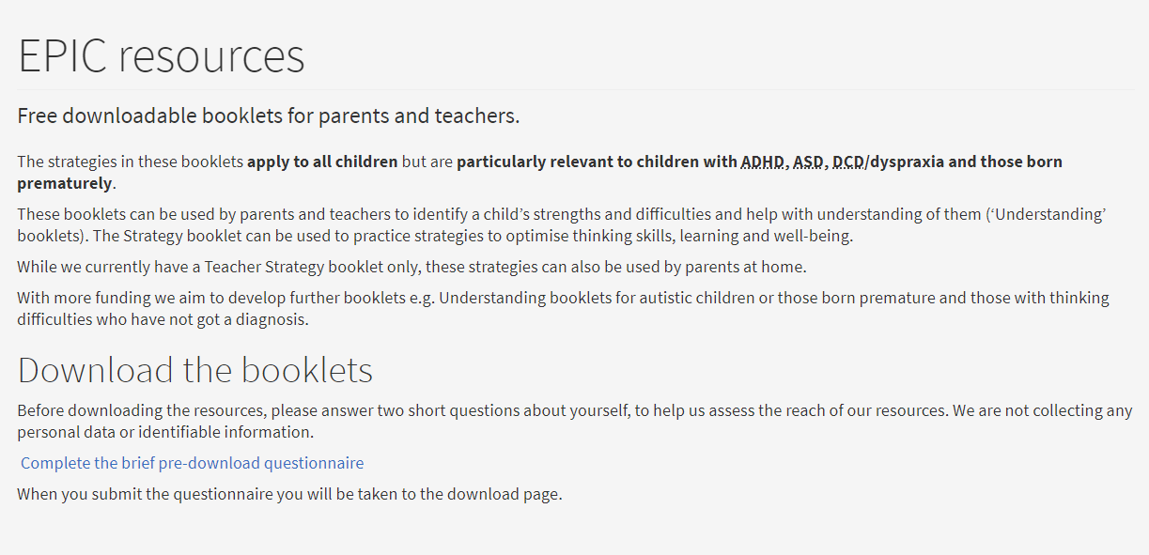
https://www.ed.ac.uk/clinical-brain-sciences/research/epic-edinburgh-psychoeducation-intervention/epic-questionnaire

