



CAMHS Resource List
Contents Page
General Mental Health Resources………. | Page 3
Online Support Services……………………. | Page 5
Abuse and Trauma…………………………… | Page 6
Bereavement…………………………………… | Page 7
Drugs and Alcohol………………………………. | Page 8
Eating Disorders…………………………………. | Page 9
Employment Support……………………… | Page 9
LGBTQ+…………………………………………… | Page 10
Mediation / Mindfulness/ Relationship Support……… | Page 11
Self-harm / Suicidal Ideation …………………………………………… | Page 11
Sleep……………………………………………….. | Page 12
Young Carers……………………………………. | Page 12
Youth Groups ………………………………….. | Page 13
Parent Resources ……………………………… | Page 15
Neurodevelopmental Supports…………… | Page 16
NHS Specific Services………………………. | Page 20
Other …………………………………………………. | Page 21

General Mental Health Resources
 | Localised school counselling service – TBC | 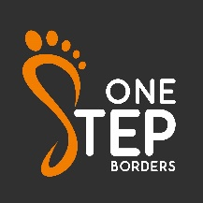  16-25 years   | One Step Borders  One Step Borders (Tier 2) support young people and their families in the Scottish Borders experiencing emotional and mental health pressures. They offer low intensity intervention to those suffering mild to moderate mental health issues and/or those at risk of developing them.  Phone: 03003110371 Email alex@onestepborders.info | 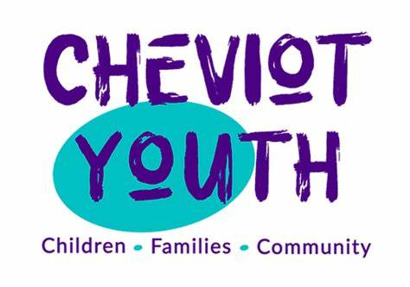  8 years +   | Cheviot Youth  Tier 2 and 3 service offering specialist group work and 1:1 for those experiencing mental ill health or who may benefit from emotional support. Hubs in Jedburgh and Kelso.  Accept self-referrals  Phone: 01573 228285 Email: info@cheviotyouth.co.uk
  16 years +   | Breathing Space  Breathing space is a free, confidential, phone and web chat service for anyone in Scotland over the age of 16 experiencing low mood, depression or anxiety.  Helpline number: 0800 83 85 87 |   Children, young people, parents   | YoungMinds  UK charity for children and young people's mental health. Their website contains lots of useful resources, support and help available to children, young people and their parents.  Parent Helpline: 0808 802 5544 (Mon-Fri 9.30am-4pm) | 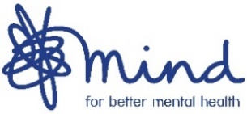  11-18 years   | Mind  Provide advice and support to empower anyone experiencing a mental health problem.  Phone: 0300 123 3393
  5-18 years   | Stable Life  Stable Life offer a variety of programmes which provide a safe, nurturing and learning experience using the horse and its environment to engage with young people.  Online referral from a variety of agencies or self –referral.  Phone: 01750 32277, Email info@stablelife.org.uk | 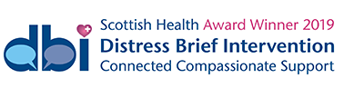  16 years +   | SAMH – DBI Borders  DBI – Distress Brief intervention works with individuals 16+ who are experiencing distress but do not need emergency support. It is a person-centred approach to encourage people to look at ways to self-manage; using tools and signposting to services that can offer longer term support, where required.  Phone: 01896 494025 |    | Nature Unlimited  Supporting wellbeing through person-centred activities in woodlands and other wild places, we aim to improve lives through meaningful and social activities in therapeutic natural environments, building resilient communities, connected to our beautiful natural resources  Phone: 07579 217794, online contact form
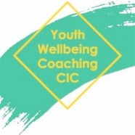  16-25 yrs   | Youth Wellbeing Coaching CIC | Facebook  Sessions are tailored to meet individual needs based on a combination of evidence-based approaches.  Also available:  Recovery coaching – young people in addiction  Drawing and talking – young people that have suffered trauma.  Email: info@youthwellbeingcoaching.com |    | Mindroom  We work directly with families, providing information, advice and one-to-one support  We support and advocate for children and young people under the age of 25  We help plan for transitions for secondary school pupils  Parents  You may wish to speak or message with our Family Advice Specialist a number of times, working through your concerns. For some, it may only be one call or message.  When enhanced support is needed, you may be referred on to our Family Outreach Specialists, who will create an individualised support plan with you to agree actions and outcomes | 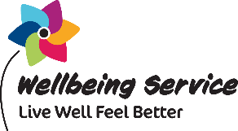  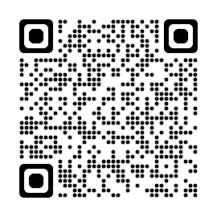 | NHS Borders Wellbeing Service  Provides low level (Tier One) support to people to help stop smoking (12+) and be more active (16+). People can self-refer or be referred by their GP/other health professionals.  Phone: 01896 824502  Email: wellbeing@borders.scot.nhs.uk
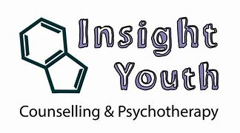 | Insight Youth  Counselling and Psychotherapy Free specialist support for individuals aged 8 – 25 Subsidised Access Scheme for over 25s Three clinical bases in Tweedbank, Kelso and Jedburgh  07394 562 716  enquiries@insightyouth.org |    | Health in Mind | Support and services (health-in-mind.org.uk)  We offer a pathway of services to support you with a range of mental health problems including anxiety, depression and the impact of trauma. We’ll walk alongside you as you build your confidence, connections and relationships.  We provide practical and emotional support to help you explore your mental health and wellbeing, achieve your personal goals and develop practical coping strategies. We’ll support you in a way and at a pace that feels right for you.  How we can support you  There are lots of ways you can access our services and support to suit your need and preferences. These include online; telephone; in person; individual; groups and digital.

Online Support Services
  11-18 years   | Kooth  Kooth is a digital mental health and wellbeing service available to all 11-18 year olds with no referrals, waiting lists or thresholds to meet. | 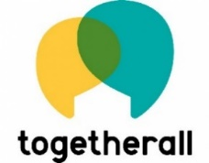  16 years +   | Togetherall  Togetherall is a safe, online community where people support each other anonymously to improve mental health and wellbeing.  Trained professionals are available 24/7 and there is a choice of safe therapeutic services, including online self-help courses. |   14 years +   | Silver Cloud  CBT program for teens to manage anxiety. Self-guided with support of an online guide.  Referral required from clinician.
  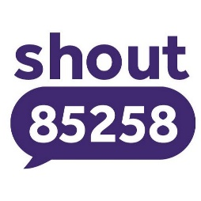 | Shout - UK's 24/7 Crisis Text Service for Mental Health Support | Shout 85258 (giveusashout.org)  Shout is a free, confidential, 24/7 text support service for anyone in the UK who is struggling to cope.  To start a conversation, text the word 'SHOUT' to 85258. Our trained volunteers are here to listen at any time of day or night, and messages won't appear on your phone bill. |    | Epic Friends  Epic Friends provides useful self-help tips, as well as guidance on listening skills to support people who are experiencing emotional issues.

Abuse and Trauma
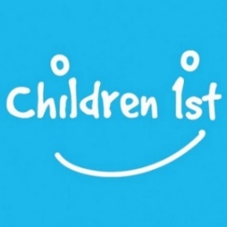   | Children 1st – Borders  Children 1st supports children in Scotland to live in safe, loving families and to build strong communities. As well as providing holistic family support and trauma recovery, they work with children, young people and their families to uphold and progress their rights and to strengthen and improve the systems that are there to support them.  Parentline: 08000 28 22 33.  Online chat service | 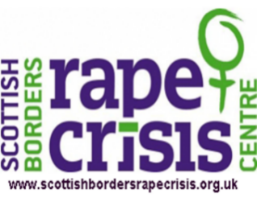  12 + years   | Scottish Borders Rape Crisis Centre  Scottish Borders Rape Crisis Centre offers practical and emotional support and information to all women and girls over 12 years old in the Scottish Borders who have experienced rape or sexual violence at any time in their life. Services are LGBT inclusive.  Phone: 01896 661 070, Email: support@sbrcc.org.uk  National Helpline: 08088 01 03 02 | 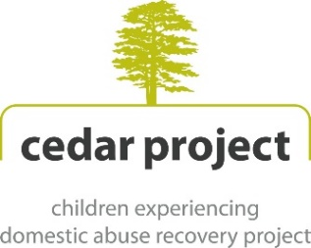  4-16 years old   | About Cedar – Cedar Network  Children Experiencing Domestic Abuse Recovery (CEDAR) is an innovative project for children and young people who may be experiencing difficulties as a consequence of domestic abuse.  Provide a therapeutic 12-week group work programme for children aged from 4-16 years old.  Phone: 01835 824000, Email: cedar@scotborders.gov.uk
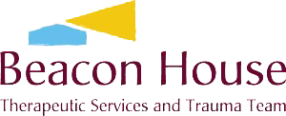   | Beacon House  With a special interest in working with those who have experienced trauma and loss, we are passionate about offering therapies in a way that enables people to re-build their lives. We support individuals and teams to develop their trauma informed practice through training, supervision and consultation. Online reources.  admin@beaconhouse.org.uk |   16 years +   | Survivors Unite  We provide dedicated, skilled, compassionate and flexible sexual abuse recovery support to adult survivors of childhood sexual abuse in the Scottish Borders through the provision of the Safe Oaks Project.  Phone: 07398 286695, email Projectcoordinator@survivorsunite.onmicrosoft.com & online contact form | 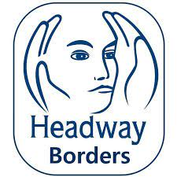   | Headway Borders  We offer a relaxed atmosphere for peer support, where people who have survived Acquired Brain Injury, carers or family members looking for understanding, support or companionship.  Phone: 07726560688, email info@headwayborders.com
  5 – 26 years   | Kibble  Kibble supports at risk children and young people across the UK. Many of the young people we care for have experienced significant trauma in their lives and Kibble offers dedicated care and support to help them move forward. This includes residential and community support, as well as dedicated schools and wellbeing services.  Phone: 01418890044, email: referrals@kibble.org |    | SBC Domestic abuse services  Domestic abuse support services in the Scottish Borders. | 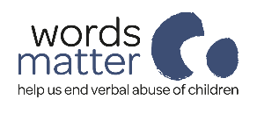   | WordsMatter  Words Matter is an ambitious new charity on a mission to improve children’s mental and physical health and development by helping to end verbal abuse of children by adults around them. They provide resources for adults, parents, teachers, and people who have experienced verbal abuse.  T: 020 3642 7737  E: hello@wordsmatter.org

Bereavement
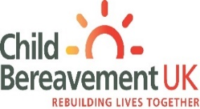  Up to age 25   | Child Bereavement UK  Support grieving children and families. Support children and young people (up to the age of 25) when someone important to them has died or is not expected to live, and parents/ wider family when a baby or child of any age dies or is dying.  Support groups for families/ young people/ parents.  Helpline: 0800 02 888 40  Email: helpline@childbereavementuk.org |  |    |  | A national, multi-professional federation of organisations and individuals working with bereaved children and young people. Support for a child or young person who has been bereaved, can be obtained by searching the online Directory of local and national 'open access' services from their website.  Phone: 020 7843 6309, Email: cbn@ncb.org.uk |  |    |  | Winston’s Wish  Provides specialist child bereavement support services across the UK. Winston’s Wish provides emotional and practical bereavement support to children, young people and those who care for them. Expert teams offer one off and ongoing bereavement support and also provide online resources, specialist publications and training for professionals.  Helpline: 08088 020 021, Email: ask@winstonswish.org
   | Children who are Bereaved – NHS Scotland  Advice and resources to help parents understand their child’s bereavement |  | 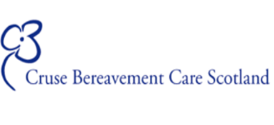   |  | Cruse Scotland Bereavement Support  A national service offering bereavement counselling, listening services, information, advice and training.  Helpline: 0808 802 6161 |  | 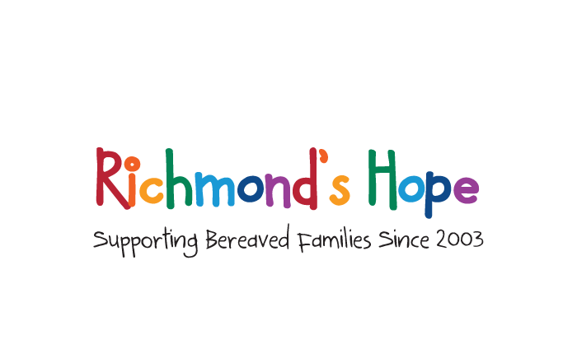   |  | Richmond's Hope  Provides support for Children and Young People aged 4-18 years who have been bereaved. They offer one-to-one, family, and group support with individualised programmes of care. Based in Edinburgh, Glasgow, Dunbar and Fife.  Phone: 0131 661 6818  Email: info@richmondshope.org.uk

Drugs and Alcohol
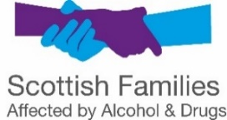   | Scottish Families Affected by Alcohol and Drugs  We a national charity that supports anyone concerned about someone else’s alcohol or drug use  Local support service.  Helpline: 08080 10 10 11 |  |   16 + years   |  | We are with you  Free and confidential support to people aged 16 years + who are worried about their own drinking or drug use, or someone else’s.  Phone: 0800 028 6664 & Online chat service  Galashiels office: 01896 757843 |  | 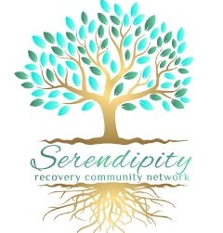  16 + years   |  | Serendipity  Recovery Network supporting community members in recovery from drug, alcohol, other addictions (gambling and eating disorders).  Support through peer to peer recovery cafés held in Galashiels.  Email: serendipity.rcn@gmail.com
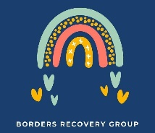  16 years +   | Borders In Recovery  Borders In Recovery is a Lived Experience Recovery Community and a member of the Scottish Recovery Consortium. Recovery communities offer recovery support, meaningful activities, socialisation opportunities and health and wellbeing activities as well as many other leisure and personal development opportunities.  Email: community@bordersinrecovery.org |  |   16 years +   |  | Talk To Frank  Offers honest information about drugs, as well as support and advice for those concerned about themselves or others in relation to drug use.  24/7 Phone line:  0300 1236600  Text: 82111  Email: frank@talktofrank.com |  |    |  | Caffeine and Energy Drinks (ADEPIS)  Information sheet for adolescents about caffeine and where it can be found and the effects of caffeine.
 | Re-think your Drink! - Lancashire County Council  These resources have been devised by young people from Lancashire Youth Councils and Lancashire's Young People's Health and Wellbeing Board (PULSE). The pack contains open access sessions for use in informal settings and a session for use within schools.  The activities may be delivered as part of a wider PSHE programme of study covering substance use, risk taking behaviour, healthy lifestyles or as standalone activities. The intention for the open access sessions is that they may be delivered by both professionals and peer mentors. The aim is to improve the knowledge, attitudes, behaviours and health literacy of children and young people around energy drinks. |  |    |  | Fast Forward  Fast forward is a force for change, supporting you people to make informed decisions about risk taking behaviours.  Their aim is to enable children and young people to make informed decisions about their health and wellbeing, through the lens of risk-taking behaviours.  We identify and deliver work that is informed by the lived experience of young people.  Telephone: 0131 554 4300  Email: admin@fastforward.org.uk

Eating Disorders
  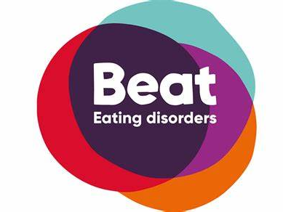 | BEAT  The UK’s eating disorder charity.  Support, helplines, 1:1 chatrooms and resources  Helpline: 0808 801 0432 |  |  |  | Endeavour - ARFID carer support group  Endeavour is a peer support group for parents and carers of children and young people aged 5-15, with an ARFID (Avoidance/Restrictive Food Intake Disorder) diagnosis and/or displaying ARFID behaviours and presentations.

Employment Support / Money Advice / Homelessness
  16 + years   | R-Evolve  Offer training and skills (relating to bike and metalwork) aiming to increase employment prospects for young people in the Scottish Borders  Referrals: Through pastoral/guidance teacher (school attenders). Contact through website for non-school attenders.  Phone: 0131 208 1892 |  |   16 – 25 years   |  | Works+  Employability project based in Galashiels, working mostly with unemployed young people aged 16-24. Also provide early intervention support to young people still attending school where required.  Self-referral via website.  https://www.facebook.com/works.plus.scottishborders  Email: enquiries@worksplus.works |  | 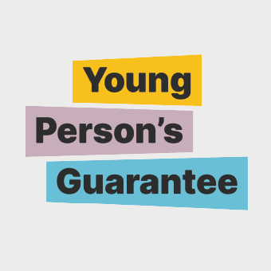  16 – 25 years   |  | The Young Person’s Guarantee  The Young Person's Guarantee is a commitment to bring together employers, partners and young people. It aims to connect every 16 to 24-year-old in Scotland to an opportunity. This could be a job, apprenticeship, further or higher education, training or volunteering.
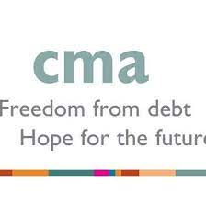   | CMA Hope Borders  CMA Hope Borders exists to provide money advice and support to anybody with financial difficulties, irrespective of age, disability, sexual orientation, faith or ethnic background.  Phone: 01743 341929, email info@communitymoneyadvice.com |  |  |  | SBC Homelessness Support  If you are homeless or facing the threat of homelessness within the next two months, you must contact Homelessness Services and ask to speak to the duty officer.  We have a responsibility to provide you with housing information, advice and assistance in accordance with the Housing (Scotland) Act 2001.  Phone: 01896 661385 |  |  |  | Developing the Young Workforce (DYW)  Bring a career to life – if a young person interested in a specific career Helen can bring the businesses into school. Organised events in school and classes.  Via pastoral teacher  Knock on door – Helen in school Wednesday and Thursday, I share a room with SDS so unable to have meetings in my room but can meet elsewhere.  Email Helen: hphillips@dywborders.co.uk
   | Corporate - Skills Development Scotland  Careers advice and guidance  via email – Julie.pollock@sds.co.uk

LGBTQ+
  13 – 25 years   | LGBT Youth Scotland  Scotland’s national charity for LGBTI young people, working with 13–25 year olds across the country offering support, information or advice.  Email: info@lgbtyouth.org.uk.  Online chat service |  |   13 – 25 years   |  | Involved  The LGBT Youth Scotland group in the Scottish Borders for all LGBTQIA+ young people aged 13-25. Group meets every Wednesday 4.30pm-6.30pm.  Referrals / self-referrals for 1:1 conversations.  Email: info@lgbtyouth.org.uk |  |  |  | Top Tips for Trans Inclusion - LGBT Youth Scotland  A resource for your youth work service to help make trans and non-binary young people feel safe and welcome.  This resource was created in partnership with Healthy Respect, LGBT Youth Scotland, Lothian Association of Youth Clubs (LAYC) and the Wester Hailes Youth Agency.

Mediation / Mindfulness/ Relationship Support

   | Relationships Scotland  Relationships Scotland’s network provide relationship counselling, family mediation, child contact centres and other family support services across all of mainland and island Scotland. Our work supports individuals, couples and families experiencing relationship difficulties.  Phone: 01721 724170, Email: info@rsborders.org.uk |  | 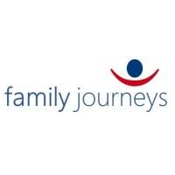   |  | Family Journeys  Family Journeys provide non-judgemental and affordable support for all families in crises from separation, especially when there is conflict. They help families recover by restoring strong family connections and help to create stronger attachments between children and their mums and dads through development of relationship skills.  Phone: 0131 322 3863, Email: info@familyjourneys.scot

Self-harm / Suicidal Ideation
   | NHS Borders self-harm leaflet |  | 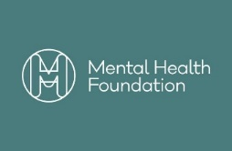   |  | The truth about self-harm (booklet)  For young people, their friends and their families  Information from the National Inquiry into self-harm among young people. |  | 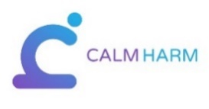  13+ years   |  | Calm Harm (app)  Self-harm app developed for teenage mental health. The app provides some immediate activities and techniques to help break the cycle of self-harm behaviour and explores underlying triggering factors.
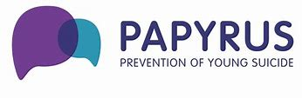   | Papyrus Prevention of Young Suicide  HOPELINE247 · For children and young people under the age of 35 who are experiencing thoughts of suicide · For anyone concerned that a young person could be thinking about suicide  0800 068 4141 (HOPELINE) [24/7]  Email: pat@papyrus-uk.org  Text – 07860039967

Sleep
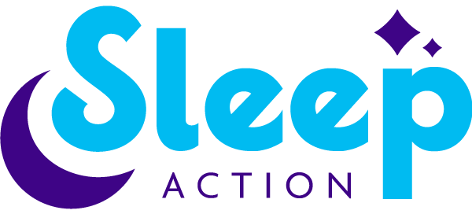   | Home - Sleep Action  Sleep Action work with professionals, families and employers to promote healthy sleep for everyone. They provide work with professionals, families and employers to promote healthy sleep for everyone.  Email: enquiries@sleepaction.org |  | 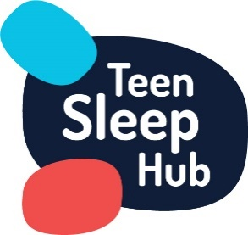   |  | Teen Sleep Hub  Offer advice on how to sleep better, tips on tweaking routine or help to understand the science behind sleep patterns. A range of advice and resources for young people, teenagers and parents.  Free e-books available for download |  | 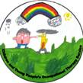 |  | Occupational Therapy Service  For any concerns in relation to a child/ young person’s, functional skills, please consider exploring the information & resources available on the website of the Children & Young People’s Occupational Therapy Service, which includes contact details for Requesting Assistance.  www.nhsborders.scot.nhs.uk/cypot

Young Carers

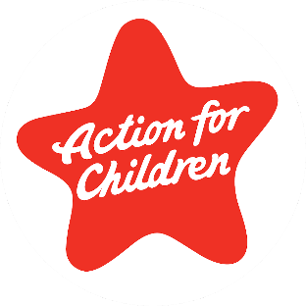  7-18 years old   | Action for Children – CHIMES  CHIMES supports young carers who are providing care and support to parents, siblings, or a family member who has a physical or mental health illness/disability, or substance use issue.  Phone: 01896 750173, Email:  ask.us@actionforchildren.org.uk |  | 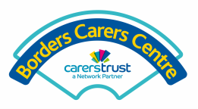  18 – 25 years   |  | Borders Carers Centre  Offer support to Young Adult Carers (aged 18-25 years) to access Carers Support Plan and mental health support, advice and advocacy. They also source ‘time out’ opportunities where required.  Phone: 01896 752431, Email: admin@borderscarers.co.uk

Youth Groups
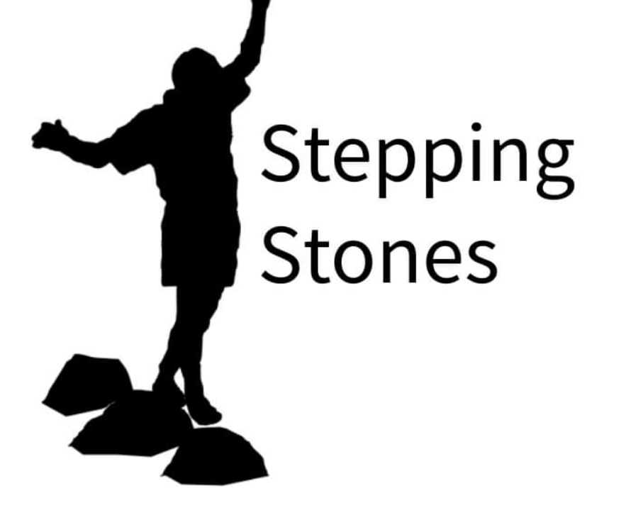  10 – 18 years   |  | Stepping Stones  A partnership youth work project that supports young people in the Scottish Borders, with the aim of improving emotional health and wellbeing, and life chances.  Project Workers support young people to develop skills through non-formal education activities within a universal youth work setting.  Phone: 01896 808 968 |  | 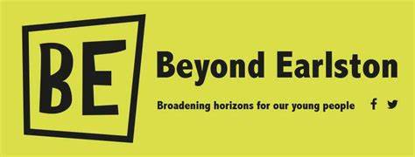  11 – 18 years  (P7- S6)   |  | Beyond Earlston  A charity based in the Scottish Borders providing a variety of activities (within catchment area) to young people irrespective of gender or ability.  Phone: 07522513728 Email:admin@beyondearlston.org.uk |  | 8 – 18 years |  | Cheviot Youth  Cheviot Youth runs a range of clubs and drop-ins throughout the Cheviot area. At the moment we run youth work activities at these drop-ins and clubs in Ancrum, Jedburgh, Kelso and Yetholm  Email: info@cheviotyouth.co.uk
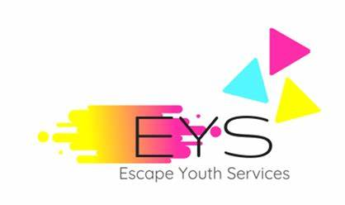  8 – 18 years   |  | Escape Youth Services  Escape is a drop-in facility for young people in Hawick and the surrounding area providing a safe and fun environment for young people to meet, creating opportunities and supporting development. They offer a wide variety of activities including creative media, games, sports, music, arts, baking and cooking, interest groups, issue-based sessions, excursions and residentials.  Phone: 01450 378001  Hawick Worker:  Name: Kaden Charley  Email: kaden@escapeyouthservices.co.uk  Phone: 0737 660 1188 |  | 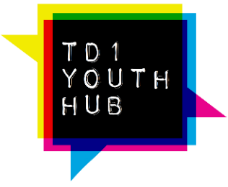  11 – 25 years   |  | TD1 Youth Hub  TD1 Youth Hub provide community-based youth work opportunities to young people aged 11-25 years in Galashiels. They deliver a range of opportunities including drop-ins, 1-1 work, young parents support, street work, transitions support, and school-based youth work.  Phone: 01896 752 442 |  | 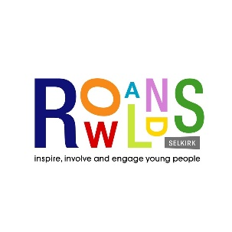  12 – 18 years   |  | Rowlands  Rowlands is a youth project based in Selkirk which is open 6 days a week. They provide a variety of group work, fun and drop-in sessions throughout the year for young people in a safe environment where all young people irrespective of gender or ability can participate.  Phone: 01750 21222
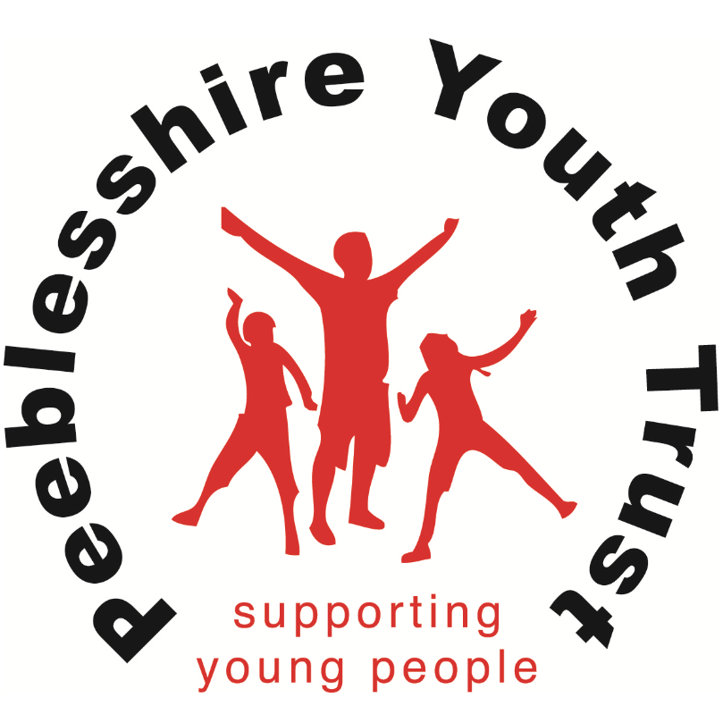  10 – 14 years   |  | Peeblesshire Youth Trust  Peeblesshire Youth Trust works across Tweeddale to support 10-14 year olds during the years of transition from primary to Peebles High School. They focus on growing confidence and self-esteem, building resilience and promoting good relationships for young people at home and in the community.  Phone: 07957 383 663, Email: info@peeblesshireyouthtrust.org |  | 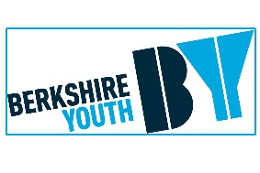   |  | Berwickshire Youth Project  Connect BYP exists to increase the confidence, wellbeing and employability of young people in Berwickshire and to develop young people's skills and experience through community activities and volunteering opportunities. We operate in the Berwickshire area with projects in Duns, Eyemouth and Coldstream in the Scottish Borders.  Telephone: 01361 884198 |  |    |  | Tweedale Youth Action (Food Punks/Bike Punks)  1 to 1 support  Group work  Food Punks  Employability  Offer school holiday provision, including trips away, and advocacy, signposting and support  They are a C-card point for sexual health information and free contraception  Skills based learning through Bike Punks (bike repairs and metal work) and Food Punks (outside and event catering and cookery demonstrations)  01721 724779  01896208160
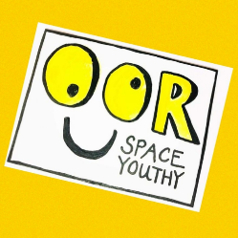   |  | Oor Space Youthy – Youth Borders  P6-S2 Juniors – Friday nights drop in 6.30-8pm  S2-S6 Seniors – Saturday Night drop in 7-9pm  S1 – S6 youth cafe – Monday and Thursday 4-6pm  S1-S6 R-evolve – Monday and Thursday 4-6pm  Junior darts – 10-17yrs Sundays 6-7.30pm  Email Admin@oorspaceyouthy.com Facebook, Instagram, Tiktok or in person at a session at the Drill Hall Peebles

Parent Resources
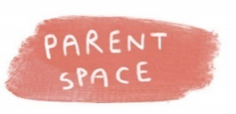   | Parent Space  Parent Space is a local charity that offers courses and workshops to help supports parents, to come together, to build a network of knowledge.  admin@parentspace.org.uk  07545 592 464 | 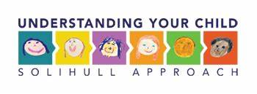   | Solihull Parenting Approach  A wide range of online courses and resources available to parents to help support emotional health and wellbeing in children and families.  Access code: tartan | 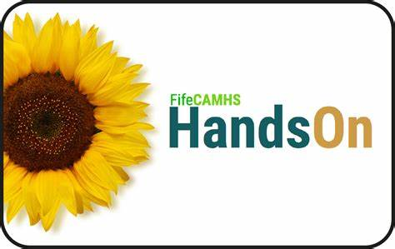   | The HandsOn website no longer exists but all of their resources have moved to: Things to try | NHS Fife  Resources are for parents, carers and those who work with young people, providing help and advice for supporting children and young people's mental health and emotional wellbeing.
 |  |    | MindED Hub  Advice and information from experts to help understand problems that occur, how to best support your family, and how to take care of yourself. | 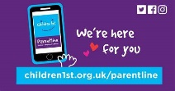   | Children 1st Parentline  Provides advice and support to parents who may be struggling.  Helpline: 08000 28 22 33, Online webchat
   | Moodcafe  A guide for parents and carers about anxiety in children and young people | 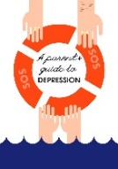   | A parent guide to depression  Pdf with advice and guidance about depression | 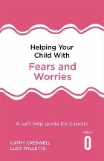   | Helping your child with fears and worries  Cathy Creswell’s great self-guided book for parents to understand and manage anxiety .
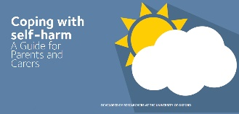 | Parent Guide for coping with self-harm  Pdf with advice and guidance for parents whose child is self-harming .
   | PALS  Parent Awareness of Learning Disabilities Support Group  (online)  PALS is a group for parents of children /Young People with a diagnosis of a Learning Disability. It consists of 5 weekly sessions, each 2 hours in length. The group is run by Psychology and The Children and Young People’s Learning Disability Nursing team. The group is for parents who would like a greater understanding of what it means for their child to have a Learning Disability. |  | PAPAS  Parent Awareness Programme for Autism Spectrum  (online)  PAPAS is a group for parents of children aged 3 to 16 years with a diagnosis of Autism Spectrum Disorder which is run over 6 weekly sessions, each 2 hours in length with a short 10 minute break. The group is run by Psychology and Speech and Language Therapy.

Neurodevelopmental Supports
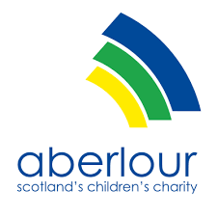  5+  8+ HAC   | Aberlour | Options Disability Service  Services that offer a variety of flexible support options for children and young people with physical and learning disabilities, including ASD.  Offer in house respite, holiday activity club (HAC), weekend activity club (WAC), adventure weekends away.  Tel: 01896 754 003  Email: Options.borders@aberlour.org.uk |    | Autism Initiatives  Helps individuals and families learn methods to cope with Autism through skill development and personal growth.  Tel: 01896 755820  Address: 54 Ladhope Vale, Galashiels, TD1 1BT | 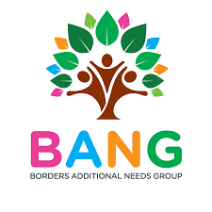  0-24 years old   | BANG (Borders Additional Needs Group)  BANG is an outreach service for parents, young carers and disabled children with rare, complex and additional needs. Membership is free and open to any family living in the Scottish Borders with a child post or pre-diagnosis from the ages of 0-24. Our meetings and activities are for the whole family unit; parents, carers, siblings and grandparents.  https://www.facebook.com/BordersAdditionalNeedsGroup/
 | CHAD  The CHAD team is part of SBC and work with:  -Children or young people who have complex needs and an ensuring disability and/ or chronic health/ life limiting condition, which has a substantial impact on their wellbeing and that of their family and  -Education, health and social work services are required to maintain the child or young person safely within their family and community.  Call 01896 662787 to make a referral. | 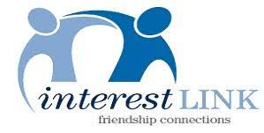  8+   | Interest Link  Provide a wide range of volunteer befriending support for people with learning disabilities ages 8+ and young people with autism aged 8-25, in the Scottish Borders. Support included 1:1 friendship, social groups and distance contact.  Online contact form | 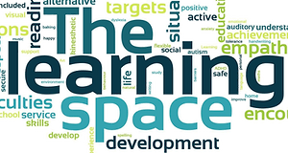   | The Learning Space  Offer learning and development experiences for young people who are experiencing barriers, difficulties and challenges academically, socially and emotionally and support their mental wellbeing, development and growth.  Phone: 07899 841246
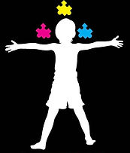   | Meeting of Minds  A voluntary parent led support group, supporting households living with additional support needs.  https://www.facebook.com/meetingofmindsscot/ |  | ADDISS  They provide people-friendly information and resources about Attention Deficit Hyperactivity Disorder to anyone who needs assistance - parents, sufferers, teachers or health professionals.  Phone: 020 8952 2800
   | Autism Initiatives Outreach  This service provides a personalised outreach service ranging from a small service to full time. It can support with social activities, higher/further education, leading an active lifestyle, leisure activities, work or occupational activities and increasing a persons independence. |    | The UK ADHD Partnership  They aim to support clinicians and allied professionals to identify and meet the needs of children and young people affected by this disorder. ADHD is now recognised as a condition that may cross the lifespan and there are multi-modal interventions for ADHD that can be delivered at every age. | 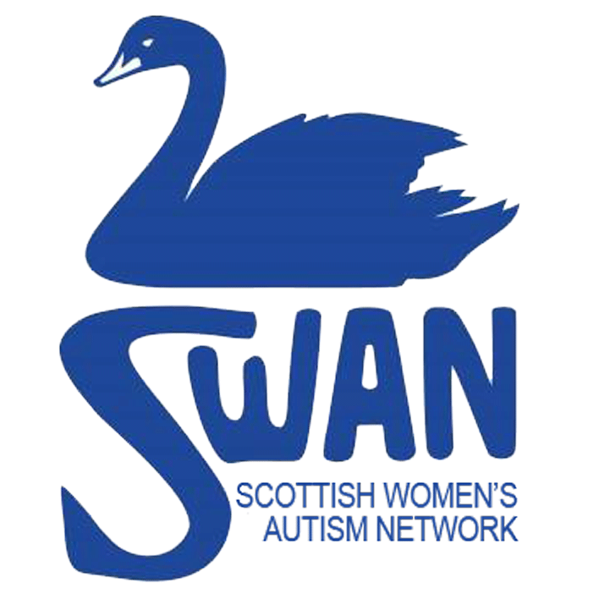   | SWAN - Scottish Women's Autism Network  SWAN aims to improve the lives of autistic girls and women, actively seek and widely promote a greater understanding of the lived experiences of autistic women and girls and provide peer-support.  Email: info@swanscotland.org
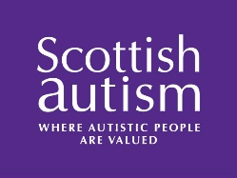  5 – 19 yrs   | Scottish Autism  Scottish Autism provides support for children and young people aged 5 to 19 through individualised outreach support, our respite and short breaks service and our education service. They take the time to build up an understanding of each young person, taking into account their processing and thinking style and maximising their learning potential.  Telephone: 01259 222022 |    | NAIT | ThirdSpace  The NAIT Team are professionals from Education, Speech and Language Therapy, Occupational Therapy and Psychiatry, who have considerable experience and expertise in working with autistic individuals of all ages, their families and others who support them. NAIT provide practitioner to practitioner advice.  E-mail: Nait@qmu.ac.uk | 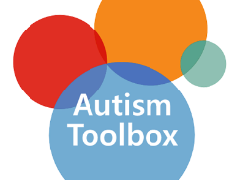   | Autism Toolbox  The Autism Toolbox is a free online resource developed to support the inclusion of autistic learners in Scottish Early Learning and Childcare settings, Primary and Secondary schools.  Email: autismtoolbox@gov.scot
   | Ambitious about Autism  They have a rapidly growing online Ambitious Youth Network to enable more autistic young people to have their voices heard. Through the network, autistic young people between the ages of 16 to 25 can share experiences, connect with others, have their say on Ambitious about Autism’s projects as well as access a range of opportunities to advocate and improve services for autistic young people. Additionally, there are numerous resources for parents/carers and children.  Email: info@ambitiousaboutautism.org.uk  Telephone: 020 8815 5444 | 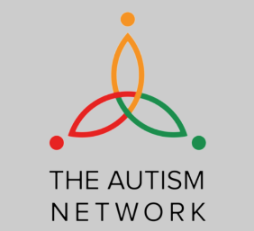   | The Autism Network  The Autism Network is a collective of independent professionals with a background in working with autistic and neurodiverse people.  Each member is available for individually contracted work and the services each member can provide are detailed on their page. If you are not sure which member of the team is the best fit for your needs, contact us and we will get back to you to discuss with you how we can help.  Email: info@theautismnetwork.co.uk |    | NEST  The Neurodevelopmental Empowerment & Strategy Team (NEST) is a small team in NHS Ayrshire & Arran who provide information and advice about autism, ADHD and FASD. NEST is for children, young people, and families who wish to learn more about neurodiversity, and you do not require a diagnosis to access their services. They have an online Learn Zone full of useful information, and they also provide regular workshops for individuals and parents.  Email: info@nest.scot
 | Access Therapies Fife  Provide information and resources to support individuals and families experiencing a range of mental health problems. They also provide courses (online and in person) for parents and families with children who have been diagnosed with Autism, ADHD, Learning Disabilities, and Developmental Delay.  Email: fife.atfife@nhs.scot  Phone: 01383565427 |    | Tourettes Action (tourettes-action.org.uk) |    | Autism missing Person’s Protocol  To work effectively the forms, need to be completed prior to any ' future' missing incidents .  The Autistic Missing Person Protocol is an information gathering tool to assist the police to find a person with autism who has been reported missing, as quickly as possible.
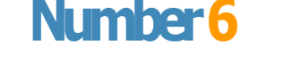  16+   | Number 6  A service part of Autism Initiatives providing free social opportunities and 1-1 advice and support on a range of issues for adults with high functioning Autism and Asperger’s syndrome in Lothian and Scottish Borders.  Accept self-referrals and third-party referrals.  Tel: 07570 953 331  Email : number6@aiscotland.org.uk  https://www.facebook.com/Number6OSS/ |    | Different Minds. One Scotland  Scottish Campaign providing information about Neurodiversity, filled with myth busting information and resources for professionals and the public | 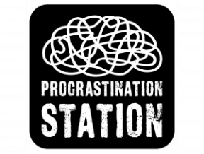   | Home - Procrastination Station (procrastination-station.co.uk)  We are the first and only Community Interest Company for Adult ADHD in Scotland. We aim to provide adults with ADHD the information and support they require to thrive. In addition to our website, we offer ADHD coaching and courses. Follow the link to find out more about us and our vision.
   | Autism Understood  A website about autism for autistic young people. Created by Spectrum Gaming, charity that is a community for autistic young people. | 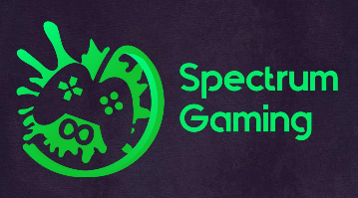   | Spectrum Gaming  Spectrum Gaming is an autistic-led UK based charity that supports autistic young people. We aim to create a world where every autistic young person knows that who they are is ok and they can be themselves, whilst still developing meaningful relationships and achieving their personal goals.  We do this by providing spaces where they feel safe and accepted, amongst others with similar shared lived experiences, and opportunities to explore who they are.

NHS Specific Services
 | Occupational Therapy Service  For any concerns in relation to a child/ young person’s, functional skills, please consider exploring the information & resources available on the website of the Children & Young People’s Occupational Therapy Service, which includes contact details for Requesting Assistance.  www.nhsborders.scot.nhs.uk/cypot | 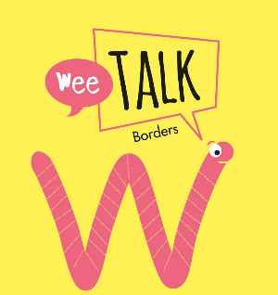   | Wee Talk Borders  NHS Borders Children's Speech and Language Therapy Services with ideas for activities and resources.  https://www.facebook.com/weetalkBorders/

Resources for Refugees
   | The English Hub for Refugees  The project helps refugees and asylum seekers gain the English language skills they need in order to integrate into their new communities and access mainstream education and jobs while also allowing University students to gain teaching experience.  Apart from the English classes, the project also develops language learning materials for refugees and migrants, which are freely available in our Materials section. |    | Cross Borders - Scottish Refugee Council  Cross Borders is a programme of arts and cultural activism projects led by Scottish Refugee Council. These projects include mentoring, commissions and collaborations with artists, activists and creative practitioners from refugee and other migrant backgrounds in Scotland. We advocate for the rights, care and protection of artists and activists whilst facilitating connections, support, exchange and artistic activity. |    | Mental health resources for refugees and asylum seekers | Mental Health Foundation  Resources to assist refugees and asylum seekers with their mental health.  This includes advice translated into Pashto (پښتو), Ukrainian (українська), Dari (دری) and Arabic (عربي).
   | SDS support for refugees | Skills Development Scotland  SDS is committed to welcoming, supporting and offering our services to all refugees fleeing war, oppression, and persecution.  With the Scottish Government having made a commitment to welcome over 3,000 people from Ukraine into Scotland, SDS recognises the need to ensure that those coming to Scotland are aware of the support which is available to them.  Support  We know that your education, employment or future choices have been affected and we can help you access the information, advice and guidance you need. |    | Children - JustRight Scotland  We provide a child-centred legal service which specifically focuses on the areas where refugee and migrant children find it difficult to realise their rights, including in the immigration/asylum and child care system systems. We also deliver specialist second-tier advice, as well as training and outreach, to better professional understanding of refugee and migrant children’s rights. |   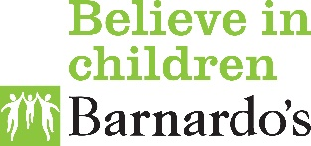 | Barnardo’s Ukrainian Support Helpline | Barnardo's (barnardos.org.uk)  In response to this, following discussion with the Association of Ukrainians in Great Britain, Barnardo's have set up the Ukrainian Support Helpline to provide a holistic support service. The Helpline is available to anyone fleeing to the UK as a result of the war in Ukraine.  You can find more information about the Helpline on our helplines website - https://helpline.barnardos.org.uk
   | Help for Ukrainian Refugees in the UK | British Red Cross  The information on this page will help you and your family to find out about services and support that might be available. For any more information about British Red Cross, or for emotional support please call the free British Red Cross support line:  0808 196 3651 and select option 1 (Open Monday to Friday 10am to 5pm, Wednesday 10am to 8pm).  If you need a support line interpreter, call and say 'can I speak to an interpreter?' |    | Supporting child refugees and their families :: Celcis  Here you will find, all in one place, information, resources, organisations, guidance and the international frameworks to understand the rights of children and what needs to be considered when supporting children in care and children who have been displaced from the war and have been separated from their families and may have arrived in the UK on their own.

Other
     |  | West Lothian Childrens Services Plan 2017-2020.  This PDF underpins the national programmes of the Curriculum for Excellence and Getting It Right For Every Child with desired outcomes that that all children become successful learners, confident individuals, effective contributors and responsible citizens through being safe, nurtured, healthy, active, included, achieving, respected and responsible. |  | 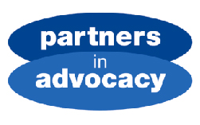  12 – 15 yrs   |  | Partners In Advocacy  They provide independent advocacy to children and young people who are living with mental health issues, additional support needs and learning disabilities. They are Scotland-wide and support children aged 12-15 to have their views considered when decisions are being made about the support they get with their learning. |  |   14 – 25 yrs   |  | Compass Scotland  Compass is for parents and carers of all young people in Scotland who need support as they make the transition to young adult life. Compass can help if your young person is 14-25 yrs and has any additional support needs (e.g. disability, physical or mental health disabilities) or experience of care (young carer/care experienced).
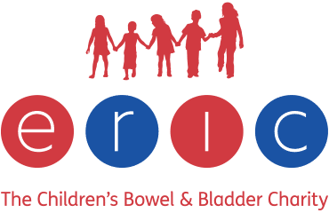   |  | ERIC - The Children's Bowel & Bladder Charity  ERIC is the national charity dedicated to improving children’s bowel and bladder health. Their mission is to reduce the impact of continence problems on children and their families. |  |   13-18 yrs   |  | Healthy Respect  Provides information regarding sexual health for young people, including where to access professional services. |  |   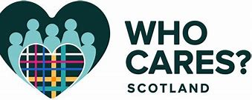 |  | Get Support - Who Cares? Scotland  We provide support to Care Experienced people across Scotland. This support takes a variety of forms including independent advocacy, our helpline, knowledge about your rights and access to local groups.  Helpline (and e-mail helpline) for advice and support 0330 107 7540 or e-mail on the website
   |  | Whole family support service  Whole Family Support is a new service that takes a different approach to providing support for families across the Borders.  We are a team of eight dedicated family support workers, supporting families in their own homes and local community, with the aim of encouraging positive change that will lead to a better future for the whole family.  Email: wholefamilysupport@scotborders.gov.uk
Internet Safety
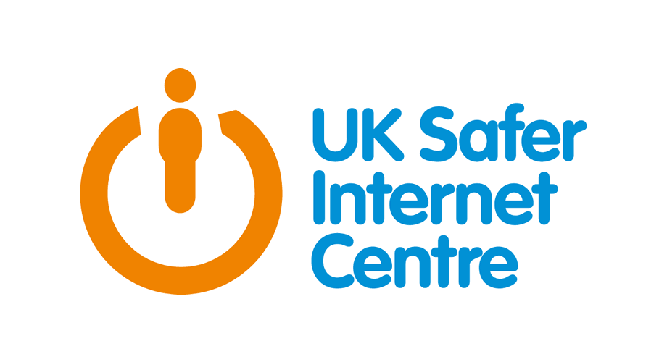   | UK Safer Internet Centre  We provide support and services to children and young people, adults facing online harms, and professionals working with children.  A bridge between Government, industry, law enforcement and society, we are the engine of the online protection landscape in the UK, dealing with both prevention and response.  We are unique. Formed of three charities, Childnet, Internet Watch Foundation and SWGfL, we work together to identify threats and harms online and then create and deliver critical advice, resources, education and interventions that help keep children and young people, and adults, safe. We share our best practices across the UK and globally. |  |    |  | Childnet  Childnet works directly with children and young people from the ages of 3-18, as well as parents, carers, teachers and professionals, finding out about their real experiences online and the positive things they are doing.  Online Sexual Harassment | Childnet  This advice is for online sexual harassment that happens between children and young people who know each other, or know of each other, online.  Online grooming | Childnet |  | 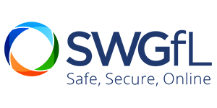   |  | SWGfL  ‘So you got naked online’  A resource that offers children, young people and parents advice and strategies to support the issues resulting from sexting incidents
   | WebWise  In Parents, The Experts, Videos, Videos For Parents  Empowering Healthy Online Behaviour in Younger Children – #BeKindOnline Webinar  As part of Safer Internet Day 2021, the Irish Safer Internet Centre hosted the #BeKindOnline Webinar Series for parents and educators.  In this online safety webinar,Mark Smyth, Consultant Clinical Psychologist, provided advice to parents on Empowering Healthy Online Behaviour in Younger Children. |  |    |  | A series of posters for parents on how to inform and help their child regarding issues they may face online such as:  Hate Speech  Cyberbullying  Cybercrime  Internet Privacy  Grooming  Gaming and Online Addiction |  |    |  | BeSmartOnline by ChildNet provide a series of informational posters on  SnapChat  Facebook  Decision trees to help young people decide:  Whether or not their Facebook contacts are appropriate to keep  Whether to post something online  How to handle being bullied online
   | Child Healthy Weight Service  This is a healthy lifestyle service for children, young people (aged 0-18 years) and their family.  Our programme offers practical tips to support you to eat well and be active.  Our experienced team can support you to make positive lifestyle changes.  We will work with you to identify specific goals that you would like to achieve, to give you the best support.  If you would like to make a self-referral to our service, please complete this Self-Referral Form and return it to us via email or post. If you would like help filling out the form or wish for us to do it for you, please contact us.  If you prefer you can speak to your GP, Health Visitor, School Nurse or another health professional. |  |  |  | Whole family support service  Whole Family Support is a new service that takes a different approach to providing support for families across the Borders.  We are a team of eight dedicated family support workers, supporting families in their own homes and local community, with the aim of encouraging positive change that will lead to a better future for the whole family. |  |   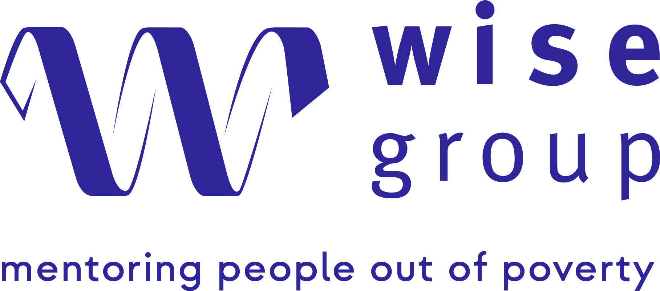 |  | The Wise Group – Relational Mentoring  Funded by the Scottish Government, the Wise Group provides Relational Mentoring support to vulnerable family households to move them onto a positive journey out of child poverty.  Our Relational Mentoring approach provides one-to-one support to better understand the wider needs of the household and addressing them to break down barriers and achieve positive progress. This may include support for skills, employability, community justice, and home energy.  Current Opportunities: This is available to family households across Glasgow, Renfrewshire, Inverclyde, the Scottish Borders, South Lanarkshire, and North Lanarkshire.  For inquiries – Visit our web page or email srm@thewisegroup.co.uk  How to refer? Please complete the below form  ➡️ Referral Form

