Agenda for Scottish Borders CHSWG
Date: Wednesday the 16th of September 2026
Time: 13:30-15:00
Venue: Galashiels Health Centre Meeting Room / MS Teams
Chair: Fred Tanner

1. Welcome and Apologies
Present
Sheila Robson - Speech and language therapist
Rosie Scott – Sensory services - specialist worker for deaf and hard of hearing
Fred Tanner- Audiologist at BGH
Pam Scott- Teacher of deaf children and young people
Emma Auty- Head teacher Targeted pupil support team
Brogan Thomson- Rehab adviser Crosshouse cochlear implant centre
Heather Young- Parent of a deaf child
Donald Gordons– Private paediatric audiologist

Apologies
Natalie Hill- community connector NDCS
Emma Chapman- advice and guidance officer NDCS
Mark Sleigh- Audiology
Hilary Broatch- inclusion Borders college
Jenna Green- parent

2. Review and Agreement of Previous Minutes
Everyone received minutes from previous meeting. Nothing needing amended.

3. Matters Arising / Actions from Previous Meeting

Logo development – Winner + Prizes discussion
Logo had been put out to school children to take part in a competition to design a logo for the group. 1 entrant came back. Some work had been done on it with the children’s permission. Logo will go on correspondence from now on.
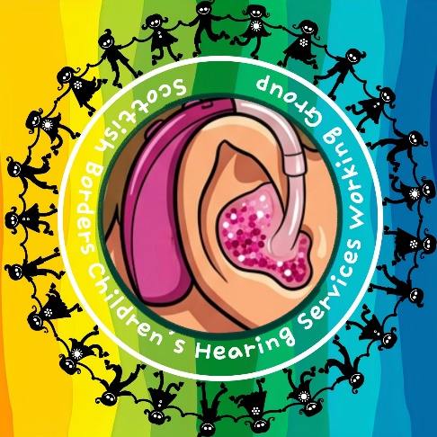

Quality assurance of CHSWG – how to measure outcomes
- Referral pathways- is there shared ways that we can speak to each other? Good communication between ToD and audiology already as far as referral goes. How does it work in other areas? Making connections with 1 person who can point in right direction if not the correct person e.g. sharing email addresses.
- SaLT have ‘first visit’ when a child is first identified as having a hearing loss. At the moment 18 / 24 month wait list- need to get in touch ASAP with speech and language to get them onto the waiting list. Better to get request for assistance in as soon as possible. During the request for assistance conversation it is determined if there is an impact and the decisions about what type of supports are needed are guided from that. Fred had never contacted SaLT up to this point. 50% have speech sound issue, not a language issue. Of that 50%, 75% get better with no intervention. Of the 25%, a risk for them is otitis media.
- Brogan- Lothian audiology saying different pathway for contacting Edinburgh ToD than Borders ToD, Edinburgh pick up immediately and Borders had to wait until ARE meeting. Pam explained that this is now not the case- referrals are coming in and being sent out to ToD straight away to review and allocate to caseload. This will continue to be worked on.
- Emma- new link for ‘request for assistance- sensory’ to be more widely sent out. As part of our service improvement plan, procedures, processes and guidance around deaf children are really clear. Key piece of work for our new team this session.
- Sheila asked about how children are identified and referred to audiology. Fred explained newborn hearing screening is done at BGH (Dawn Coventry- manager of newborn hearing screening nurses) and the children who are 5 and over are seen at BGH, children 5 and younger are seen in Lothian.
- Rosie- Referral to sensory services are done online. Lots of assistance can be given e.g. doorbells, vibrating pad for alarm clock etc. Work can be done for both adult and paediatric populations.
- Donald- referral comes from parents after being diagnosed with hearing loss. Greatest percentage with glue ear. Keen on pathways / policies / criteria for referral being publicly available online etc. for referrals.
- ToD service -In terms of education- we are going to review and co-create policy (including with this group) and happy to put on front- facing platform once it is created.
- Cochlear implant service -Whole page on Crosshouse website about referrals – who can do it? Criteria etc?
- Parent Heather- lack of clarity about what happens after referral made. Unclear about pathway to getting speech and language therapy- could phone an advice line, waiting list for assessment, waiting list for intervention. None of it very clear – nothing in writing. If processes are clear, parents can get in touch. Sheila commented that it is complex- wait list for SaLT is for 1-to-1 support. Other thing that can be done is ‘targeted level support’ e.g. parent training, staff training, environmental support. This can be done without a wait list.
- First thing to look at is each area coming up with a document / few lines saying how people can be referred and the timeline / progression of that referral. Emma- a case study could be used as well to bring it to life and good for parent to hear what has happened for others. Shared email addresses added if there is one.
- Need to think about what goalposts are moving forward. First one to work on after today is joining the services. Would it be useful to have a ‘strategy statement’?
BSL at local action plan meeting (previous James Bewsey to initiate)
Can come back to next meeting with information about this. Amy is in the progress of setting up a BSL network group for teachers to promote and celebrate BSL in schools.

Response to school acoustics consultation – Progress
Consultation responses have been published- Scottish Government. 13 responses from other services / people around deafness. Need for stronger acoustic responses and their impact on children who are deaf and hard of hearing, as well as other youngsters with additional support needs. BB93- acoustic design of schools- performance standards. Joined up approach to Scottish government – if they are going to create recommendations / regulations is there an opportunity to lobby the government and say BB93 is not sufficient? Lots of topics in 1 initial consultation paper- because it is all to do with environment, there was lots to do with toilets, transgender issues, sports pitches, water etc. Binary analysis was then done and not really suitable. Do we need to write a letter to local MP about BB93? Elaine Thornton Nichol- champion counsellor for the deaf community in the borders.
Fred to draft letter and send out to group for input
Lip reading classes – can young people access? – Update
- At present lip reading tutors are not offering classes to children.
- Emma – Are there steps we could take to get lip reading ideas/discussion into schools
- Donald – Should we be training adults (teachers) about this and children will naturally develop the necessary skills?
- Fred – This possibly falls more under deaf awareness than lipreading skills.
- To be discussed at future meetings.
Role of Cochlear Implant Rehab Advisor - Brogan Thomson
Cochlear implant rehab advisors can be either teachers of deaf children and young people or speech and language therapists. Currently we have 3 cochlear implant rehab advisor post to cover the whole of Scotland. Unfortunately, one advisor is leaving their post. As such, Brogan is having to cover the Glasgow caseload as well as her own thus reducing the amount of input she can give to individual cases. Brogan and the cochlea implant team would like to highlight that the role of a cochlear implant rehab advisor is to monitor listening outcomes post implantation and the impact this may have on language development. They provide support advise following sessions to parents and local professionals. Rehab Advisors do not hold a duty of care and are not involved in setting individual targets for children and young people
6. Any Other Business
None
Dates of Future Meetings
14th January 2027 @ 1330
14th May 2027 @ 1330
20th of September 2027 @ 1330


