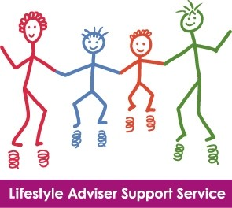

LIFESTYLE ADVISER SUPPORT SERVICE

REFERRAL PATHWAY
Patient seen by Clinical Team

Raise the issue of Lifestyle Change (e.g. Smoking, diet and nutrition, physical activity, safe alcohol
Deliver Brief Advice if appropriate. *

NO
Patient declines or is assessed as not ready to make changes. Give client information leaflet if appropriate and leave ‘door open’.

Assessment for referral to LASS “Are you interested in….”

YES
- Give patient information leaflet with local contact details
- Complete LASS Referral Form: one copy to notes and second copy to the local Lifestyle Adviser

NO
Lifestyle Adviser contacts patient if no appointment made within one month
Patient contacts their local health centre or Lifestyle Adviser to make an appointment

YES Patient attends LASS for support to make lifestyle changes in the usual way. Record name of clnical team referring to LASS on database

The Lifestyle Adviser advises the clinical team which referred the patient and the patient’s GP whether they have/have not attended LASS and any actions or changes on appropriate feedback form.

Referral Criteria:
- Patients motivated to make a change or continue with lifestyle changes
- Patients who would benefit from support as part of secondary prevention of chronic disease

Exclusion criteria:
- People not ready to make changes following ‘brief discussion’ /‘brief intervention’
- Patients who are in an acute phase of their disability or illness.

*Raise the issue: This could be done in a planned or opportunistic way.
“Are you interested in making changes in….”
“Are there any aspects of your lifestyle that you would like to improve?”
“Are you ready to make some changes to your lifestyle?”
“One of the best things we can do to ….. is to… (be active/reduce our weight)”

Brief Advice: short, structured conversation (less then 3min) used to raise awareness of unhealthy behaviours or lifestyles and to assess a person’s willingness to change. It Involves giving information about the benefits of lifestyle change and simple advice.

Exit strategies: ways to leave the pathway. You and the patient can choose not to continue at any point.

“It’s fine if you don’t want to discuss it now. Here’s a leaflet for you to take away.”

“Unfortunately we don’t have enough time to discuss (your lifestyle change / health concern) in depth today. However I can refer you to our Lifestyle Adviser Support Service( LASS) service and you will be able to discuss it more during your assessment.”

“If you think you would benefit from… I could refer you to LASS service for support. This team spends up to 45 minutes on a first assessment and 30 minutes on further appointments giving you plenty of time to explore what matters to you and how you can make change/ improve your health and wellbeing.”

