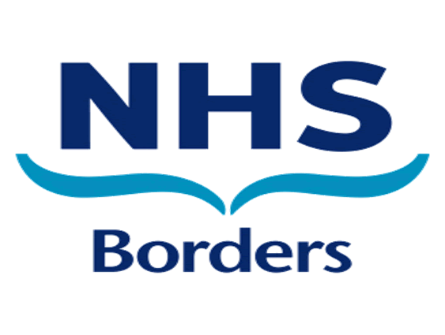
UNPLANNED CLOSURES IN COMMUNITY PHARMACY
NOTIFICATION PROCESS

It is recognised that due to exceptional circumstances out with your control you may have to close your pharmacy for a portion of the day.

It is essential that if the pharmacy is unexpectedly closed for more than 30 minutes you inform NHS Borders of this closure, and the reason for this closure.

Whilst we would not anticipate that this happens regularly, in the instance that you are in one of the following situations, please follow the advice below:-

SITUATION: Unable to open the pharmacy at the start of the day

ACTIONS REQUIRED:
- Inform local GP surgeries that you are unable to open
- Inform local Community Pharmacies that you are unable to open
- Inform Borders addiction service that you are unable to open
- If there is a member of staff in the pharmacy, display a sign on the window signposting patients to the nearest open pharmacy
- Use your individual business continuity plan to ensure that all instalment and dosette patients are informed and have arrangements made for their medications
- Complete and e-mail the template (page 3 of this doc) to communitypharmacy.team@borders.scot.nhs.uk
- If you are unable to email please call 01896 825540.

SITUATION: Pharmacy has been open but is closing early OR pharmacy closed for portion of the day

CONSIDERATIONS: Before informing NHS Borders of an early closure, please consider the following:
- Have all ORT patients had their dose for the day? If no, every effort must be made to contact the patient. If you are unable to contact the patient, the prescriber (mainly Borders Addictions Service) must be informed that the patient has not collected their medication for that day.
- Have all instalment prescriptions (including dosette trays) been collected/delivered or patients been notified of the period of closure?
- Which other community pharmacies in the area are still open? Does this provide an adequate pharmaceutical service?
- Have you informed the local GP surgeries of closure?
ACTIONS REQUIRED:
- Inform prescribers of any ORT patients who have been unable to collect their daily dose ahead of closure
- Display a notice on the window signposting patients to the nearest open pharmacy
- Complete and e-mail the template (page 3 of this doc) to communitypharmacy.team@borders.scot.nhs.uk
- If you are unable to email please call 01896 825540.

SITUATION: Pharmacy is unable to open OR is closed for a portion of the day at the weekend

ACTIONS REQUIRED:
- All actions as above
- E-mail detailing the closure to be sent to the following e-mail addresses:
  - Communitypharmacy.team@borders.scot.nhs.uk
  - nhs24providerupdates@nhs24.scot.nhs.uk
  - becs.reception@borders.scot.nhs.uk
- Complete and e-mail the template (page 3 of this doc) to communitypharmacy.team@borders.scot.nhs.uk
- If you are unable to email please call 01896 825540.

